Class XII – Information Technology (802)
Unit 4: Java Programming with NetBeans
Content 1 & 2 – Introduction and First Java Program
Note: These notes cover only Content 1: Introduction and Content 2: First Java Program (HelloWorld), as requested.

1. INTRODUCTION TO JAVA
1.1 What is Java?
Java is a high-level, general-purpose, object-oriented programming language used to develop a wide variety of applications.
Java was designed with the idea of “Write Once, Run Anywhere” (WORA). Java source code is compiled into bytecode, which can be executed by the Java Virtual Machine (JVM) on different operating systems.
Simple definition
Java is a high-level, object-oriented and platform-independent programming language used to develop desktop, web, enterprise and other applications.
Important characteristics of Java
- Simple – relatively easy to learn.
- Object-Oriented – programs are organized around classes and objects.
- Platform Independent – Java bytecode can run on different platforms with a suitable JVM.
- Portable – Java programs can be moved between systems.
- Secure – Java provides several security mechanisms.
- Robust – includes features such as strong type checking and automatic memory management.
- Multithreaded – supports execution of multiple threads.
- Distributed – provides technologies for network-based applications.
- Architecture Neutral – compiled bytecode is not tied to a particular processor architecture.

1.2 When and Who Developed Java?
Java originated at Sun Microsystems in the early 1990s.
- Original project: Green Project
- Initial name: Oak
- Key developer: James Gosling
- Organization: Sun Microsystems
- First public release of Java: 1995
James Gosling and his team developed the language with the goal of creating a portable language suitable for different kinds of computing devices and environments.
Important point
Oak was later renamed Java, and Java was publicly released in 1995.

1.3 Purposes / Uses of Java
Java is used for developing many types of software.
Major applications of Java
Area | Example
Desktop applications | Business and utility software
Web applications | Server-side applications
Enterprise applications | Banking and business systems
Android development | Historically widely used for Android apps
Scientific applications | Data and scientific computing
Network applications | Client-server programs
Database applications | Programs that communicate with databases
Educational software | Learning and programming applications
Java's standard platform provides APIs and libraries that programmers can use instead of developing every facility from scratch.

1.4 What is Object-Oriented Programming?
Object-Oriented Programming (OOP) is a programming approach in which a program is designed around objects and the classes that define them.
An object can represent a real-world or conceptual entity such as:
- Student
- Teacher
- Bank Account
- Car
- Book
- Employee
Java is fundamentally an object-oriented language and supports concepts such as classes, objects, inheritance, encapsulation and polymorphism.
Example
Suppose we want to create a program for students.
Class: Student
Possible properties:
- name
- roll number
- age
- marks
Possible behaviours:
- study()
- displayDetails()
- calculateResult()
An actual student created from this class is an object.
Diagram
CLASS
┌───────────┐
│ Student │
├───────────┤
│ name │
│ rollNo │
│ age │
│ marks │
├───────────┤
│ study() │
│ display() │
└─────┬─────┘
│
creates objects
┌─────────┼─────────┐
↓ ↓ ↓
Student 1 Student 2 Student 3

1.5 What is a Class?
A class is a blueprint or template used to create objects.
It defines the:
- data/properties of objects
- methods/behaviours of objects
Example
class Student {
String name;
int age;

void display() {
System.out.println(name);
System.out.println(age);
}
}
Here, Student is a class.

1.6 What is an Object?
An object is an instance of a class.
For example:
Student s1 = new Student();
Here:
- Student → class
- s1 → reference variable
- new Student() → creates an object
Class vs Object
Class | Object
Blueprint/template | Actual instance
Defines properties and methods | Uses those properties and methods
Does not represent one specific instance | Represents a particular instance
Example: Student | Example: s1

1.7 Benefits of Java
1. Platform Independence
Java source code is compiled into bytecode.
Java Source Code
│
│ javac
↓
Java Bytecode (.class)
│
┌────┼────┬─────┐
↓ ↓ ↓ ↓
Windows Linux macOS Other OS
│ │ │
JVM JVM JVM

The JVM provides the execution environment for Java bytecode on different platforms.
2. Object-Oriented
Java supports classes and objects, making large programs easier to organize.
3. Robust
Java provides features such as strong type checking and automatic memory management.
4. Secure
Java was designed with security mechanisms for executing code in a controlled environment.
5. Portable
Java bytecode can be transferred between systems that provide compatible Java runtime environments.
6. Multithreaded
Java supports the execution of multiple threads within a program.
7. Rich Library
Java provides a large collection of predefined classes and APIs.

1.8 What is an IDE?
IDE stands for:
Integrated Development Environment
An IDE is software that provides tools required to develop programs in one environment.
A typical IDE provides:
- Source-code editor
- Project management
- Compiler/build tools
- Debugger
- Code completion
- Error detection
- Run/execute options

1.9 What is NetBeans IDE?
Apache NetBeans IDE is an Integrated Development Environment used for developing applications, including Java applications.
It provides facilities for:
- Creating projects
- Writing Java programs
- Managing source files
- Compiling programs
- Running programs
- Debugging programs
- Managing libraries
- Building applications
Apache NetBeans documentation describes the Java Application project as a standard way to create Java SE applications.
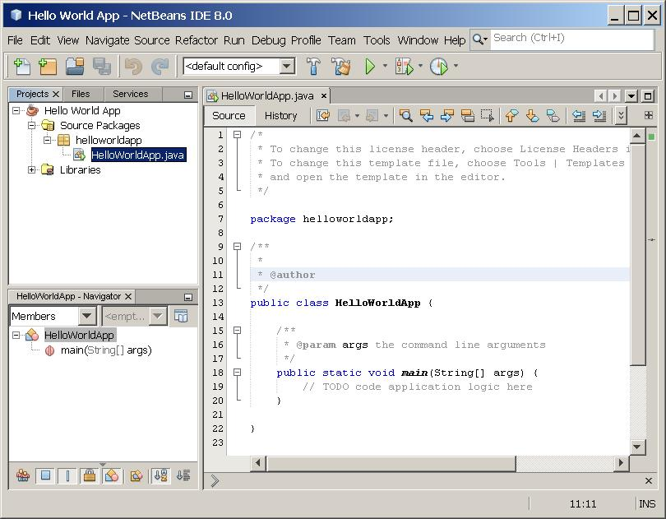
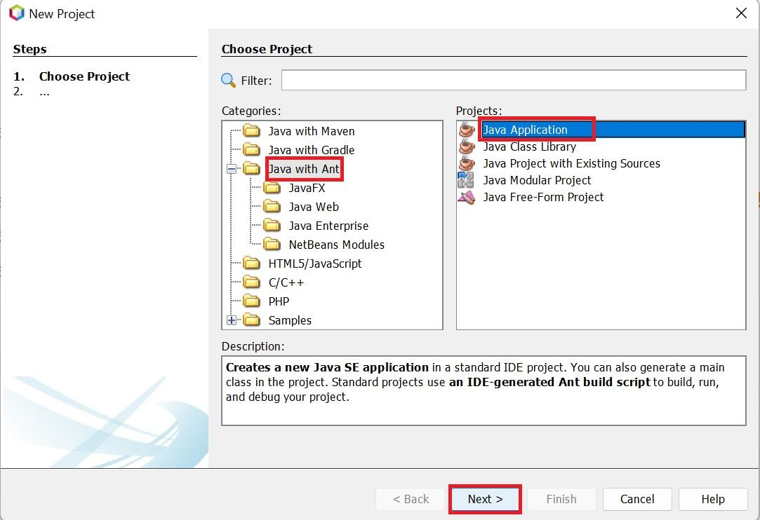
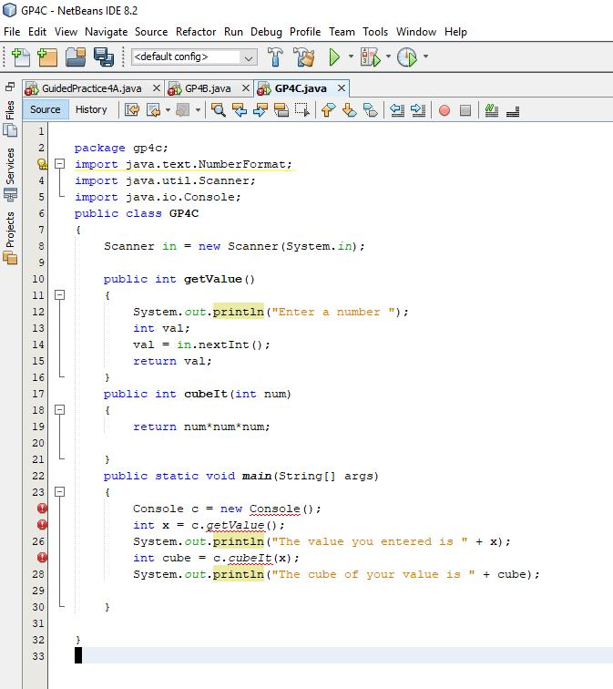

Important NetBeans windows
A Java project commonly contains areas such as:
┌─────────────────────────────────────────────────────┐
│ NETBEANS IDE │
├──────────────┬──────────────────────┬───────────────┤
│ Projects │ Source Code Editor │ Navigator / │
│ │ │ Properties │
│ HelloWorld │ public class ... │ │
│ └ Source │ │ │
│ Packages │ │ │
│ │ │ │
├──────────────┴──────────────────────┴───────────────┤
│ Output / Terminal / Build Messages │
└─────────────────────────────────────────────────────┘

1.10 Java JDK, JRE and JVM
This is an important examination topic.
JVM – Java Virtual Machine
The JVM is the virtual machine that executes Java bytecode.
It acts as the execution environment for Java .class files.
JRE – Java Runtime Environment
The JRE provides the environment and runtime components needed to run Java applications.
JDK – Java Development Kit
The JDK provides the tools required to develop Java programs, including the Java compiler and other development tools.
For Class XII understanding, remember the traditional relationship:
JDK
Java Development Kit
│
┌─────────┴─────────┐
│ │
JRE Development Tools
│ ┌───────────────┐
│ │ javac │
│ │ javadoc │
│ │ debugger etc. │
│ └───────────────┘
│
JVM
│
Runs bytecode
Important modern note: Since JDK 9, Oracle does not provide a separate JRE download in the same traditional way, but the JDK/JRE/JVM relationship is still commonly taught conceptually. Current Java documentation distinguishes the JDK from the JVM and Java SE platform components.
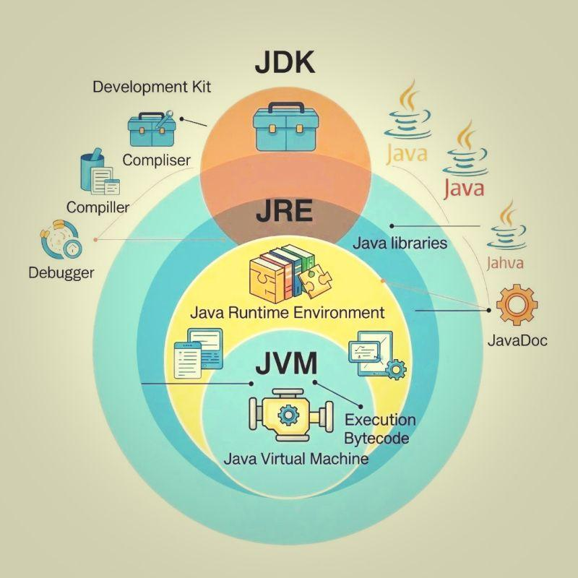
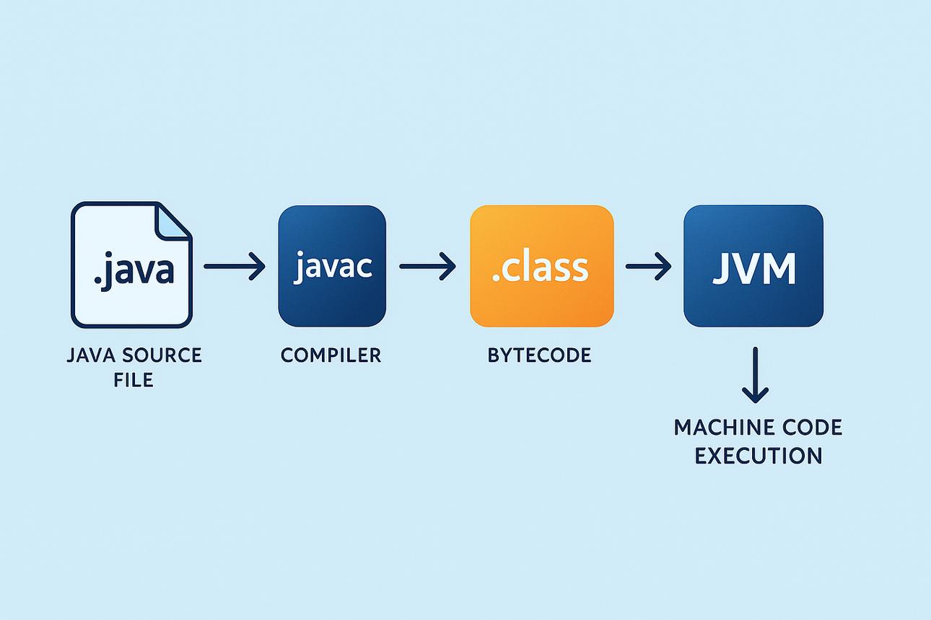
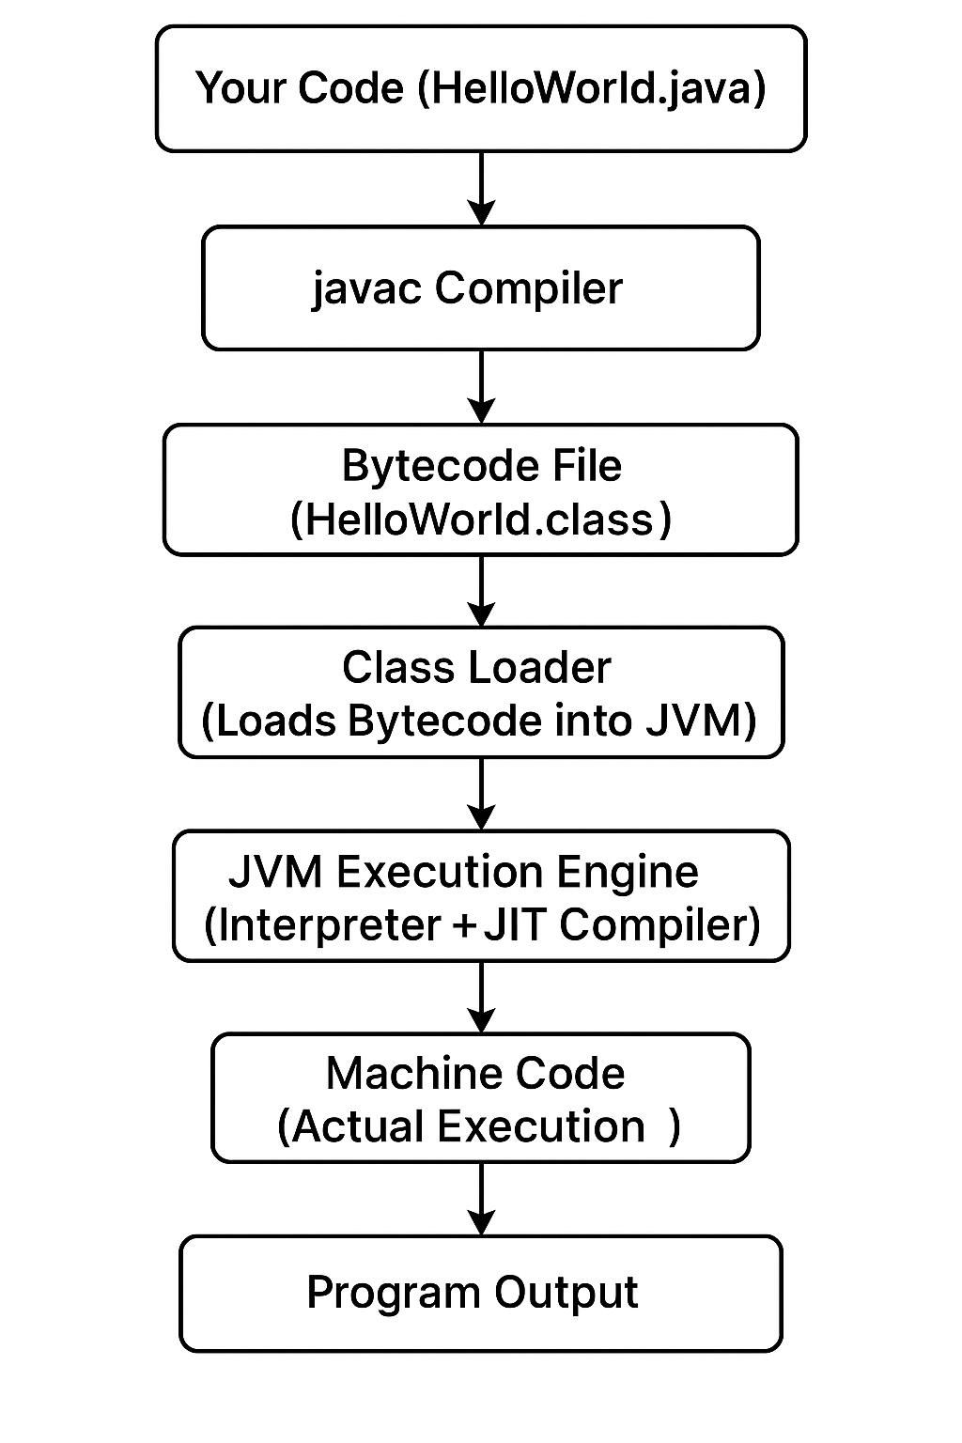
6
Easy way to remember
JDK = Develop + Run
JRE = Run
JVM = Execute Bytecode

1.11 Java Program Execution Process
A Java program normally follows this process:
Java Source Code
HelloWorld.java
│
│ javac
▼
Java Compiler
│
▼
Bytecode (.class)
│
▼
Java Virtual Machine
(JVM)
│
▼
Program Output
Oracle's Java documentation describes the process as Java source code being compiled into .class bytecode, which is then executed by the JVM.

CONTENT 2: FIRST JAVA PROGRAM
2.1 HelloWorld Program
The first Java program usually demonstrates how to display a message on the screen.
Program
public class HelloWorld {

public static void main(String[] args) {
System.out.println("Hello World");
}

}
Output
Hello World

2.2 Java Program Syntax
The basic structure of a traditional Java program is:
public class ClassName {

public static void main(String[] args) {

// statements

}
}
Important rules
- Java is case-sensitive.
- A class name conventionally starts with an uppercase letter.
- Statements normally end with a semicolon ;.
- Blocks of code are enclosed within { }.
- The conventional entry point is the main() method.
- If a class is declared public, the source file name should match the public class name.
Example:
public class HelloWorld
should normally be saved as:
HelloWorld.java

2.3 Meaning of the Lines of the HelloWorld Program
Line 1
public class HelloWorld {
This declares a class named HelloWorld.
public
public is an access modifier.
It means that the class or member can be accessed from other classes, subject to Java's access rules.
class
class is a Java keyword used to declare a class.
HelloWorld
This is the name of the class.
{
The opening curly bracket marks the beginning of the class body.

2.4 The main() Method
public static void main(String[] args) {
This is the conventional entry point from which a Java application starts execution.
Let's understand each part.
Part | Meaning
public | Makes the method accessible to the Java launcher
static | Allows the method to be invoked without creating an object of the class
void | Indicates that the method does not return a value
main | Name of the application's conventional entry-point method
String[] | Array of String values
args | Name of the parameter that refers to the array
{ | Begins the method body

In simple words
public static void main(String[] args)
means:
This is the public, static main method from which the Java application begins its conventional execution, and it accepts an array of command-line String arguments.

2.5 What is System.out.println()?
System.out.println("Hello World");
This statement displays text on the console.
Break it into parts:
System
│
└── out
│
└── println()
System
System is a predefined class in the java.lang package.
out
out refers to the standard output stream.
println()
println() prints the supplied value and then moves the cursor to the next line.
Example
System.out.println("Welcome");
System.out.println("to Java");
Output:
Welcome
to Java

2.6 print() vs println()
println()
Moves to a new line after displaying the content.
System.out.println("Hello");
System.out.println("World");
Output:
Hello
World
print()
Does not automatically move to a new line.
System.out.print("Hello ");
System.out.print("World");
Output:
Hello World

2.7 Steps to Create a Java Program in NetBeans
The exact screens can vary slightly between NetBeans versions, but the traditional Java with Ant → Java Application workflow is documented by Apache NetBeans.
Step 1: Open NetBeans IDE
Launch Apache NetBeans IDE.

Step 2: Create a New Project
Go to:
File → New Project
You can also use the New Project toolbar button.
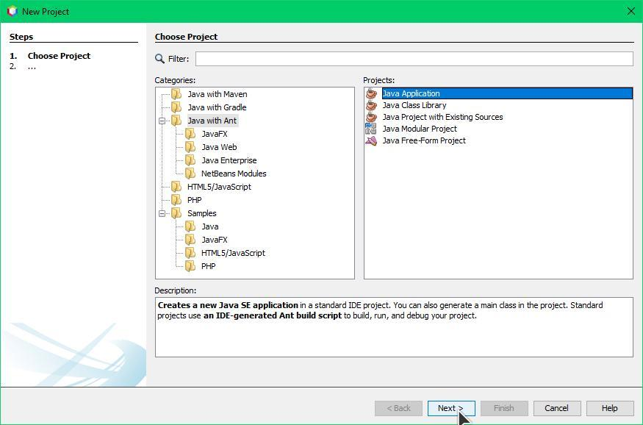
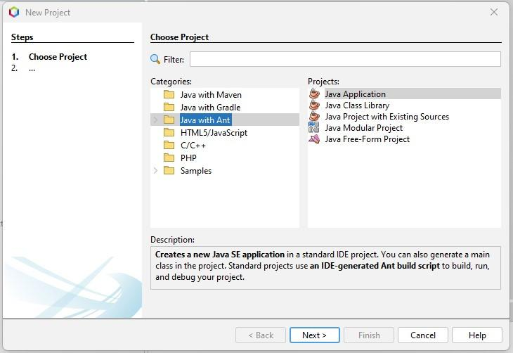
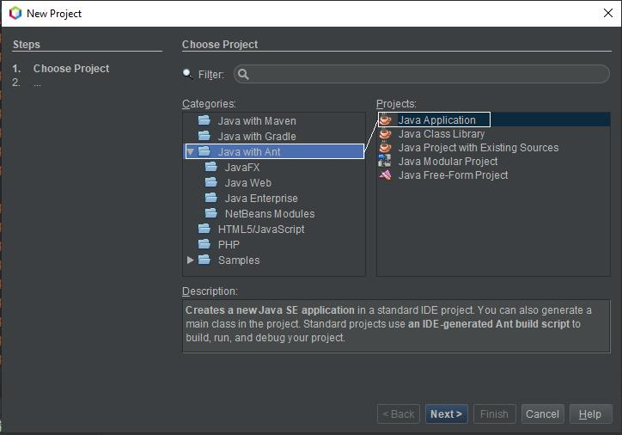

Step 3: Select Project Type
Select:
Categories: Java with Ant
Projects: Java Application
Then click:
Next
Apache NetBeans documentation shows the Java Application project workflow through the New Project wizard.

Step 4: Enter Project Name
Enter:
HelloWorld
Choose the desired project location.
Then click:
Finish

Step 5: Locate the Java File
In the Projects window, locate the source file, for example:
HelloWorld
└── Source Packages
└── <package>
└── HelloWorld.java
If NetBeans has automatically created the main class, open the .java file.

Step 6: Enter the Program
Type or paste:
public class HelloWorld {

public static void main(String[] args) {
System.out.println("Hello World");
}

}

Step 7: Save the Program
Press:
Ctrl + S
or choose the appropriate Save command from the File menu.

Step 8: Run the Program
You can use:
Run → Run File
or run the project using the Run Project button.
NetBeans provides project build/run facilities as part of its Java development workflow.

Step 9: View the Output
The output appears in the Output window.
run:
Hello World
BUILD SUCCESSFUL
The exact build messages may vary according to the NetBeans version and project configuration.

2.8 Complete NetBeans Workflow
┌──────────────────────┐
│ Open NetBeans IDE │
└──────────┬───────────┘
↓
┌──────────────────────┐
│ File → New Project │
└──────────┬───────────┘
↓
┌────────────────────────────┐
│ Java with Ant │
│ → Java Application │
└──────────┬─────────────────┘
↓
┌──────────────────────┐
│ Project: HelloWorld │
└──────────┬───────────┘
↓
┌──────────────────────┐
│ Open HelloWorld.java │
└──────────┬───────────┘
↓
┌──────────────────────┐
│ Write Java Program │
└──────────┬───────────┘
↓
┌──────────────────────┐
│ Save – Ctrl + S │
└──────────┬───────────┘
↓
┌──────────────────────┐
│ Run File / Project │
└──────────┬───────────┘
↓
┌──────────────────────┐
│ Output: Hello World │
└──────────────────────┘

2.9 Important Java Keywords in This Program
public
An access modifier that allows a class/member to be accessed from outside its defining class/package according to Java's access rules.
Example:
public class HelloWorld

static
Indicates that a member belongs to the class rather than to an individual object.
The main() method is static so the Java launcher can invoke it without first creating an object of HelloWorld.
public static void main(String[] args)

void
Specifies that a method does not return a value.
Example:
void display()

main
main is the name of the conventional Java application entry-point method.
public static void main(String[] args)

import
import allows a Java source file to refer to classes or other types by their simple names instead of repeatedly writing their fully qualified names.
Example:
import java.util.Scanner;
After this import, we can write:
Scanner input;
instead of:
java.util.Scanner input;

return
return is used to:
- Return a value from a method, or
- Immediately terminate the current method.
Example:
int add() {
return 10 + 20;
}
Here, return sends the value 30 back to the caller.
For a void method, return; can be used without a value:
void display() {
System.out.println("Hello");
return;
}

2.10 import java.util.Scanner; vs import java.util.*;
This is an important difference.
Option 1
import java.util.Scanner;
This imports only the Scanner type from the java.util package.
Example:
import java.util.Scanner;

class InputDemo {
public static void main(String[] args) {

Scanner sc = new Scanner(System.in);

System.out.println("Enter your name:");
String name = sc.nextLine();

System.out.println(name);
}
}

Option 2
import java.util.*;
The * is a wildcard.
It allows classes/types in the java.util package to be referred to by their simple names.
For example, classes such as:
Scanner
ArrayList
HashMap
Date
Random
can be used without writing their complete package names.
Important
import java.util.*;
does not mean all Java packages and it does not mean subpackages.
For example:
import java.util.*;
does not automatically import:
java.util.concurrent.*
Comparison
Statement | Meaning
import java.util.Scanner; | Imports only Scanner
import java.util.*; | Allows types in java.util to be referred to by simple names
import java.*; | Does not import all Java packages
java.util.Scanner | Fully qualified name of Scanner

Which should beginners use?
For clarity, it is generally better to import the specific class when you know exactly what you need:
import java.util.Scanner;

2.11 What is a Package?
A package is a namespace used to organize related Java classes and interfaces.
For example:
java
└── util
├── Scanner
├── ArrayList
├── HashMap
└── Random
Here:
java.util
is a package.
The complete name:
java.util.Scanner
means:
java
└── util
└── Scanner

2.12 Why Don't We Import System?
You may notice that we write:
System.out.println("Hello");
without:
import java.lang.System;
This is because the java.lang package is automatically available to Java programs.
Therefore, classes such as:
System
String
Math
Object
can normally be used directly.

2.13 Comments in Java
Comments are explanatory text in a program that is ignored by the compiler.
Single-line comment
// This is a comment
Multi-line comment
/*
This is a
multi-line comment.
*/
Example
public class HelloWorld {

public static void main(String[] args) {

// Display a message
System.out.println("Hello World");

}
}

2.14 Important Terms to Remember
Term | Meaning
Java | High-level, object-oriented programming language
Sun Microsystems | Organization where Java originated
James Gosling | Key developer associated with Java
Oak | Original name of Java
OOP | Object-Oriented Programming
Class | Blueprint for creating objects
Object | Instance of a class
IDE | Integrated Development Environment
NetBeans | IDE used for Java development
JDK | Java Development Kit
JRE | Java Runtime Environment
JVM | Java Virtual Machine
Bytecode | Intermediate code stored in .class files
javac | Java compiler
.java | Java source-code file
.class | Compiled Java bytecode file
main() | Conventional entry-point method
System.out.println() | Displays output and moves to the next line
import | Makes types available by simple name
public | Access modifier
static | Class-level member modifier
void | Indicates no return value
return | Returns a value or exits a method

2.15 Quick Revision Diagram
JAVA
│
┌──────────────────┼──────────────────┐
│ │ │
Object-Oriented Platform Independent Portable
│
↓
CLASS
│
↓
OBJECT
│
└───────────────┐
↓
JAVA PROGRAM
│
↓
.java SOURCE FILE
│
javac
↓
.class BYTECODE
│
↓
JVM
│
↓
OUTPUT

⭐ Exam-Oriented Questions
Very Short Answer
- What is Java?
- Who is known as the key developer of Java?
- What was the original name of Java?
- In which year was Java first publicly released?
- What is OOP?
- What is a class?
- What is an object?
- What does IDE stand for?
- What is NetBeans?
- What is JVM?
- What is JDK?
- What is JRE?
- What is bytecode?
- What is the extension of a Java source file?
- What is the extension of a compiled Java class file?
Short Answer
- Explain any four features of Java.
- Differentiate between a class and an object.
- Explain JDK, JRE and JVM.
- What is the role of NetBeans IDE?
- Explain the execution process of a Java program.
- Explain the meaning of public static void main(String[] args).
- What is the purpose of System.out.println()?
- Differentiate between import java.util.Scanner; and import java.util.*;.
- What is the purpose of the import keyword?
- Explain the difference between print() and println().
Long Answer
Explain the complete procedure for creating, saving and executing a HelloWorld Java program using NetBeans IDE.

📌 One-line Memory Trick
JDK → Develop | JRE → Run | JVM → Execute | .java → Source | .class → Bytecode
These notes are aligned with the conventional Class XII Java + NetBeans learning sequence, while correcting the terminology in your outline (JVM, not “JM”) and keeping the Java with Ant → Java Application workflow you specified. Apache NetBeans' documentation confirms the Java Application project workflow, while Oracle's documentation describes Java source → bytecode → JVM execution.

3. VARIABLES IN JAVA
3.1 What is a Variable?
A variable is a named memory location used to store a value that can change during program execution.
In Java, every variable has:
- Name
- Data type
- Value
Example
int age = 17;
Here:
Part | Meaning
int | Data type
age | Variable name
17 | Value
Diagram
VARIABLE
│
┌────────┼────────┐
↓ ↓ ↓
Data Type Name Value
│ │ │
int age 17

3.2 Variable Declaration
A variable is declared by specifying its data type followed by its name.
Syntax
dataType variableName;
Example
int age;
double salary;
char grade;
boolean passed;

At this point, the variables have been declared.

3.3 Variable Initialization
Giving a value to a variable for the first time is called initialization.
int age = 17;
Here, age is declared and initialized at the same time.
Declaration and initialization separately
int age; // Declaration
age = 17; // Initialization

3.4 Declaration + Initialization
Java allows both operations in one statement:
int age = 17;
double marks = 89.5;
char grade = 'A';
boolean result = true;

3.5 How to Name a Variable in Java
Java has specific rules for naming variables.
Rules for naming variables
1. A variable name can contain:
- Letters (A-Z, a-z)
- Digits (0-9)
- Underscore (_)
- Dollar sign ($)
2. A variable name must not begin with a digit.
❌ Incorrect:
int 2marks = 90;
✅ Correct:
int marks2 = 90;

3. A variable name cannot contain spaces.
❌ Incorrect:
int student age = 17;
✅ Correct:
int studentAge = 17;
or
int student_age = 17;

4. A variable name cannot be a Java keyword.
❌ Incorrect:
int class = 10;
Because class is a Java keyword.

5. Java is case-sensitive.
These are three different variable names:
age
Age
AGE

6. Special characters are not allowed, except _ and $.
❌ Incorrect:
int student@age = 17;

3.6 Examples of Valid and Invalid Variable Names
Variable | Valid/Invalid | Reason
age | ✅ Valid | Normal identifier
studentAge | ✅ Valid | Uses camelCase
marks2 | ✅ Valid | Digit is not at beginning
_marks | ✅ Valid | Underscore is allowed
$salary | ✅ Valid | $ is allowed
2marks | ❌ Invalid | Starts with digit
student age | ❌ Invalid | Contains space
student@age | ❌ Invalid | @ is not allowed
class | ❌ Invalid | Java keyword
total-marks | ❌ Invalid | - is not allowed

Important
Although $ and _ are technically permitted, meaningful names should normally be preferred.
For example:
int studentAge;
double totalMarks;
are better than:
int $a;
int _x;

3.7 Java Naming Convention for Variables
Java programmers generally use camelCase for variable names.
Examples
studentName
totalMarks
averageMarks
dateOfBirth
phoneNumber
Example
int studentAge = 17;
double totalMarks = 450.5;
Convention: Start with a lowercase letter and capitalize the first letter of each subsequent word.

3.8 Types of Variables in Java
Variables can be classified according to where they are declared and how they are associated with classes/objects.
The three commonly taught types are:
- Local variables
- Instance variables
- Static/Class variables
Diagram
VARIABLES
│
┌──────────────┼──────────────┐
↓ ↓ ↓
Local Instance Static
Variable Variable Variable
│ │ │
Inside a Belongs to Belongs to
method object class

3.9 Local Variable
A local variable is declared inside a method, constructor or block.
Example
class Student {

void display() {
int age = 17;
System.out.println(age);
}
}
Here, age is a local variable.
Important points
- Declared inside a method/block.
- Its scope is limited to that method/block.
- It must be initialized before it is used.

3.10 Instance Variable
An instance variable is declared inside a class but outside methods, constructors and blocks.
Each object generally has its own copy of an instance variable.
Example
class Student {

String name;
int age;

void display() {
System.out.println(name);
System.out.println(age);
}
}
Here:
String name;
int age;
are instance variables.

3.11 Static / Class Variable
A static variable is declared using the static keyword.
It belongs to the class, rather than to each individual object.
Example
class Student {

String name;
static String school = "Zion Mission School";

}
Here:
- name → instance variable
- school → static/class variable
A static variable is shared by instances of the class.

3.12 Comparison of Variables
Feature | Local | Instance | Static/Class
Declared | Inside method/block | Inside class, outside methods | Inside class with static
Associated with | Method/block | Object | Class
Scope | Limited to block/method | Generally throughout object context | Class-level
Separate copy for each object? | Not applicable | Yes | No, generally shared
Example | int age = 17; | String name; | static int count;

3.13 Variable Example Program
public class VariableDemo {

static int schoolCode = 101; // Static variable

String studentName; // Instance variable

void display() {

int age = 17; // Local variable

System.out.println("Name: " + studentName);
System.out.println("Age: " + age);
System.out.println("School Code: " + schoolCode);
}

public static void main(String[] args) {

VariableDemo s1 = new VariableDemo();

s1.studentName = "Rahul";
s1.display();
}
}

Output
Name: Rahul
Age: 17
School Code: 101

4. KEYWORDS AND IDENTIFIERS
4.1 What is a Keyword?
A keyword is a reserved word in Java that has a predefined meaning to the compiler.
Keywords cannot normally be used as identifiers.
Examples
class, public, static, void, int, if, else, for, while, return, new, import
Example
public class Student {
int age;
}
Here:
- public → keyword
- class → keyword
- int → keyword

4.2 Some Important Java Keywords
Keyword | Purpose
class | Declares a class
public | Access modifier
private | Restricts access
protected | Provides protected access
static | Declares a class-level member
void | Indicates no return value
int | Declares an integer variable
double | Declares a double-precision floating-point variable
char | Declares a character variable
boolean | Declares a Boolean variable
if | Conditional statement
else | Alternative condition
for | Loop
while | Loop
do | Used with do-while
switch | Multi-way selection
case | Defines a switch case
break | Terminates a loop/switch
continue | Skips to the next loop iteration
return | Returns from a method
new | Creates an object
import | Makes types available by simple name
extends | Used for class inheritance
implements | Used when a class implements interfaces
this | Refers to the current object
super | Refers to superclass members
final | Declares something that cannot be changed in certain contexts

4.3 What is an Identifier?
An identifier is a name given by the programmer to program elements such as:
- Variables
- Methods
- Classes
- Interfaces
- Packages
- Objects/reference variables
Examples
class Student {

int age;

void display() {
System.out.println(age);
}
}
Here:
Identifier | Represents
Student | Class name
age | Variable
display | Method

4.4 Rules for Identifiers
The rules are similar to variable naming rules.
Valid
studentName
Student
_marks
marks2
$total

Invalid
2marks
student-name
student name
class

Important
Keywords cannot be used as identifiers.
For example:
int class = 10;
is invalid because class is a reserved Java keyword.

4.5 Keyword vs Identifier
Keyword | Identifier
Reserved by Java | Defined by programmer
Has predefined meaning | Used to name program elements
Cannot normally be used as a user-defined name | Can be chosen by programmer
Example: class | Example: Student
Example: int | Example: age

Easy memory trick
Keyword = Java's reserved word
Identifier = Programmer's name

5. DATA TYPES IN JAVA
A data type specifies the type of value that a variable can store.
For example:
int age = 17;
Here, int tells Java that age stores an integer value.

5.1 Types of Data Types
Java data types are broadly classified into:
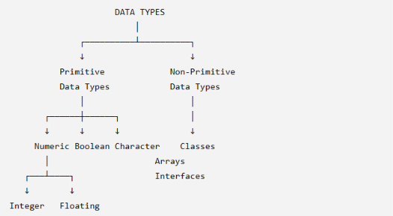

5.2 Primitive Data Types
Primitive data types are the fundamental built-in data types of Java.
Java has eight primitive data types:
- byte
- short
- int
- long
- float
- double
- char
- boolean

5.3 Primitive Data Types Table
Data Type | Category | Size | Example
byte | Integer | 8-bit | byte age = 17;
short | Integer | 16-bit | short year = 2026;
int | Integer | 32-bit | int marks = 95;
long | Integer | 64-bit | long population = 1400000000L;
float | Floating point | 32-bit | float price = 25.5f;
double | Floating point | 64-bit | double salary = 45000.75;
char | Character | 16-bit | char grade = 'A';
boolean | Logical | JVM-dependent representation | boolean passed = true;
Important
char stores a single 16-bit Unicode character.
char grade = 'A';
Use single quotation marks for a character.
'A'
not:
"A"
"A" is a String.

5.4 Integer Data Types
The integer types are:
byte
short
int
long
Example
byte age = 17;
short year = 2026;
int population = 1000000;
long distance = 9876543210L;
Important
A large integer literal assigned to a long may need the suffix L.
long population = 9876543210L;

5.5 Floating-Point Data Types
Java provides:
- float
- double
Example
float temperature = 36.5f;
double salary = 45678.90;

A float literal normally uses the suffix:
f
Example:
float price = 25.5f;
Without f, a decimal literal such as 25.5 is normally treated as a double.

5.6 Boolean Data Type
The boolean data type stores one of two values:
true
false
Example:
boolean passed = true;
boolean absent = false;
Important
Java does not use 0 and 1 as Boolean values in place of false and true.

5.7 Non-Primitive / Reference Data Types
Non-primitive types are commonly called reference types.
Examples include:
- Classes
- Objects
- Arrays
- Interfaces
- Enumerations
- String
Example
String name = "Rahul";
Here, String is a class/reference type.
Array example
int[] marks = {80, 85, 90};

5.8 Primitive vs Non-Primitive Data Types
Primitive | Non-Primitive / Reference
Built into Java | Includes classes, arrays, interfaces etc.
Eight primitive types | Many reference types
Examples: int, char, boolean | Examples: String, arrays, Student
Store primitive values | Variables generally hold references to objects/arrays
Cannot normally be null | Reference variables can hold null
Have fixed primitive type characteristics | Classes/types can define complex structures

5.9 Complete Data Type Diagram
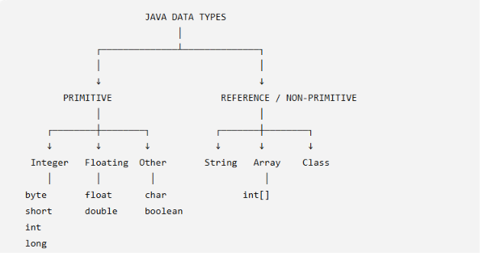
6. OPERATORS AND SEPARATORS IN JAVA
6.1 What is an Operator?
An operator is a symbol that performs an operation on one or more operands.
Example:
int sum = a + b;
Here:
- a and b → operands
- + → operator
Diagram
a + b
│ │ │
│ │ └── Operand
│ └──── Operator
└────── Operand

6.2 Types of Operators in Java
Common categories include:
- Arithmetic operators
- Unary operators
- Relational operators
- Logical operators
- Assignment operators
- Conditional/Ternary operator
- Bitwise operators
- Shift operators
- instanceof operator

6.3 Arithmetic Operators
Arithmetic operators perform mathematical calculations.
Operator | Meaning | Example | Result
+ | Addition | 10 + 5 | 15
- | Subtraction | 10 - 5 | 5
* | Multiplication | 10 * 5 | 50
/ | Division | 10 / 5 | 2
% | Remainder | 10 % 3 | 1

Example
int a = 10;
int b = 3;

System.out.println(a + b); // 13
System.out.println(a - b); // 7
System.out.println(a * b); // 30
System.out.println(a / b); // 3
System.out.println(a % b); // 1
Important: When both operands are integers, / performs integer division.

6.4 Unary Operators
Unary operators operate on one operand.
Operator | Meaning | Example
+ | Unary plus | +a
- | Unary minus | -a
++ | Increment | a++
-- | Decrement | a--
! | Logical NOT | !passed
~ | Bitwise complement | ~a
Increment example
int a = 5;
a++;
Now:
a = 6

Decrement
int a = 5;
a--;
Now:
a = 4

6.5 Relational Operators
Relational operators compare two values.
The result is a boolean value: true or false.
Operator | Meaning | Example
== | Equal to | a == b
!= | Not equal to | a != b
> | Greater than | a > b
< | Less than | a < b
>= | Greater than or equal to | a >= b
<= | Less than or equal to | a <= b

Example
int a = 10;
int b = 20;
System.out.println(a < b);
Output:
true

6.6 Logical Operators
Logical operators are used with Boolean expressions.
Operator | Name | Meaning | Example
&& | Logical AND | True when both conditions are true | a > 5 && b < 20
` |  | ` | Logical OR
! | Logical NOT | Reverses a Boolean value | !(a > 5)
Logical AND
A B A && B
T T T
T F F
F T F
F F F

Logical OR
A B A || B
T T T
T F T
F T T
F F F

Logical NOT
A !A
T F
F T
Remember:
&& → BOTH
|| → AT LEAST ONE
! → REVERSE

6.7 Assignment Operators
Assignment operators assign values to variables.
Operator | Meaning | Example | Equivalent
= | Assignment | a = 10 | —
+= | Add and assign | a += 5 | a = a + 5
-= | Subtract and assign | a -= 5 | a = a - 5
*= | Multiply and assign | a *= 5 | a = a * 5
/= | Divide and assign | a /= 5 | a = a / 5
%= | Remainder and assign | a %= 5 | a = a % 5
Example
int a = 10;
a += 5;
System.out.println(a);

Output:
15

6.8 Conditional / Ternary Operator
The conditional operator is:
?:
It is called the ternary operator because it uses three operands.
Syntax
condition ? value1 : value2;
Example
int age = 18;

String result = (age >= 18) ? "Adult" : "Minor";
If age >= 18 is true:
Adult
Otherwise:
Minor
Diagram
condition
│
┌────┴────┐
true false
│ │
↓ ↓
value1 value2

6.9 Bitwise Operators
Bitwise operators work at the level of individual bits of integral values.
Operator | Meaning | Example
& | Bitwise AND | a & b
` | ` | Bitwise OR
^ | Bitwise XOR | a ^ b
~ | Bitwise complement | ~a

Important distinction
Do not confuse:
&& → Logical AND
& → Bitwise AND
and:
|| → Logical OR
| → Bitwise OR

6.10 Shift Operators
Shift operators move bits left or right.
Operator | Meaning | Example
<< | Left shift | a << 2
>> | Signed right shift | a >> 2
>>> | Unsigned right shift | a >>> 2

These operators are mainly used in programs involving bit-level operations.

6.11 instanceof Operator
The instanceof operator checks whether an object/reference is an instance of a particular class or interface type.
Example
String name = "Rahul";
System.out.println(name instanceof String);
Output:
true

6.12 Complete Operator Summary
Category | Operators
Arithmetic | + - * / %
Unary | + - ++ -- ! ~
Relational | == != > < >= <=
Logical | `&&
Assignment | = += -= *= /= %=
Conditional | ?:
Bitwise | `&
Shift | << >> >>>
Type comparison | instanceof

6.13 What are Separators in Java?
Separators are symbols used to separate or organize different parts of Java programs.
They help define:
- Statements
- Blocks
- Method parameters
- Arrays
- Packages
- Expressions
- Members of classes

6.14 Java Separators Table
Separator | Name | Purpose | Example
() | Parentheses | Method calls, parameters, expressions, conditions | main()
{} | Braces / Curly brackets | Define blocks/classes/methods | class A { }
[] | Square brackets | Arrays | int[] marks
; | Semicolon | Terminates statements | int age = 17;
, | Comma | Separates items | int a, b;
. | Dot | Accesses members / separates package components | System.out
: | Colon | Used in case, ternary operator and other syntax | case 1:
:: | Method reference operator | Refers to a method/constructor | System.out::println
... | Ellipsis / varargs | Variable number of arguments | int... numbers
Note
The exact classification of punctuation can vary somewhat across textbooks, but these symbols are important Java syntax separators/delimiters.

6.15 Examples of Separators
Parentheses ()
System.out.println("Hello");
Parentheses contain the method argument.

Curly Braces {}
class Student {
}
They define a block.

Square Brackets []
int[] marks;
They indicate an array type.

Semicolon ;
int age = 17;
The semicolon terminates the statement.

Comma ,
int a = 10, b = 20;
The comma separates declarations.

Dot .
System.out.println();
The dot is used to access members.
It is also used between package components:
java.util.Scanner

Colon :
Used in a switch case:
switch(day) {
case 1:
System.out.println("Monday");
break;
}
It is also used in the ternary operator:
result = condition ? "Yes" : "No";

6.16 Operators vs Separators
Operators | Separators
Perform operations | Organize/separate program elements
Examples: +, -, *, == | Examples: (), {}, [], ;
Usually produce/affect values or conditions | Define program structure/syntax
Example: a + b | Example: int a;

📌 Combined Revision Diagram
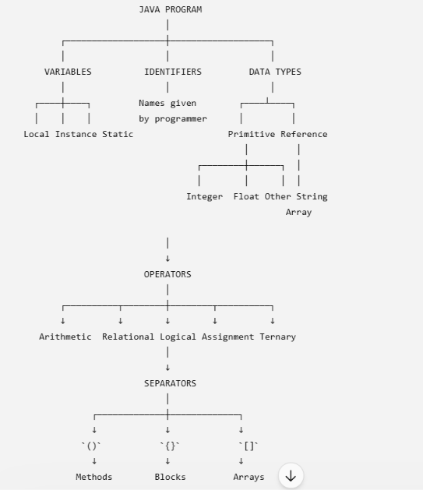

⭐ Quick Revision for Examination
Variables
A variable is a named memory location used to store a value.
Types: Local, Instance and Static/Class variables.
Identifiers
An identifier is a programmer-defined name given to a program element.
Keywords
Keywords are reserved words having predefined meanings in Java.
Data Types
Data types specify the type of value that a variable can store.
Primitive: byte, short, int, long, float, double, char, boolean
Reference: Classes, objects, arrays, interfaces, String, etc.
Operators
Operators are symbols that perform operations on operands.
Separators
Separators/delimiters are symbols that organize and separate elements of Java syntax.

📝 Important Class XII Questions
1 Mark
- What is a variable?
- What is an identifier?
- What is a keyword?
- Give two examples of valid identifiers.
- Give two examples of invalid identifiers.
- Name the eight primitive data types.
- Which data type is used to store a single character?
- Which operator is used for remainder?
- Which operator represents logical OR?
- What is the purpose of the semicolon?
- What is a static variable?
- What is a local variable?
2–3 Marks
- Explain the rules for naming variables in Java.
- Differentiate between keywords and identifiers.
- Explain local, instance and static variables with examples.
- Differentiate between primitive and reference data types.
- Explain arithmetic and relational operators with examples.
- Explain &&, || and ! with truth tables.
- Differentiate between & and &&.
- Explain assignment operators with examples.
- Explain Java separators with examples.
- Explain the difference between print() and println().
Programming Practice
int a = 15;
int b = 4;

System.out.println(a + b);
System.out.println(a - b);
System.out.println(a * b);
System.out.println(a / b);
System.out.println(a % b);
Expected output:
19
11
60
3
3
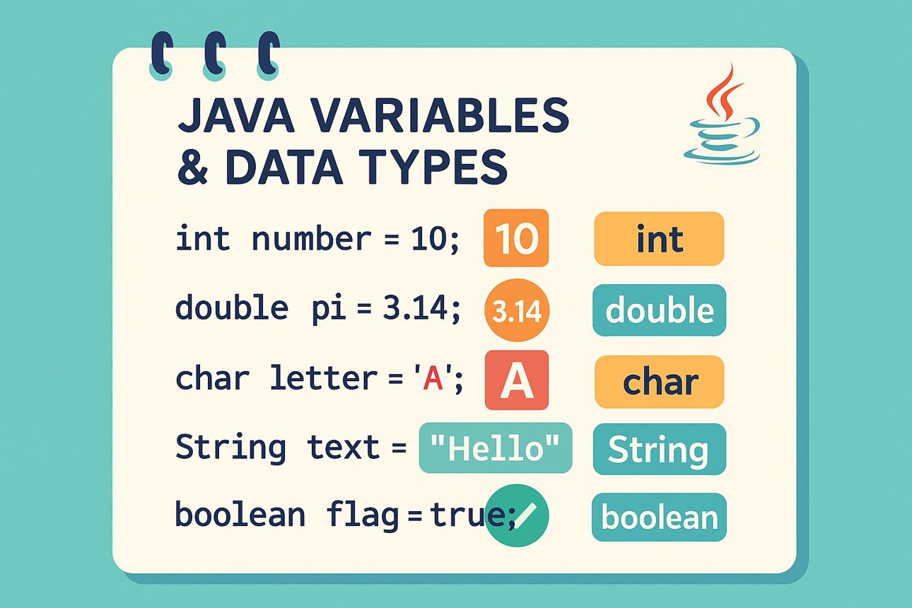
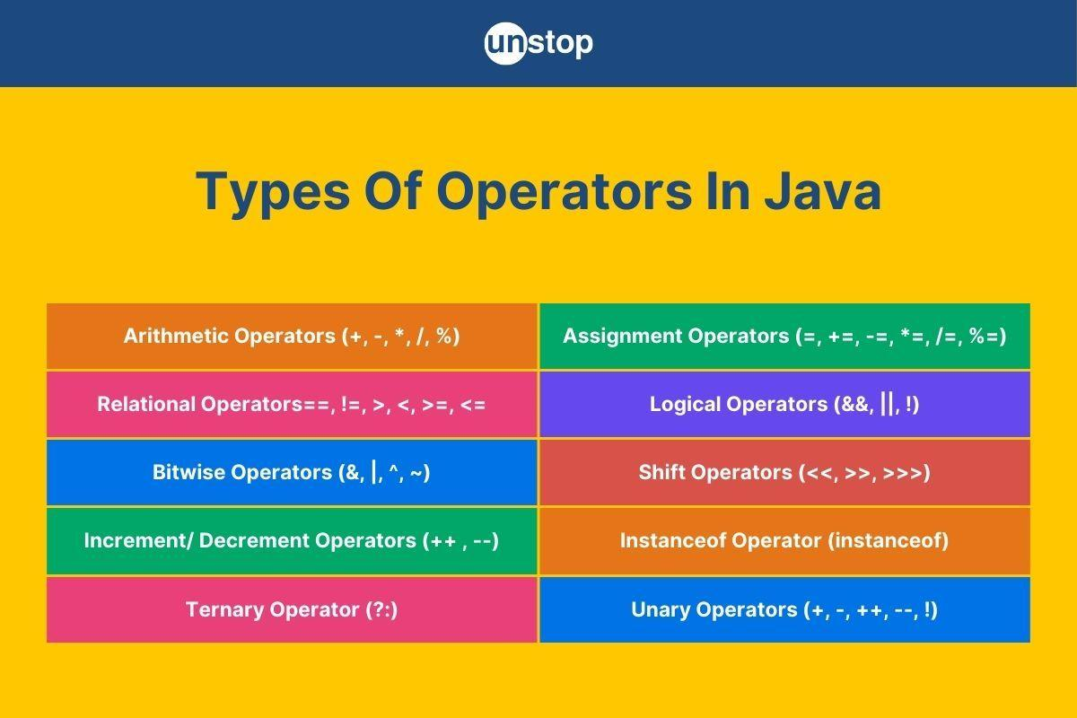
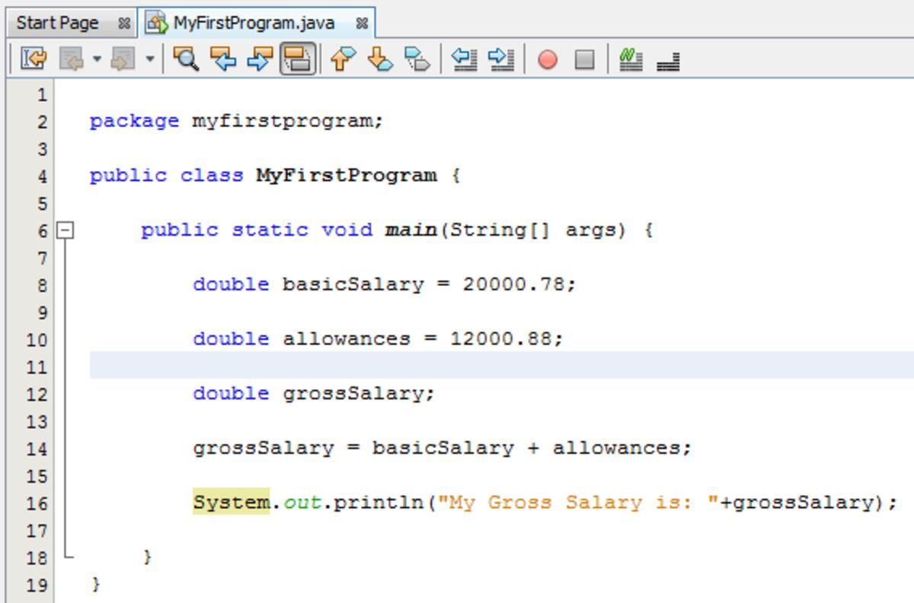

7. CONTROL FLOW STATEMENTS
7.1 What is Control Flow?
Normally, a Java program executes statements from top to bottom, one after another.
However, real programs often need to:
- make decisions,
- repeat a block of code,
- skip certain statements,
- terminate a loop,
- select one option from several choices.
The statements that control the order in which program statements are executed are called Control Flow Statements or Control Statements.
Definition
Control flow statements are statements that control the order and manner in which instructions of a program are executed.
Simple example
Without control flow:
Statement 1
↓
Statement 2
↓
Statement 3
↓
Statement 4
With control flow:
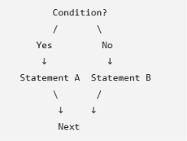
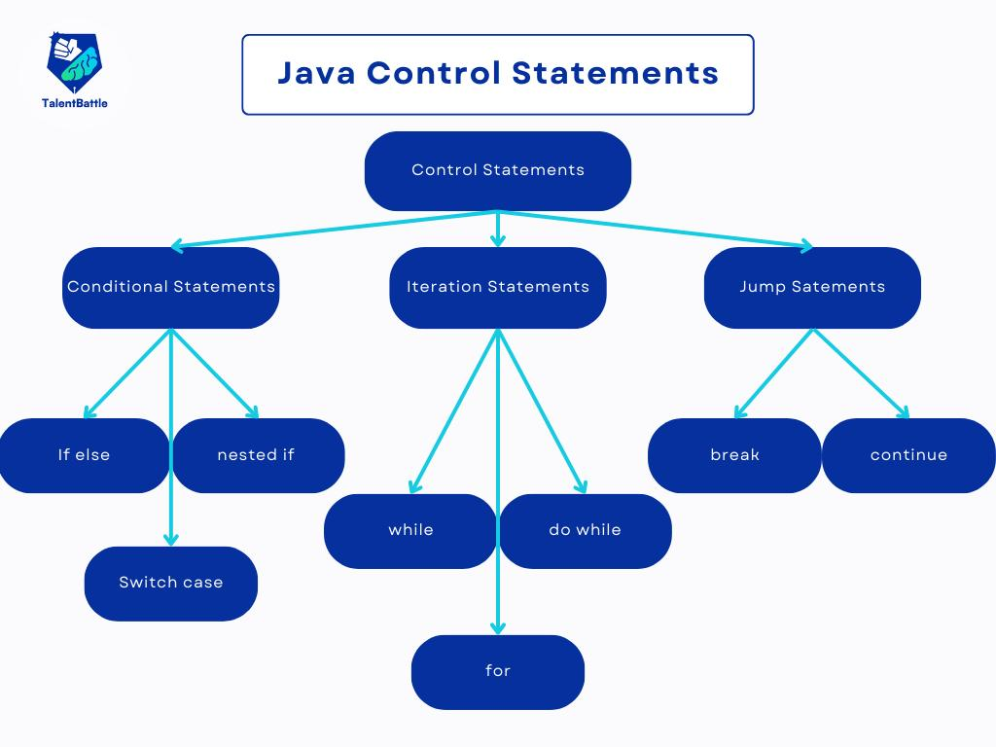
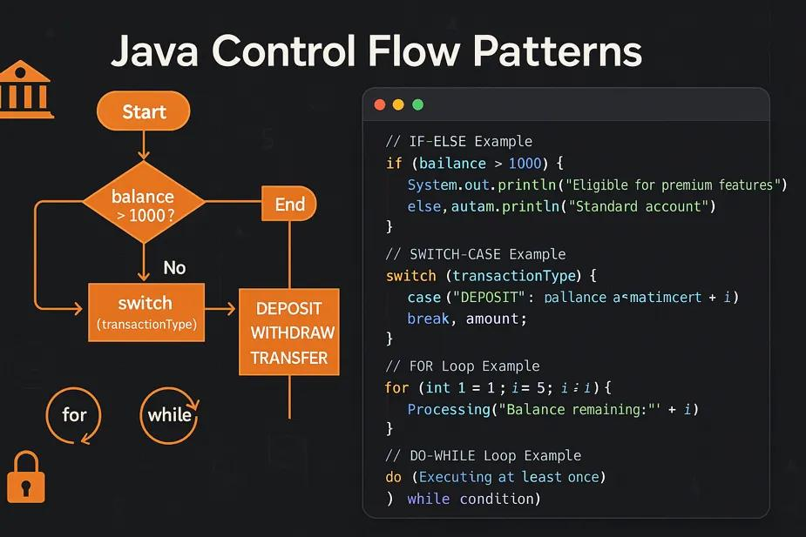
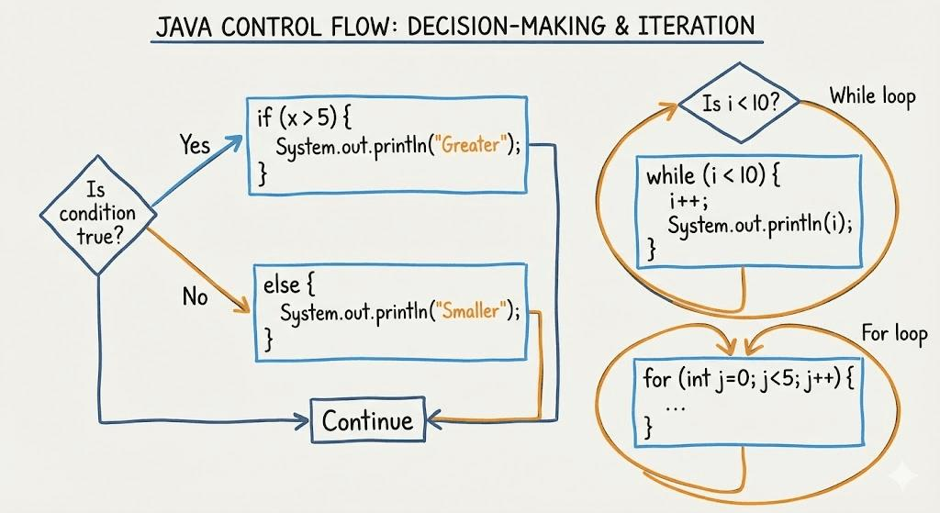
5

7.2 Types of Control Flow Statements
Java control flow statements can be broadly divided into three categories:
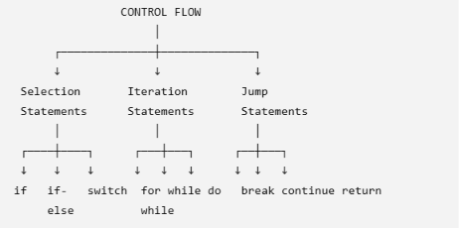

A. SELECTION / DECISION-MAKING STATEMENTS
Selection statements allow a program to choose which block of code should execute based on a condition.
Java provides:
- if
- if-else
- else-if ladder
- Nested if
- switch

7.3 if Statement
Definition
The if statement executes a block of code only when the specified condition is true.
Syntax
if (condition) {
// statements
}
Flow Diagram
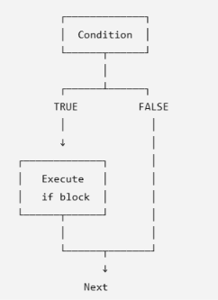
Example
int age = 20;

if (age >= 18) {
System.out.println("Eligible");
}
Output
Eligible
Usage
Use if when a block should execute only if a condition is true.

7.4 if-else Statement
Definition
The if-else statement provides two alternatives:
- one block executes when the condition is true;
- another block executes when the condition is false.
Syntax
if (condition) {
// statements when true
}
else {
// statements when false
}
Flowchart
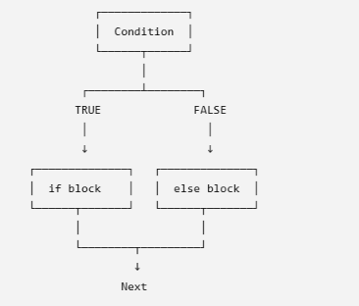
Example
int marks = 72;

if (marks >= 40) {
System.out.println("Pass");
}
else {
System.out.println("Fail");
}
Output
Pass
Usage
Use if-else when there are two possible outcomes.

7.5 else-if Ladder
Definition
An else-if ladder is used when there are multiple conditions that need to be checked one after another.
Syntax
if (condition1) {
// statements
}
else if (condition2) {
// statements
}
else if (condition3) {
// statements
}
else {
// default statements
}
The conditions are checked from top to bottom. When one condition is true, its block executes and the remaining conditions are skipped.
Flowchart
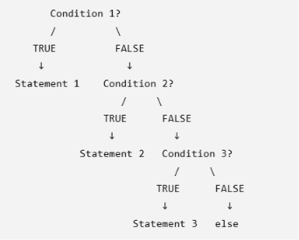
Example
int marks = 85;

if (marks >= 90) {
System.out.println("Grade A+");
}
else if (marks >= 80) {
System.out.println("Grade A");
}
else if (marks >= 70) {
System.out.println("Grade B");
}
else if (marks >= 40) {
System.out.println("Grade C");
}
else {
System.out.println("Fail");
}
Output
Grade A
Usage
Use an else-if ladder when several different conditions must be tested.

7.6 Nested if Statement
Definition
An if statement placed inside another if statement is called a nested if.
Syntax
if (condition1) {

if (condition2) {
// statements
}
}

Example
int age = 20;
boolean citizen = true;

if (age >= 18) {

if (citizen) {
System.out.println("Eligible");
}
}
Output
Eligible
Flowchart
Condition 1?
│
TRUE
↓
Condition 2?
/ \
TRUE FALSE
↓
Execute
│
↓
Next
Usage
Nested if is useful when a second condition depends on the first condition being true.

7.7 if vs if-else vs else-if Ladder vs Nested if
Feature | if | if-else | else-if ladder | Nested if
Conditions | One | One | Multiple | Multiple dependent conditions
Alternatives | One possible action | Two | Multiple | Dependent decisions
else required? | No | Yes | Optional | No
Best suited for | Single decision | Two choices | Multiple conditions | Condition inside condition
Example | age >= 18 | Pass/Fail | Grades | Age + citizenship

B. SWITCH STATEMENT
7.8 What is switch?
The switch statement is a selection statement used to choose one block of code from multiple alternatives based on the value of an expression.
It is particularly useful when one expression is compared against a number of discrete possible values.
Basic Syntax
switch (expression) {

case value1:
// statements
break;

case value2:
// statements
break;

case value3:
// statements
break;

default:
// statements
}

7.9 Parts of a switch Statement
Part | Meaning
switch | Keyword that starts the switch statement
expression | Value being evaluated
case | Specifies a possible matching value
break | Terminates the switch statement
default | Executes when no case matches

7.10 How switch Works
Suppose:
int day = 2;
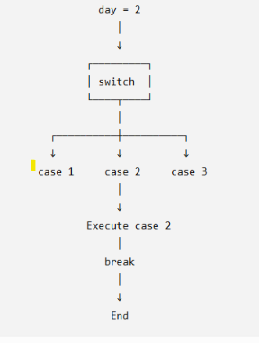
7.11 Example of switch
int day = 2;

switch (day) {

case 1:
System.out.println("Monday");
break;

case 2:
System.out.println("Tuesday");
break;

case 3:
System.out.println("Wednesday");
break;

default:
System.out.println("Invalid day");
}
Output
Tuesday

7.12 Why is break Used in switch?
The break statement terminates the switch statement.
For example:
case 2:
System.out.println("Tuesday");
break;
When case 2 matches:
- Tuesday is printed.
- break is executed.
- Control exits the switch.
Without break
Consider:
int day = 2;

switch (day) {

case 1:
System.out.println("Monday");

case 2:
System.out.println("Tuesday");

case 3:
System.out.println("Wednesday");

default:
System.out.println("Invalid");
}

With no break statements, execution can fall through from the matching case to subsequent cases.
This may produce:
Tuesday
Wednesday
Invalid
Therefore, when using the traditional switch form, break is commonly used when you want only the matching case to execute.

7.13 default in Switch
The default block executes when none of the case values matches the switch expression.
Example
int day = 8;

switch (day) {

case 1:
System.out.println("Monday");
break;

case 2:
System.out.println("Tuesday");
break;

default:
System.out.println("Invalid day");
}
Output
Invalid day
Important
default is optional.

7.14 Multiple Cases with the Same Action
Multiple case labels can lead to the same statements.
Example
int day = 6;

switch (day) {

case 1:
case 2:
case 3:
case 4:
case 5:
System.out.println("Working Day");
break;

case 6:
case 7:
System.out.println("Weekend");
break;

default:
System.out.println("Invalid");
}
Output
Weekend
This technique is useful when several values should produce the same result.

7.15 switch vs if-else
This is an important comparison for examinations.
if-else | switch
Can evaluate complex Boolean conditions | Traditionally selects based on matching case values
Can use <, >, <=, >=, &&, `
Suitable for ranges | Usually convenient for discrete choices
Conditions can be different | Cases are alternatives of one switch expression
Can test multiple unrelated expressions | Organized around one switch expression
Useful for complex decision-making | Useful for menu-like or fixed-choice selection
Example: marks >= 80 | Example: day == 1

Example where if-else is better
if (marks >= 90) {
System.out.println("A+");
}
else if (marks >= 80) {
System.out.println("A");
}

Here we are testing ranges, so if-else is appropriate.
Example where switch is convenient
switch (day) {

case 1:
System.out.println("Monday");
break;

case 2:
System.out.println("Tuesday");
break;
}
Here we are selecting among specific values.

7.16 Important Note About Modern Java switch
Modern Java versions have introduced enhanced switch features, including switch expressions and arrow labels.
For example:
int day = 2;
String name = switch (day) {
case 1 -> "Monday";
case 2 -> "Tuesday";
default -> "Invalid";
};
However, for Class XII CBSE beginner-level programming, the traditional form using:
case:
break;
default:
is generally the easiest form to learn unless your prescribed textbook specifically teaches the newer syntax.

C. ITERATION / LOOPING STATEMENTS
7.17 What is Iteration?
Iteration means repeatedly executing a block of statements while a condition is satisfied.
The statements used for repetition are called looping or iteration statements.
Java provides:
- while
- do-while
- for
There is also an enhanced for loop (for-each loop) for arrays and collections.
Diagram
LOOPING
│
┌────────────┼────────────┐
↓ ↓ ↓
while do-while for
│ │ │
Entry Exit Entry
controlled controlled controlled

7.18 while Loop
Definition
A while loop repeatedly executes a block of statements as long as its condition remains true.
Syntax
while (condition) {
// statements
}
Flowchart
┌─────────────┐
│ Condition │
└──────┬──────┘
│
┌─────┴─────┐
TRUE FALSE
│ │
↓ ↓
┌─────────────┐ END
│ Loop Body │
└──────┬──────┘
│
└──────────────→ Condition
Example
int i = 1;

while (i <= 5) {
System.out.println(i);
i++;
}
Output
1
2
3
4
5
Important
The condition is checked before each iteration.
Therefore, a while loop is called an entry-controlled loop.

7.19 do-while Loop
Definition
A do-while loop executes its body at least once, because the condition is checked after the loop body.
Syntax
do {
// statements
} while (condition);
Important: The semicolon after while(condition) is required.
Flowchart
┌─────────────┐
│ Loop Body │
└──────┬──────┘
│
↓
┌─────────────┐
│ Condition │
└──────┬──────┘
│
┌──────┴──────┐
TRUE FALSE
│ │
└──────┐ ↓
│ END
↓
Loop Body
Example
int i = 1;

do {
System.out.println(i);
i++;
} while (i <= 5);
Output
1
2
3
4
5

7.20 Why is do-while Different?
Consider:
int i = 10;

do {
System.out.println(i);
} while (i < 5);
Output:
10
Although i < 5 is false, the body executes once.
Therefore:
A do-while loop always executes its body at least once.

7.21 for Loop
Definition
A for loop is used when the number of iterations is known or can be conveniently controlled using an initialization, condition and update expression.
Syntax
for (initialization; condition; update) {
// statements
}
Example
for (int i = 1; i <= 5; i++) {
System.out.println(i);
}
Output
1
2
3
4
5

7.22 How a for Loop Works
Initialization
│
↓
Condition?
/ \
TRUE FALSE
│ │
↓ ↓
Loop Body END
│
↓
Update
│
└──────────────→ Condition
Example
for (int i = 1; i <= 3; i++) {
System.out.println(i);
}
Execution:
i = 1
↓
Check 1 <= 3 → true
↓
Print 1
↓
i++
↓
Check 2 <= 3 → true
↓
Print 2
↓
i++
↓
Check 3 <= 3 → true
↓
Print 3
↓
i++
↓
Check 4 <= 3 → false
↓
END

7.23 Enhanced for / For-Each Loop
The enhanced for loop is commonly used to traverse arrays and other iterable collections.
Syntax
for (dataType variable : arrayOrCollection) {
// statements
}
Example
int[] marks = {80, 85, 90, 95};

for (int mark : marks) {
System.out.println(mark);
}
Output
80
85
90
95
Usage
It is useful when you want to process each element without manually managing an index.

7.24 while vs do-while vs for
Feature | while | do-while | for
Type | Entry-controlled | Exit-controlled | Entry-controlled
Condition checked | Before body | After body | Before body
Minimum executions | 0 | 1 | 0
Initialization/update | Usually separate | Usually separate | Can be included in header
Best used when | Number of iterations is not known beforehand | Body must execute at least once | Counter-controlled repetition
Syntax | while(condition) | do {...} while(condition); | for(init; condition; update)

7.25 Nested Loops
A loop placed inside another loop is called a nested loop.
Example
for (int i = 1; i <= 3; i++) {

for (int j = 1; j <= 3; j++) {
System.out.print("* ");
}

System.out.println();
}
Output
* * *
* * *
* * *
Diagram
Outer Loop
│
┌────────┴────────┐
│ │
Iteration 1 Iteration 2 ...
│
↓
Inner Loop
┌───┼───┐
↓ ↓ ↓
j=1 j=2 j=3
Usage
Nested loops are commonly used for:
- Tables
- Patterns
- Matrix operations
- Two-dimensional arrays

D. JUMP / BRANCHING STATEMENTS
Java provides statements that alter the normal flow of execution.
Important jump statements are:
- break
- continue
- return

7.26 break Statement
Definition
The break statement terminates the nearest enclosing loop or switch statement and transfers control to the statement immediately following it.
Syntax
break;
Example with loop
for (int i = 1; i <= 10; i++) {

if (i == 5) {
break;
}

System.out.println(i);
}
Output
1
2
3
4
When i becomes 5, break terminates the loop.
Flow
Loop
│
↓
Condition?
│
↓
break?
│
├── YES → EXIT LOOP
│
└── NO → Continue

7.27 continue Statement
Definition
The continue statement skips the remaining statements of the current iteration and proceeds to the next iteration of the loop.
Syntax
continue;
Example
for (int i = 1; i <= 5; i++) {

if (i == 3) {
continue;
}

System.out.println(i);
}
Output
1
2
4
5
When i == 3, the continue statement skips printing 3.

7.28 return Statement
Definition
The return statement terminates the execution of the current method and, when appropriate, sends a value back to the calling code.
Syntax
For a method returning a value:
return value;
For a void method:
return;
Example
static int add(int a, int b) {

return a + b;
}
The method returns the sum.
Example with void
static void display() {

System.out.println("Hello");
return;
}

7.29 break vs continue vs return
Feature | break | continue | return
Purpose | Terminates loop/switch | Skips current iteration | Exits current method
Loop continues? | No | Yes | Method ends
Used in | Loops and switch | Loops | Methods
Can return a value? | No | No | Yes, when method requires a return value
Example | break; | continue; | return sum;
Easy memory trick
break = Stop the loop
continue = Skip this turn
return = Leave the method

7.30 Complete Control Flow Classification
CONTROL FLOW
│
┌─────────────────────┼─────────────────────┐
│ │ │
↓ ↓ ↓
SELECTION ITERATION JUMP
│ │ │
┌──────┼──────┐ ┌─────┼─────┐ ┌────┼────┐
↓ ↓ ↓ ↓ ↓ ↓ ↓ ↓ ↓
if if-else switch while do-while for break continue return
│
├── else-if
│
└── nested if

7.31 Selection vs Iteration vs Jump
Type | Purpose | Statements
Selection | Make decisions | if, if-else, else-if, switch
Iteration | Repeat statements | while, do-while, for, enhanced for
Jump | Alter normal flow | break, continue, return

7.32 if-else vs switch – Detailed Difference
Basis | if-else | switch
Main purpose | General decision making | Multiple-choice selection
Conditions | Can be complex | Traditional form compares a switch expression with case labels
Range checking | Excellent | Not the natural choice for ranges
Operators | Can use relational/logical operators | Traditional cases use matching values
Number of alternatives | Any number | Any number of cases
Readability | Can become lengthy with many alternatives | Often clearer for fixed choices
break | Not required | Commonly used in traditional switch
default | else can serve as default alternative | default handles no matching case
Example | Marks-based grading | Menu/day selection

7.33 for vs while
for | while
Initialization, condition and update can be written together | Usually written separately
Convenient for counter-controlled loops | Convenient when condition controls an uncertain number of iterations
Syntax is compact | Syntax is simple
Example: print 1–100 | Example: repeat until valid input

7.34 while vs do-while
while
while (condition) {
// body
}
Condition is checked first.
Therefore:
Possible executions = 0 or more
do-while
do {
// body
} while (condition);
Condition is checked after the body.
Therefore:
Possible executions = 1 or more
Key difference
while may execute zero times, but do-while executes at least once.

7.35 Practical Example – Student Result
The following program demonstrates selection using if-else-if.
import java.util.Scanner;

public class StudentResult {

public static void main(String[] args) {

Scanner sc = new Scanner(System.in);

System.out.print("Enter marks: ");
int marks = sc.nextInt();

if (marks >= 90) {
System.out.println("Grade A+");
}
else if (marks >= 80) {
System.out.println("Grade A");
}
else if (marks >= 70) {
System.out.println("Grade B");
}
else if (marks >= 40) {
System.out.println("Grade C");
}
else {
System.out.println("Fail");
}
}
}

7.36 Practical Example – Menu Using switch
import java.util.Scanner;

public class MenuDemo {

public static void main(String[] args) {

Scanner sc = new Scanner(System.in);

System.out.println("1. Add");
System.out.println("2. Subtract");
System.out.println("3. Multiply");
System.out.println("4. Divide");

System.out.print("Enter your choice: ");
int choice = sc.nextInt();

switch (choice) {

case 1:
System.out.println("Addition selected");
break;

case 2:
System.out.println("Subtraction selected");
break;

case 3:
System.out.println("Multiplication selected");
break;

case 4:
System.out.println("Division selected");
break;

default:
System.out.println("Invalid choice");
}
}
}
Why is switch suitable here?
Because the user selects from a set of fixed choices:
1 → Add
2 → Subtract
3 → Multiply
4 → Divide

7.37 Practical Example – Loop
Print numbers from 1 to 10
for (int i = 1; i <= 10; i++) {
System.out.println(i);
}
Find even numbers
for (int i = 1; i <= 10; i++) {

if (i % 2 == 0) {
System.out.println(i);
}
}
Output:
2
4
6
8
10

7.38 Important Points to Remember
if
Executes a block only when the condition is true.
if-else
Selects between two alternatives.
else-if
Checks multiple conditions sequentially.
Nested if
An if statement inside another if statement.
switch
Selects among multiple alternatives based on the value of an expression.
while
Repeats while the condition is true; condition is checked before the body.
do-while
Executes the body first and checks the condition afterward.
for
Convenient for counter-controlled repetition.
break
Terminates the nearest loop or switch.
continue
Skips the current loop iteration.
return
Terminates the current method and may return a value.

📝 Class XII Exam-Oriented Questions
Very Short Answer Questions
- What is a control flow statement?
- Name the three major categories of control flow statements.
- What is an if statement?
- What is the purpose of else?
- What is an else-if ladder?
- What is a nested if?
- What is a switch statement?
- What is the purpose of break in a switch?
- What is the purpose of default?
- Name three looping statements in Java.
- Which loop executes at least once?
- Which loop is entry-controlled?
- What is a nested loop?
- What does continue do?
- What does return do?

Short Answer Questions
- Explain the different types of selection statements in Java.
- Differentiate between if and if-else.
- Explain the else-if ladder with an example.
- What is nested if? Give an example.
- Explain the syntax and working of switch.
- What happens if break is omitted from a traditional switch case?
- Differentiate between if-else and switch.
- Explain while, do-while and for loops.
- Differentiate between while and do-while.
- Explain the difference between break and continue.
- Explain the purpose of the return statement.
- What is an enhanced for loop?

Programming Questions
Q1. Write a Java program to check whether a number is positive, negative or zero.
Q2. Write a Java program to find the largest of three numbers.
Q3. Write a Java program to display a grade using an else-if ladder.
Q4. Write a Java program using switch to display the day of the week.
Q5. Write a Java program using a for loop to print numbers from 1 to 100.
Q6. Write a Java program to print all even numbers between 1 and 50.
Q7. Write a Java program using nested loops to display:
*
* *
* * *
* * * *
Q8. Write a Java program demonstrating break.
Q9. Write a Java program demonstrating continue.

⭐ Final Revision Chart
CONTROL FLOW STATEMENTS
│
┌──────────────────────┼──────────────────────┐
│ │ │
▼ ▼ ▼
SELECTION ITERATION JUMP
│ │ │
│ │ │
┌─────┼──────┐ ┌──────┼──────┐ ┌────┼─────┐
│ │ │ │ │ │ │ │ │
if if-else switch while do-while for break continue return
│
├── else-if
│
└── nested if
One-line memory trick:
Selection = Decide | Iteration = Repeat | Jump = Change the normal flow
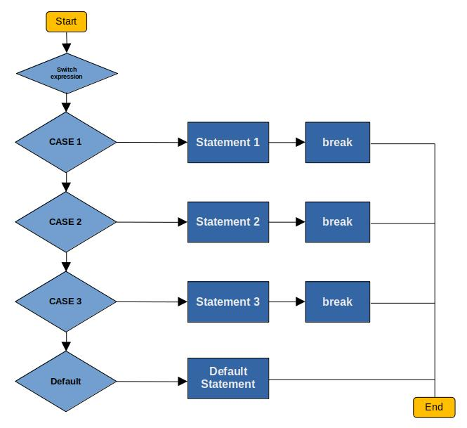
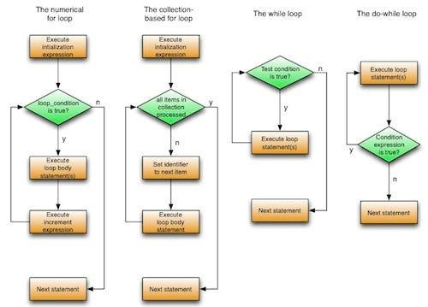
Content 8: Iteration / Looping Statements
Iteration or looping is one of the most important concepts in Java programming. It allows a program to execute a block of statements repeatedly as long as a specified condition is satisfied.
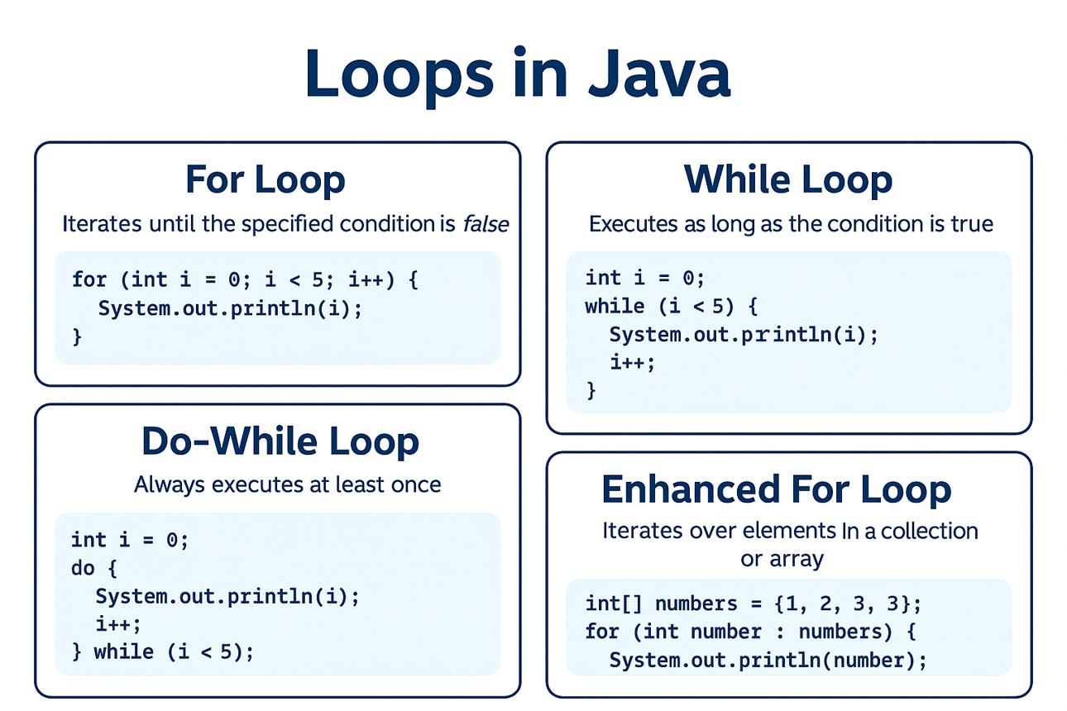
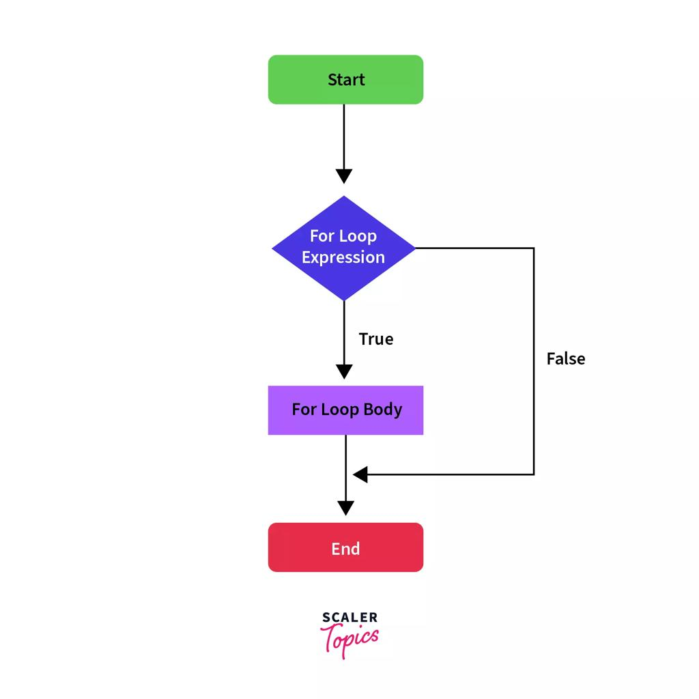
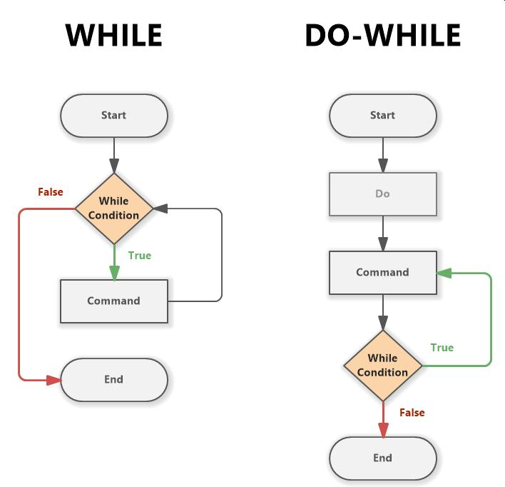
6

8.1 What is Iteration / Looping?
Iteration means repeating a set of statements again and again until a particular condition becomes false.
A loop is a control structure that allows a block of statements to be executed repeatedly.
Simple Example
Suppose we want to print numbers from 1 to 5.
Without a loop:
System.out.println(1);
System.out.println(2);
System.out.println(3);
System.out.println(4);
System.out.println(5);
Using a loop:
for (int i = 1; i <= 5; i++) {
System.out.println(i);
}
The second approach is shorter, easier to understand and useful when a large number of repetitions are required.

8.2 Types of Looping Statements in Java
Java provides four commonly used looping statements:
- for loop
- while loop
- do-while loop
- for-each loop / Enhanced for loop
Classification
LOOPING STATEMENTS
|
+-----------------+------------------+
| | |
for loop while loop do-while loop
|
for-each loop
Another way to understand them:
Java Loops
|
+----------+----------+
| |
Entry-Controlled Exit-Controlled
| |
+----+----+ |
| | do-while
for while
|
for-each
Important Point
- for, while and for-each → condition is generally checked before executing the next iteration.
- do-while → body executes first, then condition is checked.
- Therefore, a do-while loop executes at least once.

8.3 Parts of a Loop
Most loops contain three important parts:
Initialization
↓
Condition Check
↓
Loop Body
↓
Update
↓
Condition Check
↓
Repeated
For example:
for (int i = 1; i <= 5; i++) {
System.out.println(i);
}
Here:
Part | Code | Purpose
Initialization | int i = 1 | Sets the starting value
Condition | i <= 5 | Determines whether the loop continues
Body | System.out.println(i); | Performs the required task
Update | i++ | Changes the loop variable

8.4 for Loop
Definition
The for loop is used when the number of iterations is known or can be determined in advance.
It is commonly used for:
- Printing numbers
- Repeating calculations
- Processing arrays
- Generating tables
- Counting from one value to another

Syntax of for Loop
for (initialization; condition; update) {
// statements
}
Example
for (int i = 1; i <= 5; i++) {
System.out.println(i);
}
Output
1
2
3
4
5

How a for Loop Works
Start
↓
Initialization
↓
Check condition
/ \
True False
↓ ↓
Execute End
body
↓
Update
↓
Condition
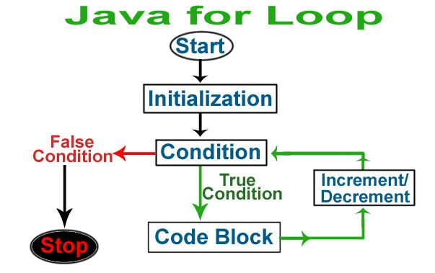
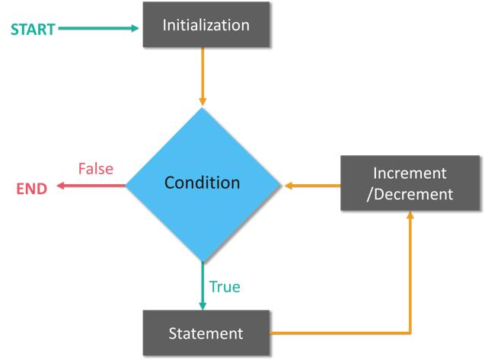
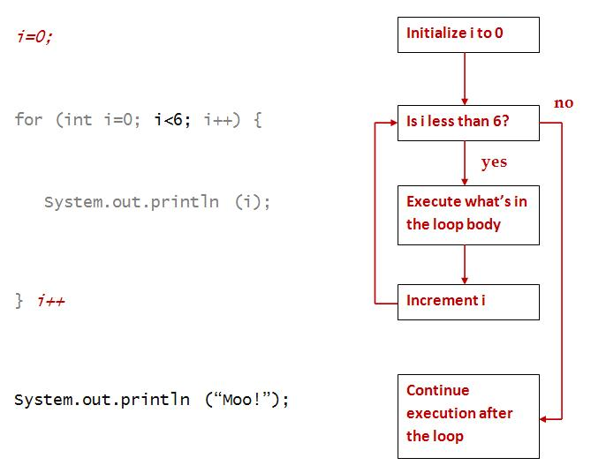
5

Example: Print 1 to 10
class PrintNumbers {
public static void main(String[] args) {

for (int i = 1; i <= 10; i++) {
System.out.println(i);
}

}
}
Output
1
2
3
4
5
6
7
8
9
10

8.5 Forward Order Loop
A forward order loop executes from a smaller value towards a larger value.
Example
Print numbers from 1 to 10:
for (int i = 1; i <= 10; i++) {
System.out.println(i);
}
Output
1
2
3
4
5
6
7
8
9
10
Explanation
- Starting value = 1
- Ending value = 10
- Increment = 1
- i++ increases the value by 1 each time.

Forward Loop with Different Increment
for (int i = 2; i <= 20; i += 2) {
System.out.println(i);
}
Output
2
4
6
8
10
12
14
16
18
20
Here, i += 2 increases the value by 2 during every iteration.

8.6 Reverse Order Loop
A reverse order loop executes from a larger value towards a smaller value.
Example
Print numbers from 10 to 1:
for (int i = 10; i >= 1; i--) {
System.out.println(i);
}
Output
10
9
8
7
6
5
4
3
2
1
Explanation
- Starting value = 10
- Ending condition = i >= 1
- Decrement = i--
- The value decreases by 1 after each iteration.

Forward vs Reverse Loop
Forward Order | Reverse Order
Starts with a smaller value | Starts with a larger value
Moves towards a larger value | Moves towards a smaller value
Usually uses ++ | Usually uses --
Example: 1 → 10 | Example: 10 → 1
Condition may be i <= 10 | Condition may be i >= 1

8.7 while Loop
Definition
The while loop repeatedly executes a block of statements as long as the specified condition is true.
It is useful when the exact number of iterations is not known in advance.

Syntax
while (condition) {
// statements
}
Example
int i = 1;

while (i <= 5) {
System.out.println(i);
i++;
}
Output
1
2
3
4
5

Working of while Loop
Start
↓
Initialization
↓
Check condition
/ \
True False
↓ ↓
Loop Body End
↓
Update
↓
Check again
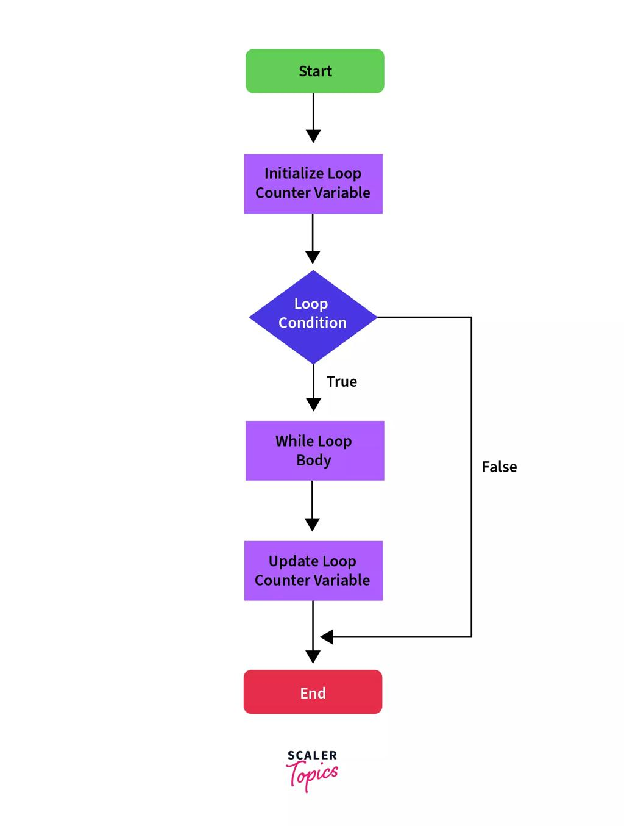
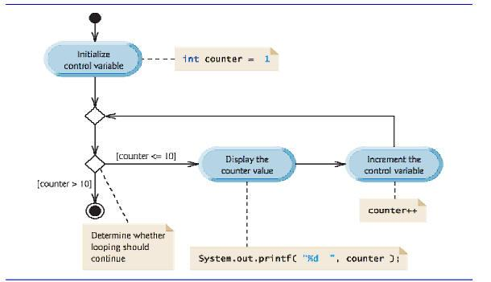
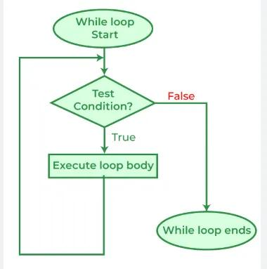
6
Important Point
The while loop is an entry-controlled loop because the condition is checked before the loop body executes.
Therefore, if the condition is false initially, the loop may execute zero times.
Example
int i = 10;

while (i < 5) {
System.out.println(i);
}
Here, nothing is printed because 10 < 5 is false.

8.8 Forward Order Using while
int i = 1;

while (i <= 5) {
System.out.println(i);
i++;
}
Output
1
2
3
4
5

8.9 Reverse Order Using while
int i = 5;

while (i >= 1) {
System.out.println(i);
i--;
}
Output
5
4
3
2
1

8.10 do-while Loop
Definition
The do-while loop executes the loop body first and checks the condition afterwards.
Therefore, the body of a do-while loop executes at least once, even if the condition is false.

Syntax
do {
// statements
} while (condition);
Important
There is a semicolon (;) after the while condition.
} while (condition);

Example
int i = 1;

do {
System.out.println(i);
i++;
} while (i <= 5);
Output
1
2
3
4
5

Working of do-while
Start
↓
Initialization
↓
Loop Body
↓
Update
↓
Check condition
/ \
True False
↓ ↓
Repeat End
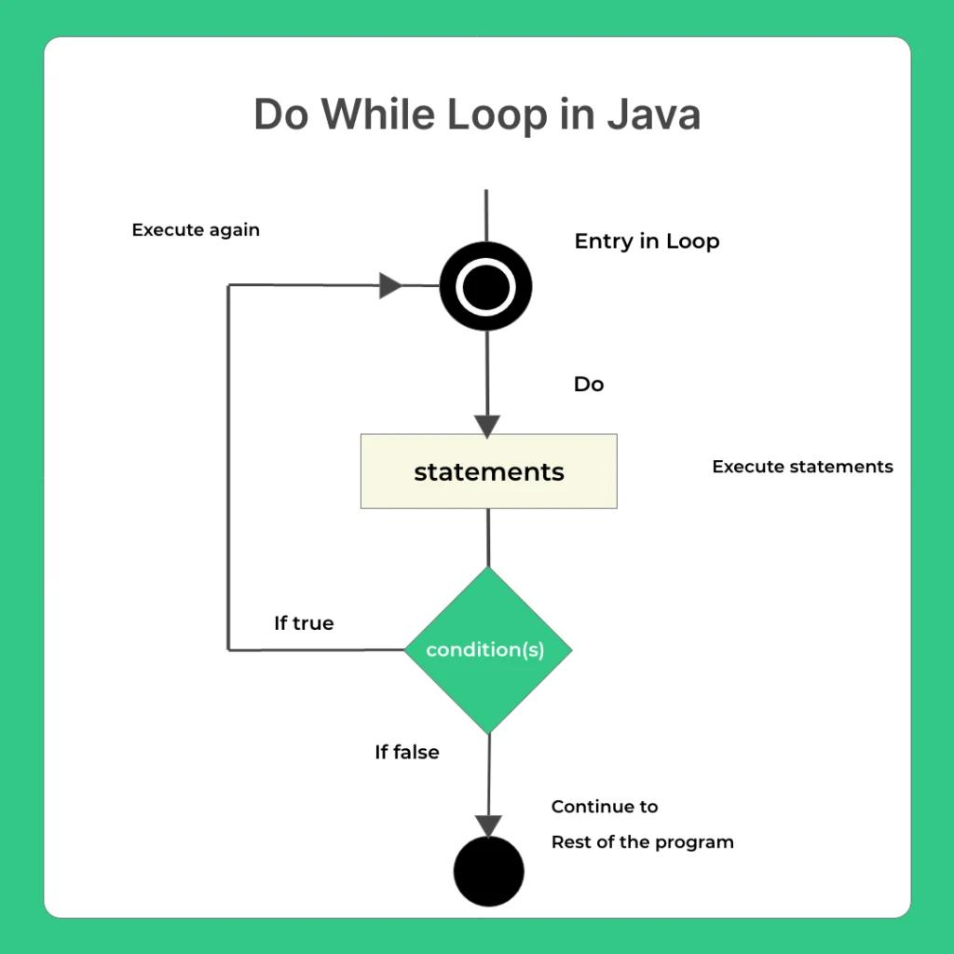
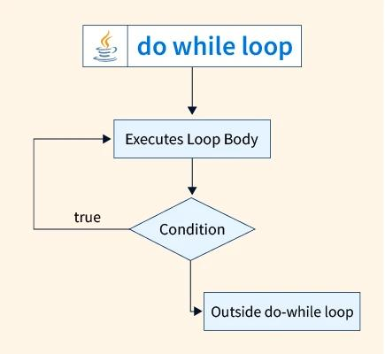
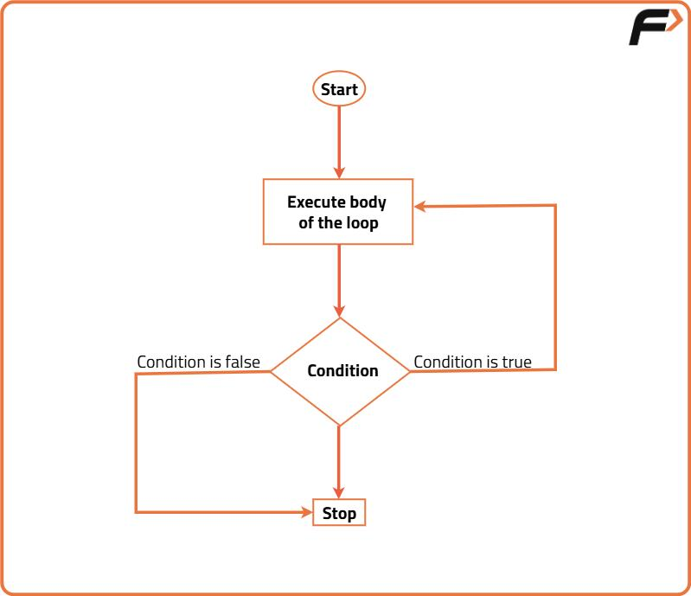
4

8.11 Important Feature of do-while
Consider:
int i = 10;

do {
System.out.println(i);
} while (i < 5);
Output
10
Although i < 5 is false, the statement executes once.
Why?
Because the condition is checked after executing the body.

8.12 Forward Order Using do-while
int i = 1;

do {
System.out.println(i);
i++;
} while (i <= 5);
Output
1
2
3
4
5

8.13 Reverse Order Using do-while
int i = 5;

do {
System.out.println(i);
i--;
} while (i >= 1);
Output
5
4
3
2
1

8.14 for-each Loop
The for-each loop, also called the enhanced for loop, is used to traverse elements of an array or other iterable collection one by one.
It is especially useful when we want to access every element without manually managing an index.

Syntax
for (dataType variable : array) {
// statements
}
Example
int[] numbers = {10, 20, 30, 40, 50};

for (int n : numbers) {
System.out.println(n);
}
Output
10
20
30
40
50

How for-each Works
Array
↓
[10] [20] [30] [40] [50]
↓ ↓ ↓ ↓ ↓
10 20 30 40 50
↓
Execute statement for each element
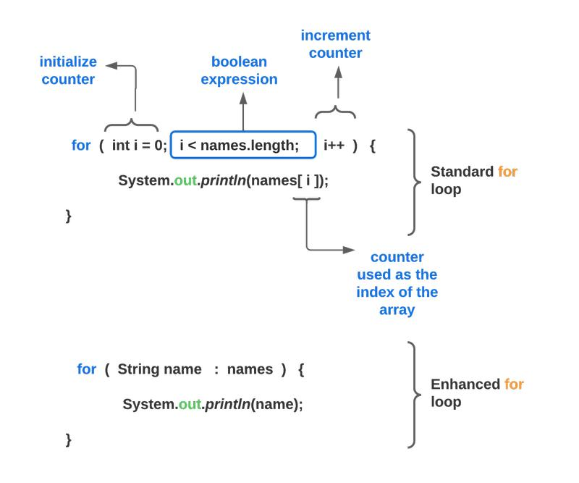
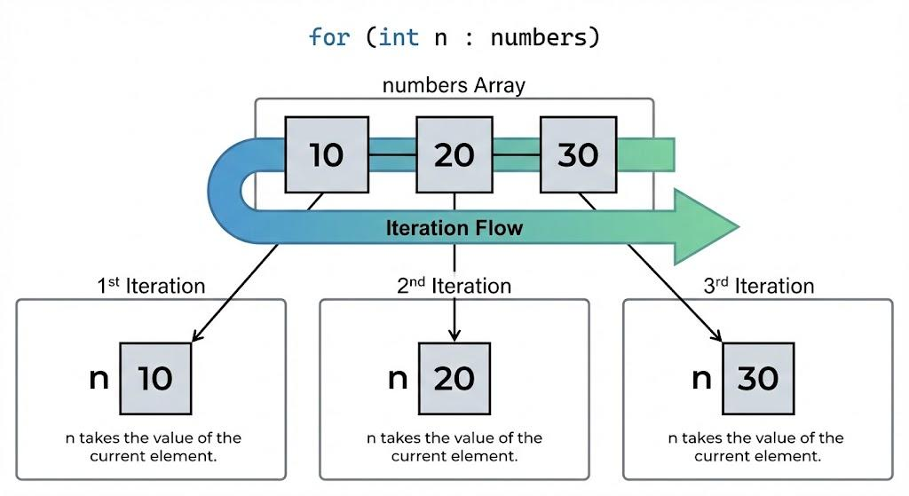
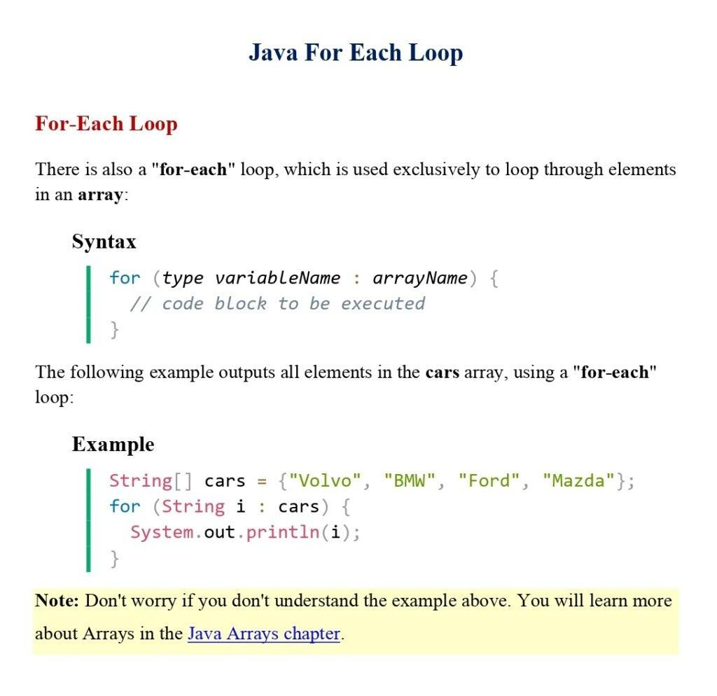
4

8.15 Example of for-each with String Array
String[] names = {"Rahul", "Priya", "Amit", "Neha"};

for (String name : names) {
System.out.println(name);
}
Output
Rahul
Priya
Amit
Neha

8.16 Forward and Reverse Order with Arrays
A normal for loop can easily traverse an array in either direction.
Forward Order
int[] numbers = {10, 20, 30, 40, 50};

for (int i = 0; i < numbers.length; i++) {
System.out.println(numbers[i]);
}
Output
10
20
30
40
50
Reverse Order
int[] numbers = {10, 20, 30, 40, 50};

for (int i = numbers.length - 1; i >= 0; i--) {
System.out.println(numbers[i]);
}
Output
50
40
30
20
10
Important Point
The for-each loop normally processes elements in their natural traversal order. It does not provide an index that can simply be decremented for reverse traversal.
For reverse-order traversal of an array, a traditional for loop is generally used.

8.17 Comparison: for vs while vs do-while vs for-each
Feature | for | while | do-while | for-each
Type | Entry-controlled | Entry-controlled | Exit-controlled | Enhanced loop
Condition | Before iteration | Before iteration | After iteration | Managed automatically
Minimum executions | 0 | 0 | 1 | Depends on elements
Best used when | Number of repetitions is known | Number of repetitions may be unknown | Body must execute at least once | Processing every element
Initialization | Usually in loop | Usually before loop | Usually before loop | Automatic
Update | Usually in loop | Usually inside body | Usually inside body | Automatic
Index available | Yes | Yes | Yes | Not directly
Reverse traversal | Easy | Easy | Easy | Not directly convenient
Array traversal | Yes | Yes | Yes | Excellent
Syntax length | Compact | Simple | Simple | Very simple

8.18 for vs while
for Loop | while Loop
Generally preferred when the number of iterations is known | Useful when the number of iterations is not known beforehand
Initialization, condition and update are written together | Initialization and update are generally written separately
More compact | More flexible for condition-based repetition
Example: printing 1–100 | Example: reading until a condition changes
for
for (int i = 1; i <= 10; i++) {
System.out.println(i);
}
while
int i = 1;

while (i <= 10) {
System.out.println(i);
i++;
}
Both produce the same output.

8.19 while vs do-while
while | do-while
Entry-controlled | Exit-controlled
Condition checked first | Condition checked after body
May execute zero times | Executes at least once
No semicolon after condition | Semicolon after condition
while (condition) | do { } while (condition);
Example
int x = 10;

while (x < 5) {
System.out.println("Hello");
}
Output: Nothing.
But:
int x = 10;

do {
System.out.println("Hello");
} while (x < 5);
Output:
Hello

8.20 for vs for-each
for Loop | for-each Loop
Uses an index/counter when needed | Automatically visits each element
Can move forward or backward | Normally follows traversal order
Can skip selected indexes | Designed mainly for each element
Can modify/access elements using indexes | Does not directly provide index
More flexible | Simpler for sequential traversal
Traditional for
int[] marks = {80, 75, 90, 85};

for (int i = 0; i < marks.length; i++) {
System.out.println(marks[i]);
}
for-each
int[] marks = {80, 75, 90, 85};

for (int mark : marks) {
System.out.println(mark);
}

8.21 Nested Loops
A nested loop is a loop placed inside another loop.
Outer Loop
|
+---- Inner Loop
| |
| +-- Statement
|
+---- Repeats
Example
for (int i = 1; i <= 3; i++) {

for (int j = 1; j <= 3; j++) {
System.out.print("* ");
}

System.out.println();
}
Output
* * *
* * *
* * *
The inner loop completes all its iterations for every one iteration of the outer loop.

8.22 Example: Multiplication Table
int n = 5;

for (int i = 1; i <= 10; i++) {
System.out.println(n + " x " + i + " = " + (n * i));
}
Output
5 x 1 = 5
5 x 2 = 10
5 x 3 = 15
5 x 4 = 20
5 x 5 = 25
5 x 6 = 30
5 x 7 = 35
5 x 8 = 40
5 x 9 = 45
5 x 10 = 50

8.23 Example: Sum of Numbers Using for
int sum = 0;

for (int i = 1; i <= 10; i++) {
sum = sum + i;
}

System.out.println("Sum = " + sum);
Output
Sum = 55

8.24 Example: Sum Using while
int i = 1;
int sum = 0;

while (i <= 10) {
sum = sum + i;
i++;
}

System.out.println("Sum = " + sum);
Output
Sum = 55

8.25 Example: Even Numbers
Print even numbers from 2 to 20:
for (int i = 2; i <= 20; i += 2) {
System.out.println(i);
}
Output
2
4
6
8
10
12
14
16
18
20

8.26 Example: Odd Numbers in Reverse Order
for (int i = 19; i >= 1; i -= 2) {
System.out.println(i);
}
Output
19
17
15
13
11
9
7
5
3
1

8.27 Infinite Loop
An infinite loop is a loop that continues indefinitely because its condition never becomes false.
Example
while (true) {
System.out.println("Hello");
}
This loop has no normal termination condition.
Another example:
for (;;) {
System.out.println("Hello");
}
Important
Care should be taken to ensure that a loop eventually reaches its terminating condition unless an infinite loop is intentionally required.

8.28 Common Errors in Loops
1. Forgetting to update the loop variable
Incorrect:
int i = 1;

while (i <= 5) {
System.out.println(i);
}
The value of i never changes, so the loop does not terminate normally.
Correct:
int i = 1;

while (i <= 5) {
System.out.println(i);
i++;
}

2. Incorrect condition
for (int i = 1; i >= 10; i++) {
System.out.println(i);
}
The condition is false initially, so the loop does not execute.
Correct forward loop:
for (int i = 1; i <= 10; i++) {
System.out.println(i);
}

3. Incorrect reverse loop
Incorrect:
for (int i = 10; i >= 1; i++) {
System.out.println(i);
}
Here i++ increases the value instead of decreasing it.
Correct:
for (int i = 10; i >= 1; i--) {
System.out.println(i);
}

8.29 Quick Revision Chart
JAVA LOOPS
|
+----------------+----------------+
| | |
for while do-while
| | |
Known/controlled Condition Executes body
repetitions first at least once
|
for-each
|
Traverse elements
Key Points
Loop | Main Feature
for | Best when repetition/count is known
while | Condition checked before execution
do-while | Executes at least once
for-each | Easily traverses array/iterable elements
Forward loop | Uses increasing values such as i++
Reverse loop | Uses decreasing values such as i--
Nested loop | One loop inside another
Infinite loop | Condition never becomes false

8.30 Important CBSE Examination Questions
Very Short Answer Questions
- What is iteration?
- What is a loop?
- Name the four commonly used looping statements in Java.
- Which loop executes at least once?
- Which loop is called an enhanced for loop?
- What is the purpose of i++?
- What is the purpose of i--?
- What is a nested loop?
Short Answer Questions
- Explain the for loop with syntax and example.
- Explain the while loop with syntax and example.
- Explain the do-while loop with syntax and example.
- What is a for-each loop? Give an example.
- Differentiate between while and do-while.
- Differentiate between for and while.
- Explain forward and reverse order loops with examples.
- What is a nested loop?
Programming Questions
Q1. Write a Java program to print numbers from 1 to 10.
Q2. Write a Java program to print numbers from 10 to 1.
Q3. Write a Java program to print even numbers from 1 to 20.
Q4. Write a Java program to calculate the sum of numbers from 1 to 100.
Q5. Write a Java program to display the multiplication table of a number.
Q6. Write a Java program to display all elements of an integer array using a for-each loop.

⭐ Exam-Oriented Summary
Iteration/Looping allows a set of statements to execute repeatedly.
- for loop → useful when the number of iterations is known.
- while loop → condition is checked before the body.
- do-while loop → body executes before condition checking; therefore it executes at least once.
- for-each loop → used to access elements of an array or other iterable one by one.
- Forward loop → generally uses ++.
- Reverse loop → generally uses --.
- Nested loop → loop inside another loop.
- Always ensure that the loop has a proper condition and update mechanism to avoid unintended infinite loops.
Content 9: Arrays
9.1 Introduction
In Java, a program often needs to store many values of the same data type.
For example, suppose we need to store the marks of 5 students. We could create five separate variables:
int mark1 = 78;
int mark2 = 85;
int mark3 = 92;
int mark4 = 67;
int mark5 = 88;
This becomes difficult when there are hundreds of values.
Instead, we can use an array:
int[] marks = {78, 85, 92, 67, 88};
An array allows multiple values of the same data type to be stored under a single variable name.
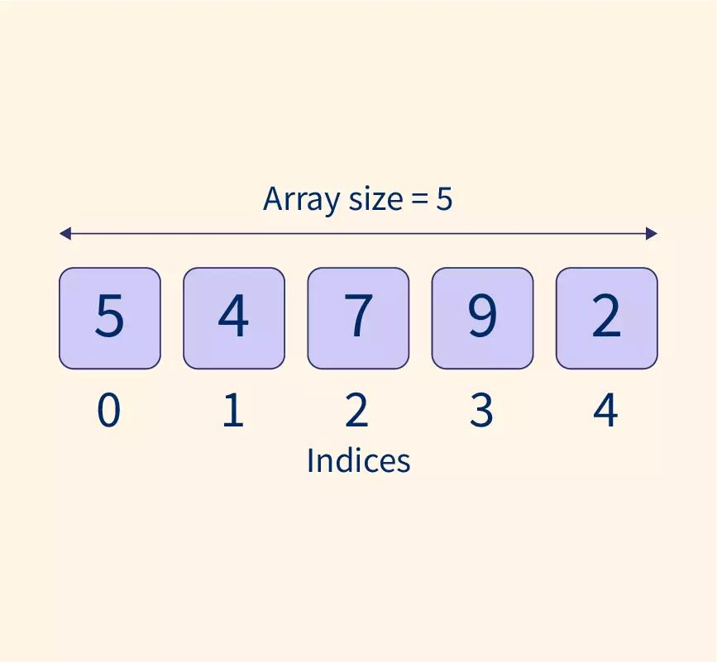
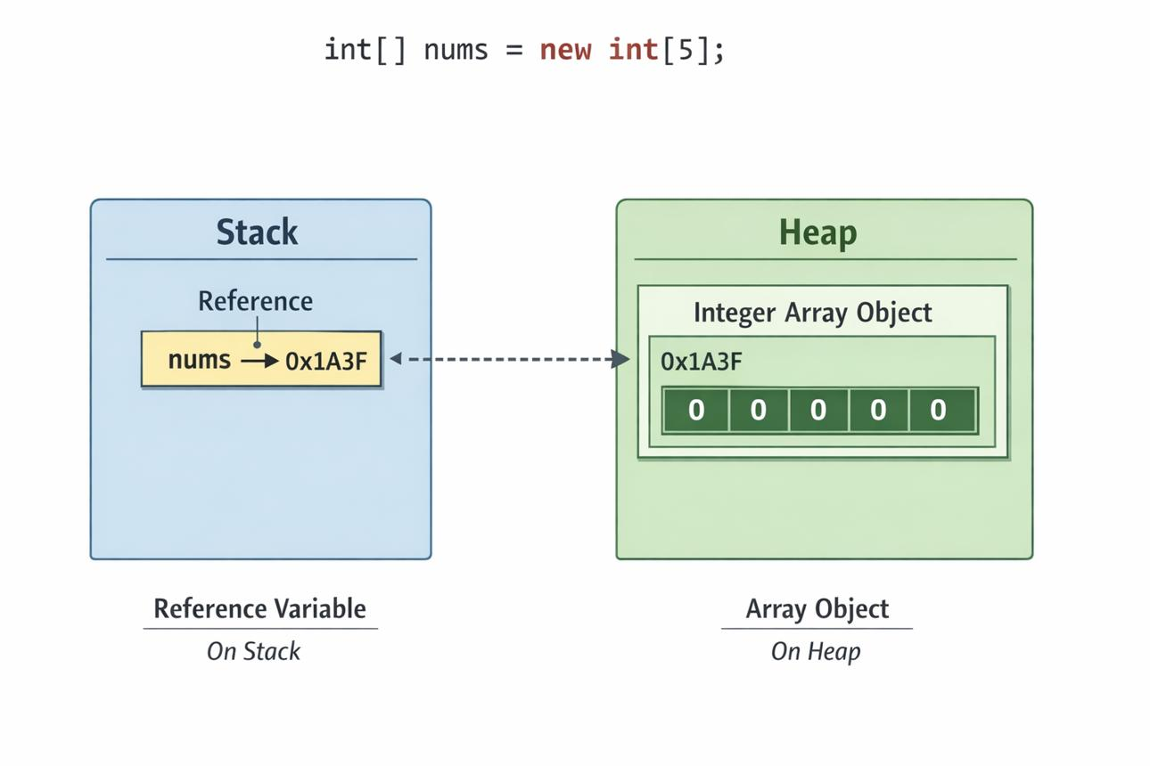
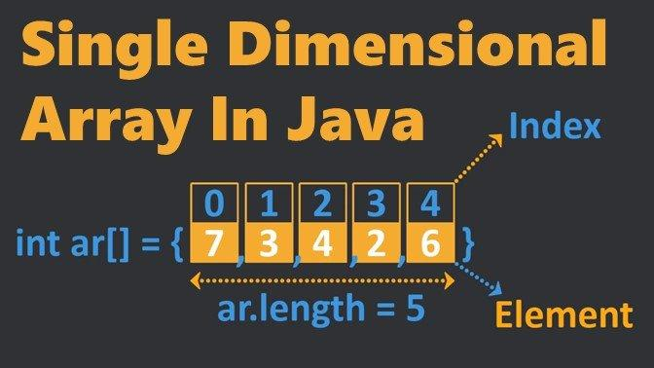
5

9.2 What is an Array?
An array is a collection of elements of the same data type, stored under a single variable name and accessed using an index.
Example
int[] marks = {78, 85, 92, 67, 88};
Here:
- int → data type
- marks → array variable
- {78, 85, 92, 67, 88} → array elements
- Each element has an index.
- Java array indexing starts from 0.
Array representation
Array: marks

Index: 0 1 2 3 4
+-----+-----+-----+-----+-----+
Value: | 78 | 85 | 92 | 67 | 88 |
+-----+-----+-----+-----+-----+
Therefore:
marks[0] = 78
marks[1] = 85
marks[2] = 92
marks[3] = 67
marks[4] = 88

9.3 Features of an Array
Important features of Java arrays are:
- An array stores multiple values.
- All elements normally have the same data type.
- Array indexing starts from 0.
- The last index is always length - 1.
- The size of an array is fixed after creation.
- Elements are accessed using their index.
- Java provides the length property to determine the number of elements.
- Arrays are objects in Java.
- Arrays can be traversed using loops.
- Java supports one-dimensional and multidimensional arrays.

9.4 Why Do We Use Arrays?
Arrays are useful when we need to store and process a large number of similar values.
Common uses
- Storing student marks
- Storing employee salaries
- Storing temperatures
- Storing prices
- Storing roll numbers
- Storing names
- Processing mathematical data
- Searching and sorting values
- Working with tables and matrices
Example
Instead of:
int mark1 = 80;
int mark2 = 75;
int mark3 = 90;
int mark4 = 85;
int mark5 = 88;
We can write:
int[] marks = {80, 75, 90, 85, 88};

9.5 Array Index
An index identifies the position of an element in an array.
Java uses zero-based indexing.
For an array containing 5 elements:
Position: 1 2 3 4 5
Index: 0 1 2 3 4
↓ ↓ ↓ ↓ ↓
Value: 10 20 30 40 50
Important Formula
For an array of n elements:
First index = 0
Last index = n - 1
For example:
int[] numbers = {10, 20, 30, 40, 50};
The array has 5 elements.
Therefore:
First index = 0
Last index = 5 - 1 = 4

9.6 Declaring an Array
Syntax
dataType[] arrayName;
Example
int[] marks;
Another valid syntax is:
int marks[];
However, the first form is generally preferred:
int[] marks;
Other examples
double[] prices;
char[] letters;
String[] names;
boolean[] answers;

9.7 Creating an Array
After declaring an array, memory can be allocated using the new keyword.
Syntax
arrayName = new dataType[size];
Example
int[] marks;
marks = new int[5];
This creates an integer array capable of storing 5 elements.
The indexes are:
0 1 2 3 4

9.8 Declaration and Creation Together
Declaration and creation can be combined into one statement.
int[] marks = new int[5];
This creates an array named marks that can contain 5 integers.
Diagram
int[] marks = new int[5];

marks
|
↓
+-----+-----+-----+-----+-----+
| | | | | |
+-----+-----+-----+-----+-----+
0 1 2 3 4
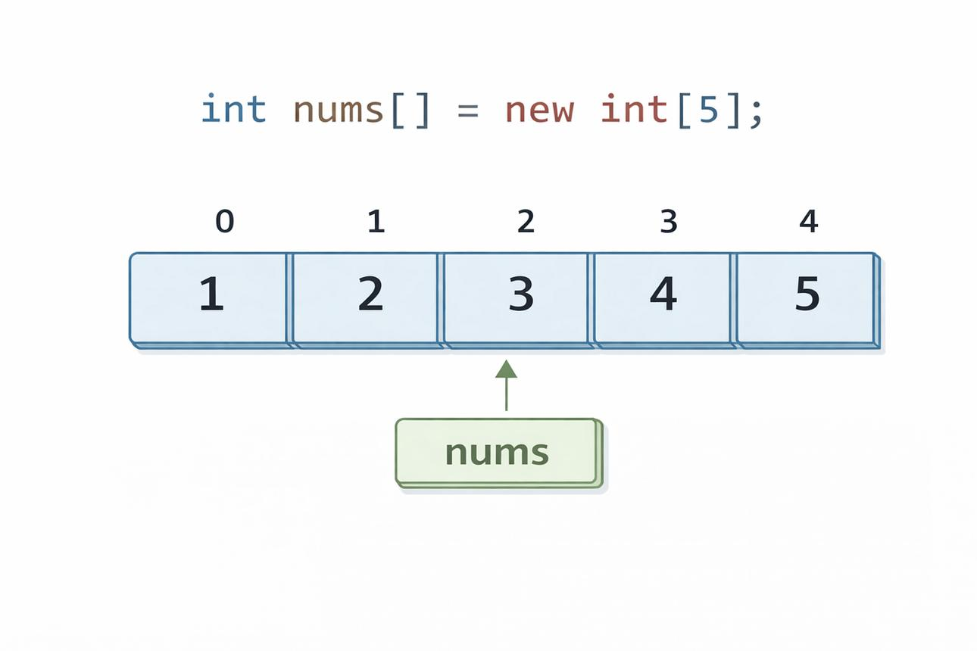
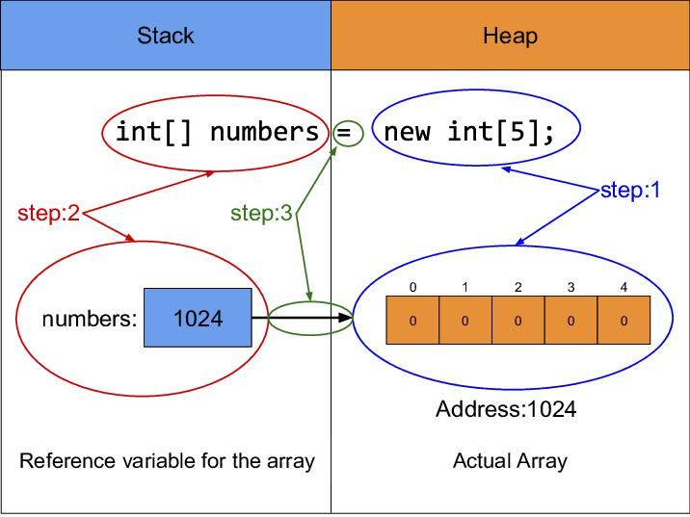
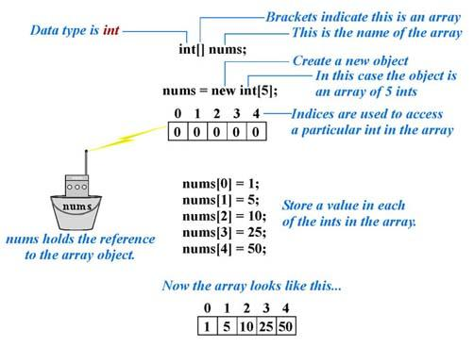
5

9.9 Initializing an Array
Array initialization means assigning values to the elements of an array.
Method 1: Initialization during declaration
int[] numbers = {10, 20, 30, 40, 50};
This is the simplest method.

Method 2: Assigning values individually
int[] numbers = new int[5];

numbers[0] = 10;
numbers[1] = 20;
numbers[2] = 30;
numbers[3] = 40;
numbers[4] = 50;
Representation
Index: 0 1 2 3 4
+-----+-----+-----+-----+-----+
Value: | 10 | 20 | 30 | 40 | 50 |
+-----+-----+-----+-----+-----+

9.10 Accessing Array Elements
An individual element is accessed using its index.
Syntax
arrayName[index]
Example
int[] marks = {78, 85, 92, 67, 88};

System.out.println(marks[0]);
System.out.println(marks[2]);
System.out.println(marks[4]);
Output
78
92
88

Accessing a Specific Element
int[] numbers = {10, 20, 30, 40, 50};

System.out.println(numbers[3]);
Output
40
Because:
Index: 0 1 2 3 4
Value: 10 20 30 40 50
↑
[3]

9.11 Modifying an Array Element
An existing element can be changed by assigning a new value to its index.
Example
int[] marks = {70, 80, 90};

marks[1] = 95;

System.out.println(marks[1]);
Output
95
The original value 80 at index 1 is replaced by 95.

9.12 Array length Property
Java provides the length property to determine the number of elements in an array.
Syntax
arrayName.length
Example
int[] numbers = {10, 20, 30, 40, 50};

System.out.println(numbers.length);
Output
5
Important
length is a property, not a method.
Therefore:
numbers.length
is correct.
Do not write:
numbers.length()
for an array.

9.13 length and Last Index
Suppose:
int[] numbers = {10, 20, 30, 40, 50};
Then:
numbers.length = 5
But the last index is:
numbers.length - 1
Therefore:
5 - 1 = 4
So:
numbers[4]
is the last element.
Important Relationship
Number of elements = array.length

Last valid index = array.length - 1

9.14 Traversing an Array
Array traversal means visiting or processing each element of an array one by one.
Loops are commonly used for array traversal.
Consider:
int[] numbers = {10, 20, 30, 40, 50};
Traversal
10 → 20 → 30 → 40 → 50
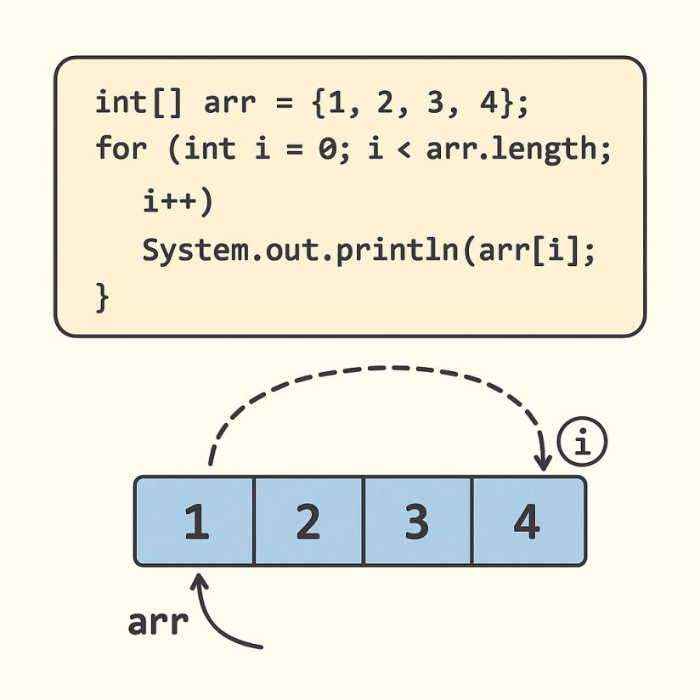
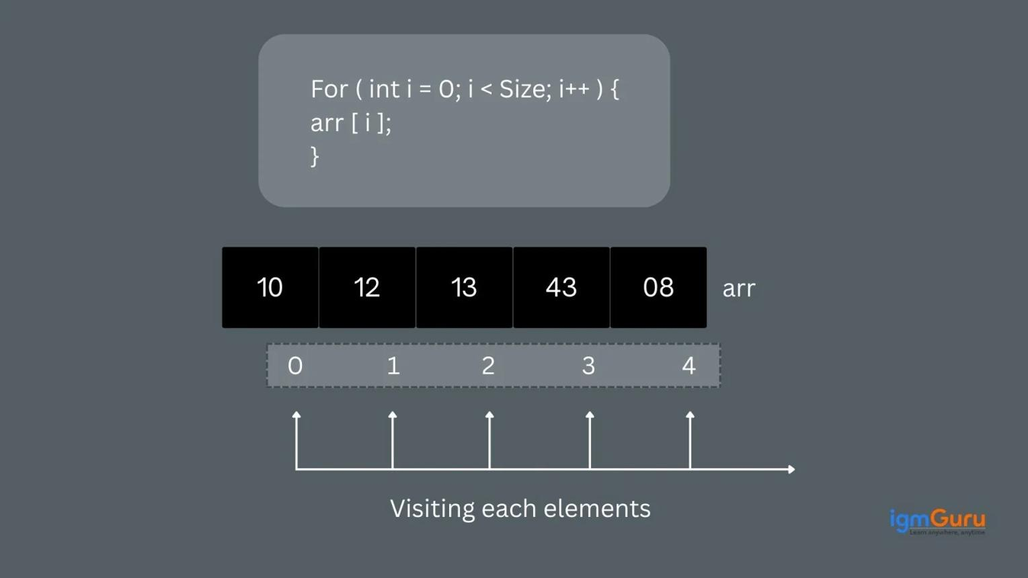

9.15 Array Traversal Using for Loop
The traditional for loop is commonly used to traverse an array.
Syntax
for (int i = 0; i < array.length; i++) {
// access array[i]
}
Example
int[] numbers = {10, 20, 30, 40, 50};

for (int i = 0; i < numbers.length; i++) {
System.out.println(numbers[i]);
}
Output
10
20
30
40
50
How it works
i = 0 → numbers[0] → 10
i = 1 → numbers[1] → 20
i = 2 → numbers[2] → 30
i = 3 → numbers[3] → 40
i = 4 → numbers[4] → 50
When:
i = 5
the condition:
i < numbers.length
becomes:
5 < 5
which is false, so the loop stops.

9.16 Array Traversal Using for-each
The for-each loop provides a simple way to access every element.
Syntax
for (dataType variable : arrayName) {
// statements
}
Example
int[] numbers = {10, 20, 30, 40, 50};

for (int n : numbers) {
System.out.println(n);
}
Output
10
20
30
40
50
Comparison
Traditional for:
for (int i = 0; i < numbers.length; i++) {
System.out.println(numbers[i]);
}
for-each:
for (int n : numbers) {
System.out.println(n);
}
The for-each loop is simpler when we only need to process each element and do not need its index.

9.17 Forward Traversal
Forward traversal means accessing elements from the first element to the last element.
Example
int[] numbers = {10, 20, 30, 40, 50};

for (int i = 0; i < numbers.length; i++) {
System.out.println(numbers[i]);
}
Output
10
20
30
40
50
Diagram
Forward Traversal
↓
10 → 20 → 30 → 40 → 50
0 1 2 3 4

9.18 Reverse Traversal
Reverse traversal means accessing elements from the last element to the first element.
Example
int[] numbers = {10, 20, 30, 40, 50};

for (int i = numbers.length - 1; i >= 0; i--) {
System.out.println(numbers[i]);
}
Output
50
40
30
20
10
Diagram
Reverse Traversal
↓
50 → 40 → 30 → 20 → 10
4 3 2 1 0
Important
For reverse traversal:
i = array.length - 1
is used as the starting index.

9.19 Complete Example: Array and Traversal
class ArrayExample {
public static void main(String[] args) {

int[] marks = {78, 85, 92, 67, 88};

System.out.println("Number of elements: " + marks.length);

System.out.println("Array elements:");

for (int i = 0; i < marks.length; i++) {
System.out.println(marks[i]);
}
}
}
Output
Number of elements: 5
Array elements:
78
85
92
67
88

9.20 Finding the Sum of Array Elements
class ArraySum {
public static void main(String[] args) {

int[] numbers = {10, 20, 30, 40, 50};
int sum = 0;

for (int i = 0; i < numbers.length; i++) {
sum = sum + numbers[i];
}

System.out.println("Sum = " + sum);
}
}
Output
Sum = 150

9.21 Finding the Average of Array Elements
class ArrayAverage {
public static void main(String[] args) {

int[] marks = {80, 70, 90, 85, 75};
int sum = 0;

for (int i = 0; i < marks.length; i++) {
sum = sum + marks[i];
}

double average = (double) sum / marks.length;

System.out.println("Average = " + average);
}
}
Output
Average = 80.0

9.22 Finding the Largest Element
class LargestElement {
public static void main(String[] args) {

int[] numbers = {25, 80, 45, 90, 60};

int largest = numbers[0];

for (int i = 1; i < numbers.length; i++) {
if (numbers[i] > largest) {
largest = numbers[i];
}
}

System.out.println("Largest = " + largest);
}
}
Output
Largest = 90

9.23 Finding the Smallest Element
class SmallestElement {
public static void main(String[] args) {

int[] numbers = {25, 80, 45, 90, 60};

int smallest = numbers[0];

for (int i = 1; i < numbers.length; i++) {
if (numbers[i] < smallest) {
smallest = numbers[i];
}
}

System.out.println("Smallest = " + smallest);
}
}
Output
Smallest = 25

9.24 Array of Strings
Arrays can also store strings.
String[] names = {"Rahul", "Priya", "Amit", "Neha"};
Traversing the String Array
for (int i = 0; i < names.length; i++) {
System.out.println(names[i]);
}
Output
Rahul
Priya
Amit
Neha

9.25 Different Types of Arrays
Java supports arrays of different data types.
Integer Array
int[] numbers = {10, 20, 30};
Double Array
double[] prices = {10.5, 20.75, 30.25};
Character Array
char[] letters = {'A', 'B', 'C'};
Boolean Array
boolean[] answers = {true, false, true};
String Array
String[] names = {"Amit", "Riya", "John"};

9.26 Default Values in an Array
When an array is created using new, its elements are automatically assigned default values.
Example:
int[] numbers = new int[5];
The default value of each int element is 0.
Index: 0 1 2 3 4
+----+----+----+----+----+
Value: | 0 | 0 | 0 | 0 | 0 |
+----+----+----+----+----+
Some common default values are:
Data Type | Default Value
byte | 0
short | 0
int | 0
long | 0L
float | 0.0f
double | 0.0d
char | '\u0000'
boolean | false
Reference types such as String | null

9.27 Array Index Out of Bounds
An index must always be within the valid range.
For:
int[] numbers = {10, 20, 30, 40, 50};
valid indexes are:
0, 1, 2, 3, 4
This is invalid:
System.out.println(numbers[5]);
It causes:
ArrayIndexOutOfBoundsException
Important Rule
Valid index range:

0 to array.length - 1

9.28 Important Array Syntax
Operation | Syntax
Declaration | int[] numbers;
Creation | numbers = new int[5];
Declaration + creation | int[] numbers = new int[5];
Initialization | int[] numbers = {10, 20, 30};
Access | numbers[0]
Modify | numbers[0] = 100;
Length | numbers.length
Forward traversal | for (int i = 0; i < numbers.length; i++)
Reverse traversal | for (int i = numbers.length - 1; i >= 0; i--)
For-each traversal | for (int n : numbers)

9.29 Important Points to Remember
⭐ Array indexing starts from 0.
⭐ The last index is:
array.length - 1
⭐ length is a property, not a method.
Correct:
numbers.length
Incorrect:
numbers.length()
⭐ Array size is fixed after creation.
⭐ All elements of a normal Java array have the same declared element type.
⭐ for loops are useful when the index is required.
⭐ for-each loops are useful when we simply want to process each element.
⭐ Reverse traversal can be performed using:
for (int i = array.length - 1; i >= 0; i--)
⭐ Accessing an invalid index causes ArrayIndexOutOfBoundsException.

9.30 Quick Revision Diagram
ARRAY
|
Collection of same-type elements
|
Zero-based index
|
+----------------+----------------+
| |
Declaration Creation
| |
int[] marks; new int[5]
| |
+----------------+----------------+
|
Initialization
|
{10, 20, 30, 40, 50}
|
+-------------+-------------+
| | |
Access length Traversal
| | |
marks[0] marks.length for / for-each
|
Index 0

9.31 CBSE Exam-Oriented Questions
Very Short Answer Questions
- What is an array?
- What is the first index of a Java array?
- What is the last index of an array containing 10 elements?
- What is the purpose of the length property?
- Is length a method or a property?
- What is array traversal?
- Which exception occurs when an invalid array index is accessed?
- Which loop is commonly used for array traversal?
- What is a for-each loop?
- What is the index of the first element of an array?
Short Answer Questions
- Define an array with an example.
- Explain array declaration and creation.
- Explain how to access an array element.
- Explain the length property with an example.
- Differentiate between array index and array length.
- Explain forward and reverse traversal of an array.
- Differentiate between for and for-each loops for array traversal.
Programming Questions
Q1. Write a Java program to create an integer array and display all its elements.
Q2. Write a Java program to find the sum of all elements of an array.
Q3. Write a Java program to find the average of array elements.
Q4. Write a Java program to find the largest element in an array.
Q5. Write a Java program to display the elements of an array in reverse order.
Q6. Write a Java program to display all elements of an array using a for-each loop.
Q7. Write a Java program to find the smallest element in an array.

⭐ One-Minute Revision
ARRAY
↓
Stores multiple values of the same declared type
↓
Index starts from 0
↓
Last index = length - 1
↓
Access → array[index]
↓
Length → array.length
↓
Traversal → for / for-each
↓
Forward → 0 to length - 1
↓
Reverse → length - 1 to 0
Most important syntax to remember:
int[] numbers = {10, 20, 30, 40, 50};

System.out.println(numbers[0]);

System.out.println(numbers.length);

for (int i = 0; i < numbers.length; i++) {
System.out.println(numbers[i]);
}

for (int n : numbers) {
System.out.println(n);
}
These four forms cover the core Class XII concepts of array creation, array access, the length property, and array traversal.

Unit 4: Java Programming with NetBeans
Content 10: Methods / Functions
10.1 Introduction to Methods
A method is a named block of Java statements designed to perform a particular task.
Methods help us divide a large program into smaller, manageable and reusable parts.
Important: In Java, the term method is normally used instead of function. Java does not have standalone functions; methods are declared inside classes.
Advantages of Methods
- Modularity: Divides a large program into smaller units.
- Reusability: A method can be called multiple times.
- Readability: Makes programs easier to understand.
- Easy debugging: Errors can be isolated more easily.
- Less repetition: Common code does not need to be written repeatedly.

10.2 General Syntax of a Method
[access_modifier] [optional_keyword] return_type method_name(parameter_list)
{
// Method body
}
Example
public static int add(int a, int b)
{
return a + b;
}
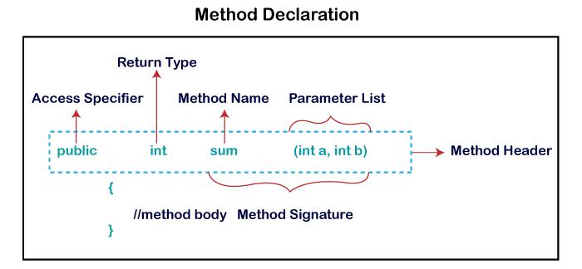
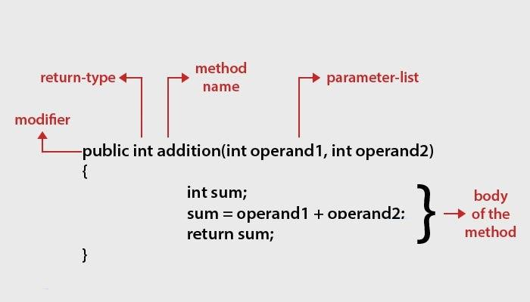
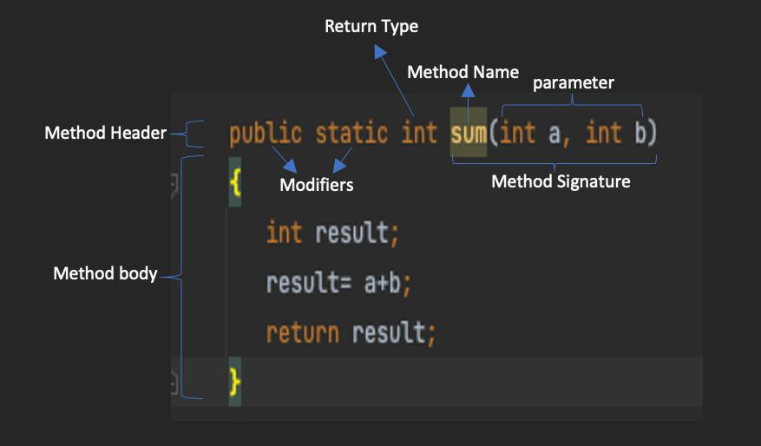
4
Parts of a Method
Part | Meaning | Example
Access modifier | Specifies accessibility of the method | public
Return type | Specifies the type of value returned | int, double, String, void
Method name | Name used to identify/call the method | add
Parameter list | Input variables received by the method | int a, int b
Method body | Statements that perform the task | { return a+b; }

10.3 Access Modifiers
Access modifiers control the accessibility of a method.
Modifier | Meaning | Example
public | Can be accessed from any class, subject to Java's access rules | public void show()
private | Accessible only within the same class | private void calculate()
protected | Accessible within the same class/package and through inheritance according to Java's protected-access rules | protected void display()
default / package-private | No modifier is written; accessible within the same package | void print()
Example
public void display()
{
System.out.println("Hello");
}
Here, public is the access modifier.

10.4 Return Type
The return type specifies the type of value a method returns.
A method can return:
- int
- double
- float
- char
- boolean
- String
- Other object/reference types
- void — when no value is returned
Example 1 – int
public int square(int n)
{
return n * n;
}
Example 2 – double
public double area(double r)
{
return 3.14 * r * r;
}
Example 3 – String
public String message()
{
return "Welcome";
}
Example 4 – void
public void greetings()
{
System.out.println("Hello");
}
Note: A void method does not return a value.

10.5 Method Name
The method name identifies the task performed by the method.
Examples:
calculateTotal()
displayName()
findAverage()
printResult()
greetings()
Java programmers generally use camelCase for method names.
For example:
calculateMarks()
rather than:
calculate_marks()

10.6 Parameter List
A parameter is a variable declared inside the parentheses of a method definition. It receives data when the method is called.
Example
static int add(int a, int b)
{
return a + b;
}
Here:
- a → parameter
- b → parameter
When calling the method:
int result = add(10, 20);
10 and 20 are called arguments.
Parameter vs Argument
Parameter | Argument
Appears in method definition | Appears in method call
Acts as a receiving variable | Provides the actual value
Example: int a | Example: 10

10.7 Method Body
The method body is the block of statements enclosed within { }.
Example:
static void greetings()
{
System.out.println("Good Morning!");
}
The following statement is part of the method body:
System.out.println("Good Morning!");

10.8 Types of Methods Based on Parameters and Return Value
There are four common combinations.
Type | Example | Description
No parameter, no return value | void greetings() | Performs a task without input or returned value
Parameter, no return value | void show(int n) | Accepts input but returns nothing
No parameter, return value | int getNumber() | Returns a value without receiving parameters
Parameter and return value | int add(int a, int b) | Accepts input and returns a result

Type 1: No Parameter and No Return Value
static void greetings()
{
System.out.println("Hello, Class 12!");
}
Calling:
greetings();

Type 2: Parameter but No Return Value
static void showSquare(int n)
{
System.out.println("Square = " + (n * n));
}
Calling:
showSquare(5);
Output:
Square = 25

Type 3: No Parameter but Return Value
static int getNumber()
{
return 100;
}
Calling:
int n = getNumber();
System.out.println(n);
Output:
100

Type 4: Parameter and Return Value
static int add(int a, int b)
{
return a + b;
}
Calling:
int sum = add(10, 20);
System.out.println(sum);
Output:
30

10.9 Complete Example of a Method
public class Main
{
static int multiply(int x, int y)
{
return x * y;
}

public static void main(String[] args)
{
int result = multiply(5, 4);
System.out.println("Result = " + result);
}
}
Output
Result = 20
How it works
main()
↓
multiply(5, 4)
↓
x = 5, y = 4
↓
return 5 × 4
↓
20
↓
result = 20

10.10 main() Method
main() is the entry point of a standard standalone Java application.
The standard form is:
public static void main(String[] args)
{
// statements
}
Meaning of Each Part
Part | Meaning
public | Allows the JVM to access the method
static | Allows the method to be invoked without creating an object of the class
void | The method does not return a value
main | Standard name recognized as the application entry point
String[] args | Receives command-line arguments
Example
public class Main
{
public static void main(String[] args)
{
System.out.println("Hello Java!");
}
}
Output:
Hello Java!

10.11 greetings() Method
greetings() is an example of a user-defined method.
It is not a special Java method.
static void greetings()
{
System.out.println("Welcome to Java!");
}
It executes only when it is called.
For example:
public static void main(String[] args)
{
greetings();
}
Output:
Welcome to Java!

10.12 main() vs greetings()
Basis | main() | greetings()
Purpose | Entry point of a standard Java application | Performs a task defined by the programmer
Status | Special entry-point method | Ordinary user-defined method
Who starts it? | JVM/runtime starts it for a standard application | Usually called by another method
Name | Must be main for the standard entry point | Programmer can choose the name
Return type | void in the standard signature | Can be void or another return type
Parameters | String[] args in the standard signature | Can have zero or more parameters
Example | public static void main(String[] args) | static void greetings()

10.13 Complete Program: main() Calling greetings()
public class Main
{
public static void main(String[] args)
{
greetings();

System.out.println("Program completed.");
}

static void greetings()
{
System.out.println("Welcome to Java Programming!");
}
}
Output
Welcome to Java Programming!
Program completed.
Execution Flow
START
↓
main()
↓
greetings() called
↓
greetings() executes
↓
"Welcome to Java Programming!"
↓
Control returns to main()
↓
"Program completed."
↓
END

10.14 Important Point: static
You will frequently see static in examples:
static void greetings()
static means that the method belongs to the class rather than to a particular object.
Therefore, a static method can be called from another static method, such as main(), without first creating an object.
Example:
public class Main
{
static void greetings()
{
System.out.println("Hello!");
}

public static void main(String[] args)
{
greetings();
}
}

10.15 return Statement
The return statement is used to send a value back to the calling method.
Example:
static int add(int a, int b)
{
return a + b;
}
When:
int result = add(10, 20);
the value 30 is returned and stored in result.
Important
If the return type is not void, the method must return a compatible value.
Correct:
static int square(int n)
{
return n * n;
}
Incorrect:
static int square(int n)
{
System.out.println(n * n);
}
The second method does not return an int.

10.16 Method Calling
A method is executed when it is called.
Method definition
static void greetings()
{
System.out.println("Hello!");
}
Method call
greetings();
A method can also be called multiple times:
greetings();
greetings();
greetings();
This demonstrates code reusability.

10.17 Example: Method with Parameter and Return Value
public class Main
{
static int square(int n)
{
return n * n;
}

public static void main(String[] args)
{
int answer = square(6);

System.out.println("Square = " + answer);
}
}
Output
Square = 36

10.18 NetBeans and Methods
In NetBeans IDE, Java methods are written inside the class in the source-code editor.
A typical structure is:
public class Main
{
public static void main(String[] args)
{
greetings();
}

static void greetings()
{
System.out.println("Hello, Class 12!");
}
}
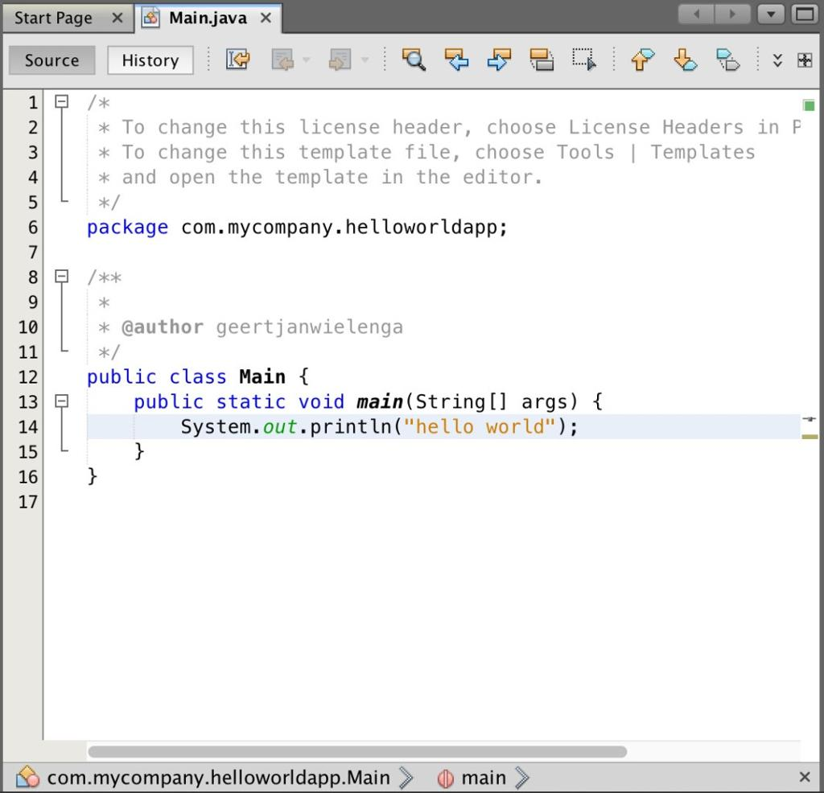
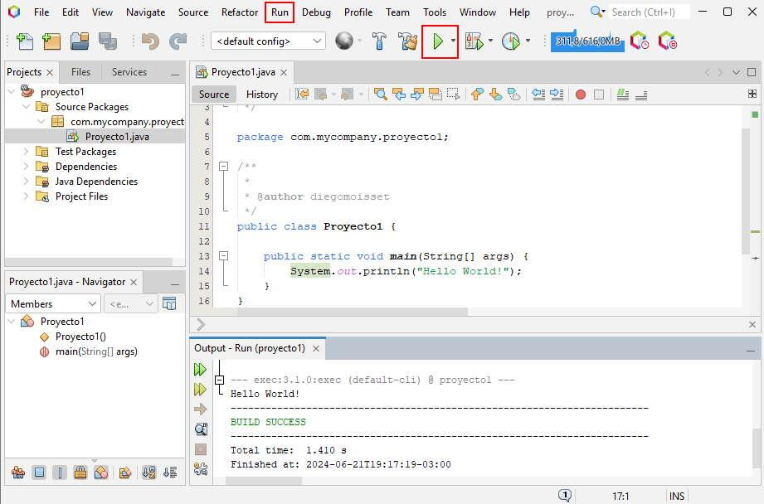
4
Classroom note: The NetBeans visual above is for understanding the IDE/editor environment. The exact appearance may vary between NetBeans versions.

10.19 Key Points to Remember
- A method is a reusable block of Java statements.
- Methods are declared inside classes.
- Java generally uses the term method, rather than standalone function.
- A method may have zero or more parameters.
- A method may return a value or use void.
- return sends a value back to the caller.
- main() is the standard entry point of a standalone Java application.
- greetings() is an ordinary user-defined method.
- A method executes when it is called.
- Methods reduce code repetition and improve program organization.

10.20 Quick Revision
Method = Named, reusable block of statements.
Syntax:
access_modifier return_type method_name(parameters)
{
// statements
}
Example:
public static int add(int a, int b)
{
return a + b;
}
Call:
int result = add(10, 20);
Special entry method:
public static void main(String[] args)
User-defined method:
static void greetings()
{
System.out.println("Hello!");
}

10.21 Practice Questions
Very Short Answer
- What is a method?
- Why are methods used in Java?
- What is a return type?
- What is a parameter?
- What is an argument?
- What is the purpose of void?
- What is the purpose of return?
- What is the standard entry point of a Java application?
Short Answer
- Write the general syntax of a Java method.
- Explain the different parts of a method.
- Differentiate between a parameter and an argument.
- Explain the four common types of methods based on parameters and return values.
- Differentiate between main() and greetings().
Programming Questions
Q1. Write a method square() that accepts an integer and returns its square.
Q2. Write a method greetings() that displays "Welcome to Java".
Q3. Write a Java program in which main() calls a user-defined greetings() method.
Q4. Write a method add() that accepts two integers and returns their sum.
Q5. Write a Java program using a method to calculate the area of a circle.

Content 11: Object-Oriented Programming (OOP)
Class XII – CBSE Information Technology (402)
Topic: Object-Oriented Programming, Classes, Objects, Constructors, Methods, Access Modifiers, Getters and Setters
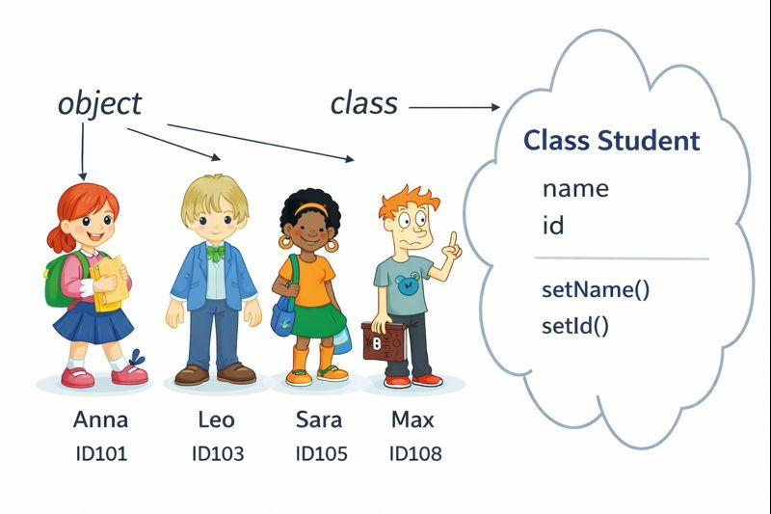
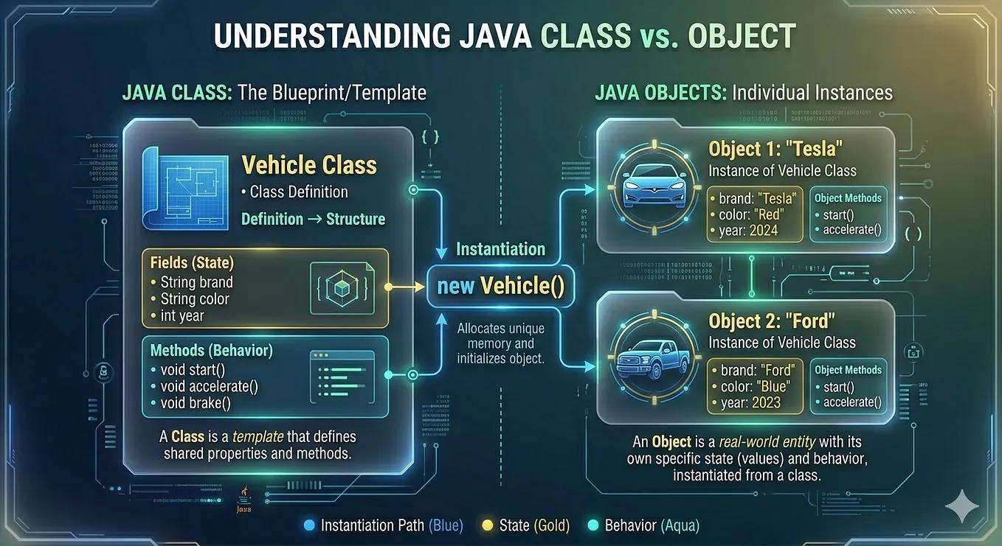
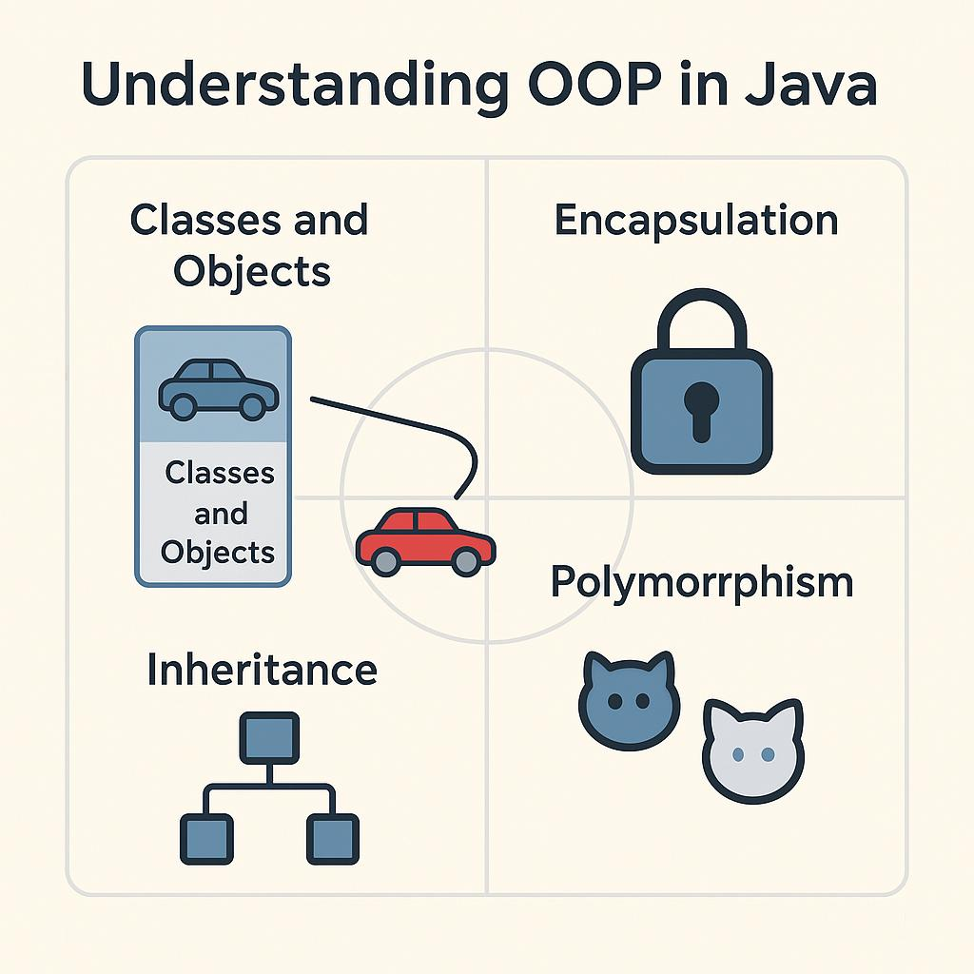
7

11. Object-Oriented Programming (OOP)
11.1 Meaning of Object-Oriented Programming
Object-Oriented Programming (OOP) is a programming approach in which a program is designed using objects and classes.
An object represents a real-world entity, such as:
- Student
- Teacher
- Car
- Bank Account
- Book
- Employee
Each object can have:
- Data / Attributes – characteristics of the object
- Methods / Behaviours – actions performed by the object
Real-world example
Consider a Student.
Attributes:
Name
Roll Number
Class
Age
Behaviours:
study()
attendClass()
displayDetails()
Therefore:
STUDENT
│
┌─────────┴─────────┐
│ │
Attributes Behaviours
│ │
┌────┼────┐ ┌─────┼─────┐
│ │ │ │ │ │
name roll age study attend display

11.2 Benefits of OOP
Object-oriented programming provides several important benefits.
1. Reusability
Existing classes and methods can be reused in other programs.
2. Modularity
A large program can be divided into smaller classes and methods.
3. Encapsulation
Data and the methods that operate on that data can be grouped together inside a class.
4. Data Security
Access modifiers such as private can restrict direct access to data.
5. Easy Maintenance
Changes can often be made to a particular class without rewriting the complete program.
6. Real-world Modelling
Real-world entities can be represented naturally using classes and objects.
7. Reduced Code Duplication
Methods and classes can be reused instead of repeatedly writing the same code.

11.3 Uses of OOP
OOP is widely used for developing:
- Desktop applications
- Web applications
- Mobile applications
- Banking software
- School management systems
- E-commerce applications
- Games
- Enterprise software
- Database applications
Java is a major object-oriented programming language.

11.4 Important Concepts of OOP
The major concepts students should know are:
Object-Oriented Programming
│
┌───────────────┼───────────────┐
│ │ │
Class Object Encapsulation
│ │
└───────────────┬───────────────┘
│
Inheritance
│
Polymorphism
For this Content 11, our main focus is:
Class → Object → Fields → Constructor → Methods → Access Modifiers → Getter/Setter

11.5 Class
Definition
A class is a blueprint or template used for creating objects.
It defines:
- Data/fields
- Methods/behaviours
- Constructors
Real-world analogy
A building plan is not an actual building. It is a blueprint from which buildings can be constructed.
Similarly:
Class = Blueprint
Object = Actual entity created from the blueprint
Diagram
CLASS
┌─────────────────┐
│ Student │
├─────────────────┤
│ name │
│ rollNo │
│ age │
├─────────────────┤
│ study() │
│ display() │
└─────────────────┘
│
creates objects
┌─────────┼─────────┐
↓ ↓ ↓
Student1 Student2 Student3
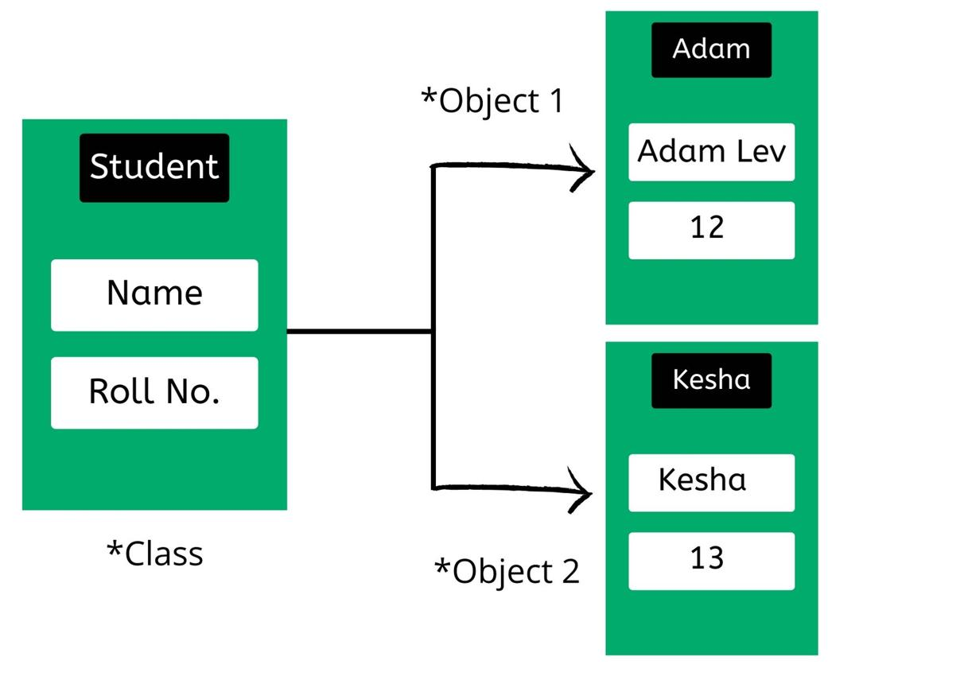
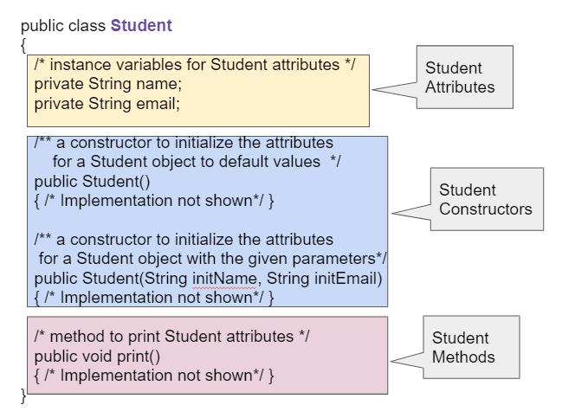
4

11.6 Object
Definition
An object is an instance of a class.
When an object is created, memory is generally allocated for its instance data.
For example:
Student s1 = new Student();
Here:
- Student → class
- s1 → reference variable
- new → creates a new object
- Student() → calls the constructor
Example
public class Student
{
String name;
int rollNo;
}
Creating an object:
Student s1 = new Student();
Another object:
Student s2 = new Student();
Both s1 and s2 refer to separate Student objects.

11.7 Class vs Object
Basis | Class | Object
Meaning | Blueprint/template | Instance of a class
Purpose | Defines structure and behaviour | Represents an actual entity
Memory | Defining a class does not create an instance of its fields | An object occupies memory for its instance data
Example | Student | s1
Creation | Declared using class | Usually created using new
Number | One class can create many objects | Many objects can be created from one class

11.8 Basic Class Syntax
The general syntax of a class is:
public class ClassName
{
// fields
// constructors
// methods
}
Example
public class Student
{
}
Here:
- public → access modifier
- class → keyword
- Student → class name
- { } → class body

11.9 Class Declaration
i. General Declaration
public class ClassName
{
}
ii. Example: Students Class
public class Students
{
}
The class name should normally follow PascalCase naming convention.
Examples:
Student
BankAccount
Employee
SchoolStudent

11.10 Fields / Attributes
A field is a variable declared inside a class but outside methods, constructors, and other blocks.
Fields represent the data or state of an object.
Syntax
dataType fieldName;
Examples
String name;
int rollNo;
int age;
double marks;
Complete example
public class Students
{
String name;
int rollNo;
int age;
double marks;
}
Here:
name → field
rollNo → field
age → field
marks → field
Diagram
Students Class
┌───────────────────┐
│ Fields │
│ │
│ String name │
│ int rollNo │
│ int age │
│ double marks │
├───────────────────┤
│ Methods │
│ │
│ display() │
│ study() │
└───────────────────┘

11.11 Field Declaration
Syntax
dataType fieldName;
Examples:
int age;
String name;
double salary;
boolean passed;
char grade;
Fields can also be initialized:
int age = 17;
String name = "Rahul";
double marks = 85.5;

11.12 Creating Objects from a Class
Consider:
public class Students
{
String name;
int rollNo;
}
Create an object:
Students s1 = new Students();
Explanation
Students s1 = new Students();
│ │ │
│ │ └── Constructor call
│ └────────── Reference variable
└────────────────── Class type
The new keyword creates a new object.

11.13 Assigning Values to Fields
public class Main
{
public static void main(String[] args)
{
Students s1 = new Students();

s1.name = "Rahul";
s1.rollNo = 12;

System.out.println(s1.name);
System.out.println(s1.rollNo);
}
}
Output
Rahul
12

11.14 Constructor
Definition
A constructor is a special member of a class that is used to initialize objects.
A constructor:
- Has the same name as the class.
- Has no return type, not even void.
- Is called when an object is created.
- Can accept parameters.
- Can be overloaded.
Syntax
class ClassName
{
ClassName()
{
// initialization statements
}
}
Example
public class Student
{
Student()
{
System.out.println("Student object created");
}
}
Creating an object:
Student s1 = new Student();
Output:
Student object created

11.15 Parameterized Constructor
A constructor can receive parameters.
public class Student
{
String name;
int rollNo;

Student(String n, int r)
{
name = n;
rollNo = r;
}
}
Creating an object:
Student s1 = new Student("Rahul", 10);
Now:
name = Rahul
rollNo = 10

11.16 Constructor vs Method
Basis | Constructor | Method
Purpose | Initializes an object | Performs a specific task
Name | Must have same name as class | Can have any valid method name
Return type | No return type | Has a return type or void
Invocation | Called when object is created | Called explicitly
void | Cannot have void | Can have void
Example | Student() | display()
Constructor
Student()
{
name = "Unknown";
}
Method
void display()
{
System.out.println(name);
}

11.17 Destructors in Java
Important CBSE Concept
Languages such as C++ have destructors, but Java does not provide a programmer-defined destructor like C++.
Java uses automatic garbage collection to reclaim memory occupied by objects that are no longer reachable.
Therefore, do not write a Java destructor such as:
~Student()
This is not valid Java syntax.
Garbage Collection
When an object is no longer reachable by the program, the Java runtime may eventually reclaim its memory through the Garbage Collector (GC).
Object created
↓
Object used
↓
No longer reachable
↓
Eligible for Garbage Collection
↓
Memory may be reclaimed
Remember: Garbage collection is automatic; the programmer does not normally explicitly destroy an object like in C++.

11.18 Methods / Behaviours
A method represents an action or behaviour of an object.
For example, a Student can:
- study
- attend class
- display details
- calculate marks
General Syntax
returnType methodName(parameterType parameterName)
{
// method body
}
Example
void display()
{
System.out.println("Student Details");
}
Method with Parameter
void displayName(String name)
{
System.out.println("Name: " + name);
}
Method with Return Value
int square(int n)
{
return n * n;
}

11.19 Class Containing Fields, Constructor and Methods
public class Student
{
// Fields
String name;
int rollNo;

// Constructor
Student(String n, int r)
{
name = n;
rollNo = r;
}

// Method
void display()
{
System.out.println("Name: " + name);
System.out.println("Roll No: " + rollNo);
}
}
Creating and using the object:
public class Main
{
public static void main(String[] args)
{
Student s1 = new Student("Rahul", 10);

s1.display();
}
}
Output:
Name: Rahul
Roll No: 10
Complete Structure
CLASS
│
┌────────────┼────────────┐
↓ ↓ ↓
Fields Constructor Methods
│ │ │
name Student() display()
rollNo Student() calculate()
age

11.20 Access Modifiers
Definition
Access modifiers are keywords used to control the accessibility of classes, fields, methods and other members.
The four commonly discussed access levels in Java are:
public
protected
default (package-private)
private

11.21 Types of Access Modifiers
1. public
A public member can generally be accessed from anywhere the class itself is accessible.
Field
public String name;
Method
public void display()
{
}
Class
public class Student
{
}

11.22 private
A private member can be accessed only within the same class.
Field
private int age;
Method
private void calculate()
{
}
Important
A top-level class cannot be declared private.
This is valid:
public class Student
{
private int age;
}
But this is not valid for a top-level class:
private class Student
{
}

11.23 protected
A protected member is accessible within its class and package, and is also available to subclasses according to Java's protected-access rules.
Field
protected int marks;
Method
protected void display()
{
}
For a top-level class, protected is not a permitted access modifier.

11.24 Default / Package-Private
When no access modifier is written, the member has default/package-private access.
Example:
class Student
{
String name;

void display()
{
System.out.println(name);
}
}
Here:
String name;
has package-private access.

11.25 Access Modifier Comparison
Access Modifier | Same Class | Same Package | Subclass in Different Package | Other Classes
public | ✓ | ✓ | ✓ | ✓
protected | ✓ | ✓ | ✓* | ✗
default / package-private | ✓ | ✓ | ✗** | ✗
private | ✓ | ✗ | ✗ | ✗
* Protected access across packages is subject to Java's inheritance/member-access rules.
** A subclass in another package does not receive ordinary package-private access.

11.26 Access Modifiers – Class Declaration
For a top-level class, the commonly used access levels are:
Public class
public class Student
{
}
Default/package-private class
class Student
{
}
A top-level class cannot normally be declared:
private class Student
{
}
or
protected class Student
{
}
Important: Nested classes can have access modifiers such as private and protected. The restriction above applies to top-level classes.

11.27 Access Modifiers – Field Declaration
Public field
public int age;
Private field
private int age;
Protected field
protected int age;
Default field
int age;

11.28 Access Modifiers – Method Declaration
Public method
public void display()
{
}
Private method
private void calculate()
{
}
Protected method
protected void show()
{
}
Default method
void print()
{
}

11.29 Why private Fields Are Commonly Used
Consider:
public class Student
{
public int marks;
}
Any accessible code could directly change marks.
For example:
s1.marks = -500;
This may lead to invalid data.
Instead, we can use:
private int marks;
and provide controlled methods to read and update it.
This concept is closely related to encapsulation.

11.30 Getter and Setter Methods
Getter
A getter method is a method used to read/access the value of a private field.
It commonly begins with:
get
Example:
public int getAge()
{
return age;
}

Setter
A setter method is a method used to set/update the value of a private field.
It commonly begins with:
set
Example:
public void setAge(int age)
{
this.age = age;
}

11.31 Why Getters and Setters Are Used
Getters and setters provide controlled access to private data.
PRIVATE FIELD
│
┌───────┴────────┐
↓ ↓
Getter Setter
│ │
READ DATA UPDATE DATA
This is an important part of encapsulation.

11.32 Complete Getter and Setter Example
public class Student
{
private String name;
private int age;

// Setter for name
public void setName(String name)
{
this.name = name;
}

// Getter for name
public String getName()
{
return name;
}

// Setter for age
public void setAge(int age)
{
this.age = age;
}

// Getter for age
public int getAge()
{
return age;
}
}
Using the class:
public class Main
{
public static void main(String[] args)
{
Student s1 = new Student();

s1.setName("Rahul");
s1.setAge(17);

System.out.println(s1.getName());
System.out.println(s1.getAge());
}
}
Output
Rahul
17

11.33 Understanding this Keyword
In:
public void setAge(int age)
{
this.age = age;
}
there are two age identifiers:
this.age → instance field of the current object
age → method parameter
Therefore:
this.age = age;
means:
Store the parameter age in the current object's age field.
Diagram
setAge(17)
│
↓
parameter age = 17
│
↓
this.age = age
│
↓
Object's age becomes 17

11.34 Complete OOP Example
public class Student
{
private String name;
private int rollNo;
private double marks;

// Constructor
public Student(String name, int rollNo, double marks)
{
this.name = name;
this.rollNo = rollNo;
this.marks = marks;
}

// Getter
public String getName()
{
return name;
}

// Setter
public void setName(String name)
{
this.name = name;
}

// Getter
public int getRollNo()
{
return rollNo;
}

// Setter
public void setRollNo(int rollNo)
{
this.rollNo = rollNo;
}

// Method / Behaviour
public void display()
{
System.out.println("Name: " + name);
System.out.println("Roll No: " + rollNo);
System.out.println("Marks: " + marks);
}
}
Main Class
public class Main
{
public static void main(String[] args)
{
Student s1 = new Student("Rahul", 12, 87.5);

s1.display();

s1.setName("Aman");

System.out.println("Updated Name: " + s1.getName());
}
}
Output
Name: Rahul
Roll No: 12
Marks: 87.5
Updated Name: Aman

11.35 Complete OOP Structure
CLASS
│
┌───────────┼───────────┐
│ │ │
↓ ↓ ↓
FIELDS CONSTRUCTOR METHODS
│ │ │
↓ ↓ ↓
name Student() display()
age Student() study()
marks calculate()
│
↓
Access Control
│
┌─────┴─────┐
↓ ↓
private public
│
↓
Getter / Setter
│
↓
Object

11.36 Class, Object, Constructor and Method – One Example
public class Car
{
// Fields
String brand;
int speed;

// Constructor
Car(String brand, int speed)
{
this.brand = brand;
this.speed = speed;
}

// Method
void display()
{
System.out.println("Brand: " + brand);
System.out.println("Speed: " + speed);
}
}
Creating the object:
Car c1 = new Car("Toyota", 120);
Calling the method:
c1.display();
Concept Diagram
Class: Car
│
│ new Car("Toyota",120)
↓
Object: c1
│
├── brand = "Toyota"
├── speed = 120
│
└── display()
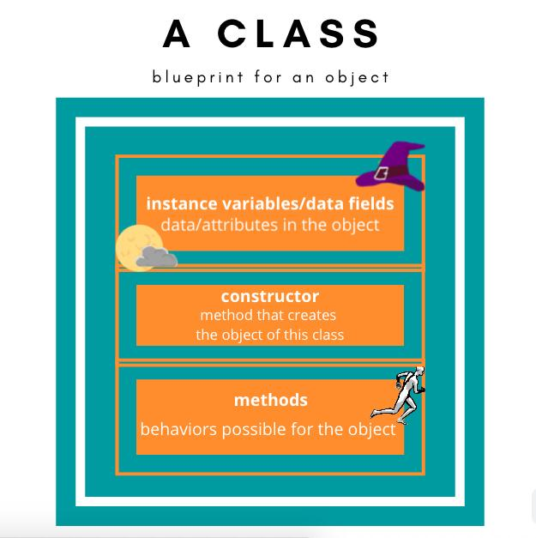
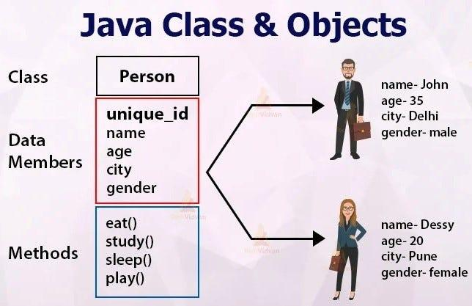
5

11.37 Constructor vs Destructor in Java
Feature | Constructor | Destructor
Java support | ✓ Yes | ✗ No C++-style destructor
Purpose | Initializes objects | C++ uses destructors for cleanup
Name | Same as class | C++ destructor uses ~ClassName()
Return type | No return type | Not applicable in Java
Called | During object creation | No programmer-defined destructor in Java
Java memory cleanup | Not applicable | Handled automatically by Garbage Collection
Remember
Java:
Object creation → Constructor
↓
Object becomes unreachable
↓
Garbage Collector may reclaim memory

11.38 Class vs Object vs Constructor vs Method
Term | Meaning | Example
Class | Blueprint/template | Student
Object | Instance of a class | s1
Constructor | Initializes an object | Student()
Field | Stores object data/state | name, age
Method | Defines behaviour/action | display()
Getter | Reads private data | getAge()
Setter | Updates private data | setAge()

11.39 Important Exam Points
Remember these points:
- A class is a blueprint for creating objects.
- An object is an instance of a class.
- Fields represent the state/data of an object.
- Methods represent the behaviour/actions of an object.
- A constructor has the same name as the class.
- A constructor has no return type, not even void.
- Java does not have a C++-style programmer-defined destructor.
- Java uses garbage collection for automatic memory management.
- public, private, protected and default/package-private are access levels used in Java.
- A top-level class can be public or package-private; it cannot be private or protected.
- private fields are commonly accessed through getter and setter methods.
- A getter generally reads a value.
- A setter generally modifies a value.
- this refers to the current object.
- OOP promotes modularity, reusability and encapsulation.

11.40 Quick Revision Chart
OOP
│
↓
CLASS
│
┌────────┼────────┐
↓ ↓ ↓
Fields Constructor Methods
│ │ │
│ │ ↓
│ │ Behaviour
│ │
↓ ↓
State Initialization
│
↓
OBJECT
│
↓
Encapsulation
│
┌─────┴─────┐
↓ ↓
Getter Setter
READ UPDATE

11.41 Practice Questions
A. Very Short Answer
- What is OOP?
- Define a class.
- Define an object.
- What is a field?
- What is a constructor?
- Can a constructor have a return type?
- Does Java support a C++-style destructor?
- What is a method?
- What is an access modifier?
- What is a getter?
- What is a setter?
- What is the purpose of the this keyword?
B. Short Answer
- Explain the benefits of Object-Oriented Programming.
- Differentiate between a class and an object.
- Explain the syntax of a class declaration.
- Explain fields with suitable examples.
- Explain constructors with syntax and an example.
- Differentiate between a constructor and a method.
- Explain why Java does not use a programmer-defined destructor like C++.
- Explain the four access levels in Java.
- Differentiate between public, private, protected and default access.
- Explain getter and setter methods with an example.
C. Programming Questions
Q1.
Create a Student class having the following fields:
name
rollNo
marks
Create an object and display the values.
Q2.
Create a Student class with a parameterized constructor.
Q3.
Create a class containing private fields and appropriate getter and setter methods.
Q4.
Create a BankAccount class with:
accountNumber
holderName
balance
Use a constructor and a display() method.
Q5.
Write a Java program demonstrating the use of:
Class
Object
Fields
Constructor
Method
Getter
Setter

⭐ One-Line Summary
In Java OOP, a class defines the structure and behaviour, an object is an instance of that class, fields store its data, constructors initialize objects, methods define behaviour, access modifiers control visibility, and getters/setters provide controlled access to private fields.

Content 12: Java Libraries
Class XII – CBSE Information Technology (402)

12. Java Libraries
12.1 Introduction
While developing a Java program, programmers often need to perform common tasks such as:
- displaying output
- working with strings
- performing mathematical calculations
- accepting input
- working with dates and collections
- reading and writing files
- handling data
Writing all these features from scratch would take a lot of time.
Java therefore provides a large collection of pre-written classes and methods that programmers can use in their programs.
These collections are called Java Libraries.
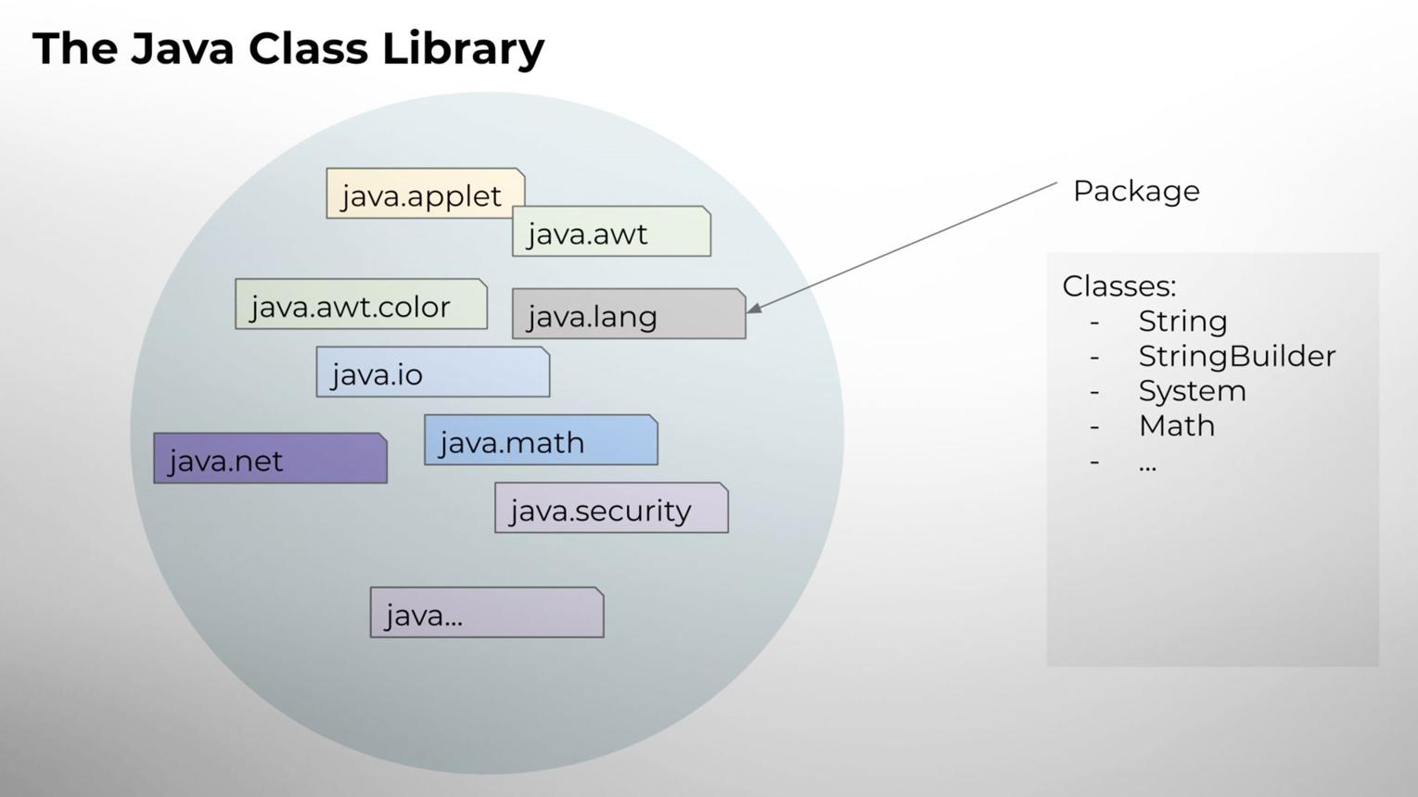
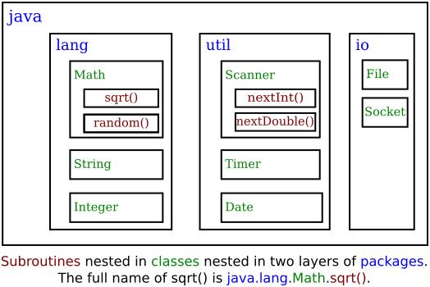
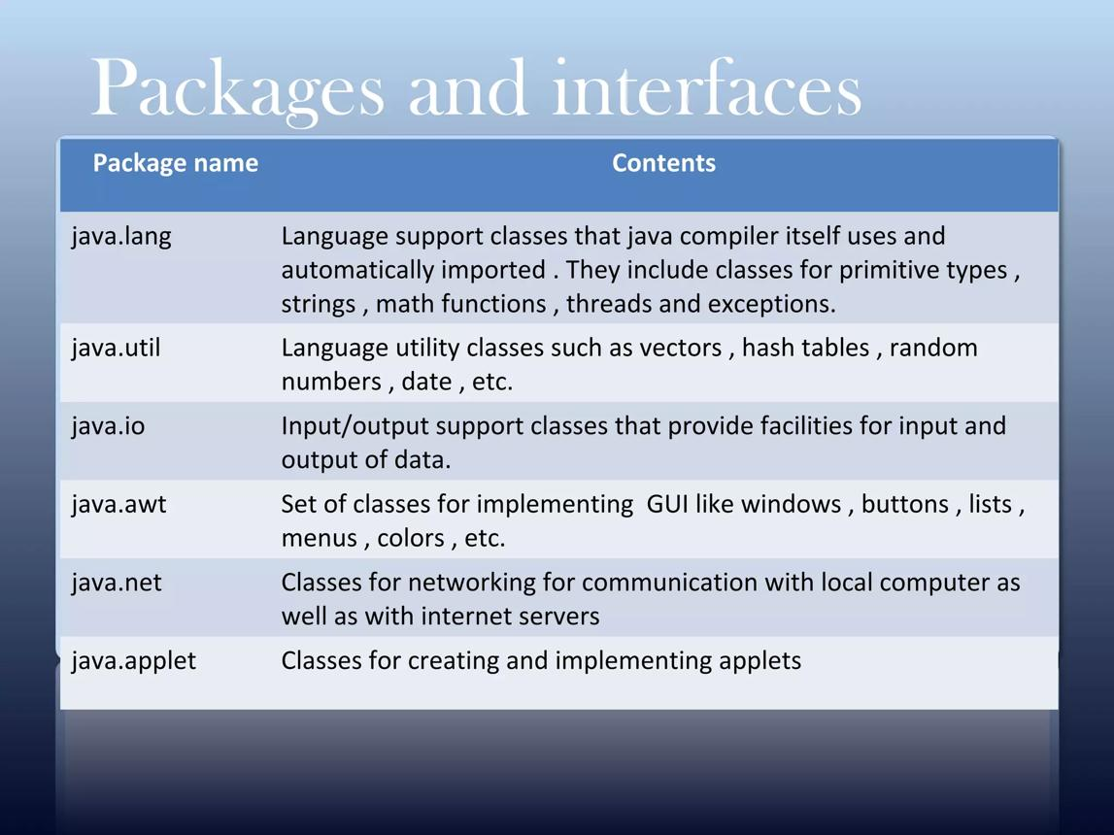
6

12.2 Definition of Java Library
A Java library is a collection of pre-written classes, interfaces, methods and other resources that can be used by programmers to perform commonly required tasks.
Instead of creating everything from the beginning, a programmer can use the functionality already provided by Java.
Simple Example
Suppose we want to find the square root of a number.
Instead of writing our own square-root algorithm, Java provides:
Math.sqrt()
Example:
double result = Math.sqrt(25);

System.out.println(result);
Output:
5.0
Thus, Java libraries help programmers reuse existing functionality.

12.3 Java API
Java provides a large set of standard libraries through the Java API (Application Programming Interface).
The Java API contains packages, classes, interfaces and methods that programmers can use in Java applications.
Basic Structure
Java API
│
┌───────────────┼────────────────┐
│ │ │
Packages Classes Interfaces
│ │ │
↓ ↓ ↓
java.lang String List
java.util Math Map
java.io System ...
Remember: A package groups related Java classes and interfaces.

12.4 Package
A package is a group of related classes and interfaces.
For example:
java.lang
java.util
java.io
are Java packages.
Example
The Math class belongs to:
java.lang
The Scanner class belongs to:
java.util
The File class belongs to:
java.io

12.5 Why Java Libraries Are Used
Java libraries provide ready-to-use functionality.
Example
For keyboard input, instead of developing an input system ourselves, we can use:
Scanner
from:
java.util
For file operations, we can use classes from:
java.io
For mathematical calculations:
Math
from:
java.lang

12.6 Benefits of Java Libraries
1. Code Reusability
Programmers can reuse existing classes and methods.
2. Saves Development Time
Common functionality does not need to be implemented from scratch.
3. Reliability
Standard library classes have been widely used and tested.
4. Simpler Programs
A complex task can often be performed using a few library methods.
5. Productivity
Programmers can focus on the actual problem instead of developing basic functionality.
6. Standardization
Java provides standard ways of performing common programming tasks.

12.7 Major Java Libraries / Packages
For this topic, we will study:
Java Libraries
│
├── java.lang
│
├── java.util
│
└── java.io

12.8 java.lang Package
Definition
java.lang is one of the most fundamental Java packages.
It contains classes that provide basic functionality required by many Java programs.
Some important classes include:
String
System
Math
Object
Integer
Double
Boolean
Character
Important Point
The java.lang package is automatically imported by Java.
Therefore, we normally do not need to write:
import java.lang.*;
at the beginning of a program.

12.9 Important Classes of java.lang
Class | Main Use
String | Working with text
System | Standard input/output and system-related operations
Math | Mathematical calculations
Object | Root class of Java's class hierarchy
Integer | Wrapper class for int
Double | Wrapper class for double
Character | Wrapper class for char
Boolean | Wrapper class for boolean

12.10 String Class
The String class is used to represent a sequence of characters.
Example
String name = "Rahul";
Useful String Methods
Method | Purpose
length() | Returns number of characters
toUpperCase() | Converts text to uppercase
toLowerCase() | Converts text to lowercase
charAt() | Returns character at a specified index
substring() | Extracts part of a string
equals() | Compares two strings
trim() | Removes leading/trailing whitespace
Example
String name = "Rahul";

System.out.println(name.length());
System.out.println(name.toUpperCase());
System.out.println(name.toLowerCase());
Output:
5
RAHUL
rahul

12.11 Math Class
The Math class provides methods for mathematical operations.
It belongs to:
java.lang
Therefore, it does not normally require an import statement.
Examples
System.out.println(Math.sqrt(25));
System.out.println(Math.pow(2, 3));
System.out.println(Math.abs(-10));
Output:
5.0
8.0
10
Common Math Methods
Method | Purpose | Example
Math.sqrt() | Square root | Math.sqrt(25)
Math.pow() | Power | Math.pow(2,3)
Math.abs() | Absolute value | Math.abs(-10)
Math.max() | Larger value | Math.max(10,20)
Math.min() | Smaller value | Math.min(10,20)
Math.round() | Rounds a value | Math.round(5.6)
Math.ceil() | Rounds upward | Math.ceil(5.2)
Math.floor() | Rounds downward | Math.floor(5.8)
Math.random() | Generates a pseudo-random value | Math.random()

12.12 System Class
The System class provides several system-related facilities.
One of its most commonly used features is standard output:
System.out.println();
Example:
System.out.println("Hello Java");
Here:
System
↓
out
↓
println()
System.out.println() displays text and then moves the cursor to the next line.

12.13 java.lang Concept Diagram
java.lang
│
┌─────────────┼──────────────┐
↓ ↓ ↓
String Math System
│ │ │
↓ ↓ ↓
Text Calculations Output
│ │ │
↓ ↓ ↓
length() sqrt() println()
charAt() pow() print()
substring() max()
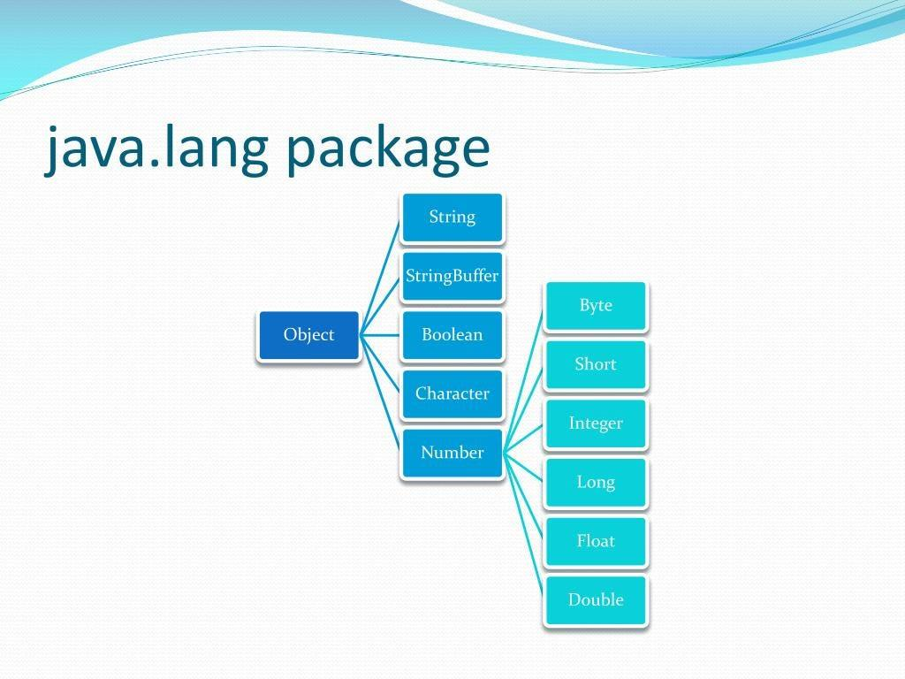
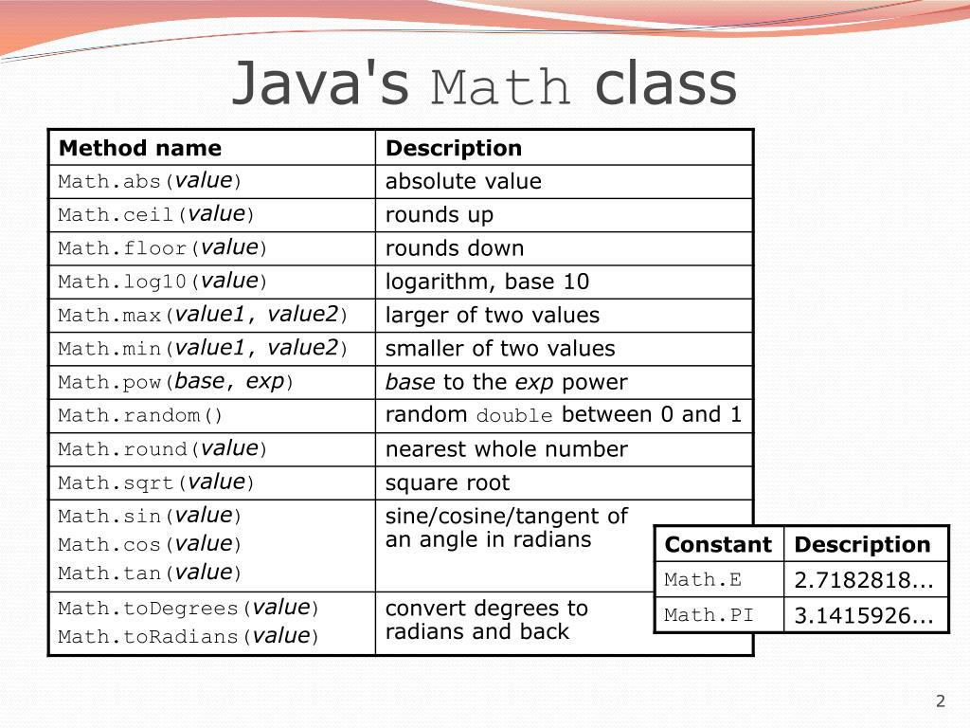
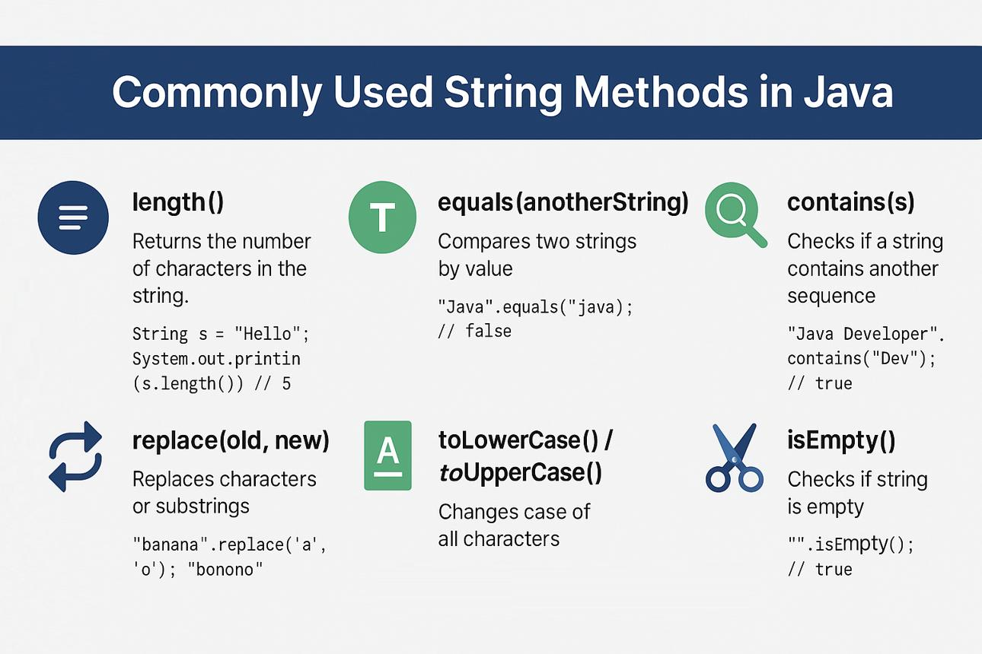
6

12.14 java.util Package
Definition
The java.util package contains utility classes and interfaces used for common programming tasks.
It provides classes for:
- taking input
- collections
- date/time-related utilities
- random values
- data structures
- utility operations
Some important classes include:
Scanner
ArrayList
HashMap
HashSet
Random
Collections
Arrays

12.15 Scanner Class
The Scanner class is commonly used to accept input from the keyboard.
It belongs to:
java.util
Therefore, we normally import it using:
import java.util.Scanner;
Example
import java.util.Scanner;

public class Main
{
public static void main(String[] args)
{
Scanner sc = new Scanner(System.in);

System.out.print("Enter your name: ");
String name = sc.nextLine();

System.out.println("Hello " + name);
}
}
Sample Output
Enter your name: Rahul
Hello Rahul

12.16 Common Scanner Methods
Method | Used For
nextInt() | Reading an integer
nextDouble() | Reading a double
nextFloat() | Reading a float
next() | Reading one token/word
nextLine() | Reading a complete line
nextBoolean() | Reading a boolean value
Example
int age = sc.nextInt();
double marks = sc.nextDouble();
String name = sc.next();

12.17 ArrayList Class
ArrayList is a resizable array implementation provided by Java.
It belongs to:
java.util
Import:
import java.util.ArrayList;
Example
import java.util.ArrayList;

public class Main
{
public static void main(String[] args)
{
ArrayList<String> students = new ArrayList<>();

students.add("Rahul");
students.add("Aman");
students.add("Priya");

System.out.println(students);
}
}
Output:
[Rahul, Aman, Priya]
Useful Methods
Method | Purpose
add() | Adds an element
get() | Gets an element
set() | Changes an element
remove() | Removes an element
size() | Returns number of elements
clear() | Removes all elements

12.18 Random Class
The Random class can be used to generate pseudo-random values.
It belongs to:
java.util
Example:
import java.util.Random;

public class Main
{
public static void main(String[] args)
{
Random r = new Random();

int number = r.nextInt(100);

System.out.println(number);
}
}
nextInt(100) generates an integer from 0 to 99.

12.19 Arrays Class
The Arrays class provides useful methods for working with arrays.
It belongs to:
java.util
Example:
import java.util.Arrays;

public class Main
{
public static void main(String[] args)
{
int[] numbers = {5, 2, 8, 1};

Arrays.sort(numbers);

System.out.println(Arrays.toString(numbers));
}
}
Output:
[1, 2, 5, 8]

12.20 java.util Concept Diagram
java.util
│
┌───────────────┼────────────────┐
↓ ↓ ↓
Scanner ArrayList Random
│ │ │
Input Collection Random values
│ │
└───────────────┼───────────────┐
↓ ↓
Arrays Collections
│ │
Arrays Utility
operations methods
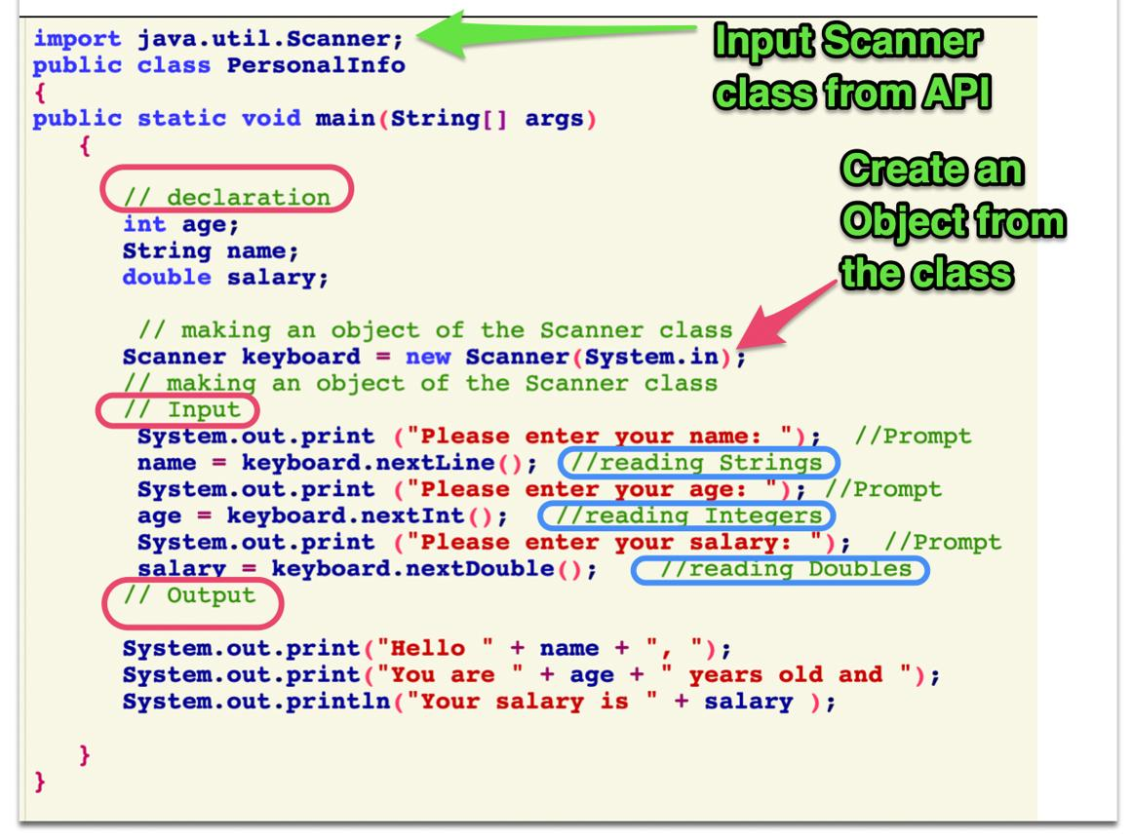
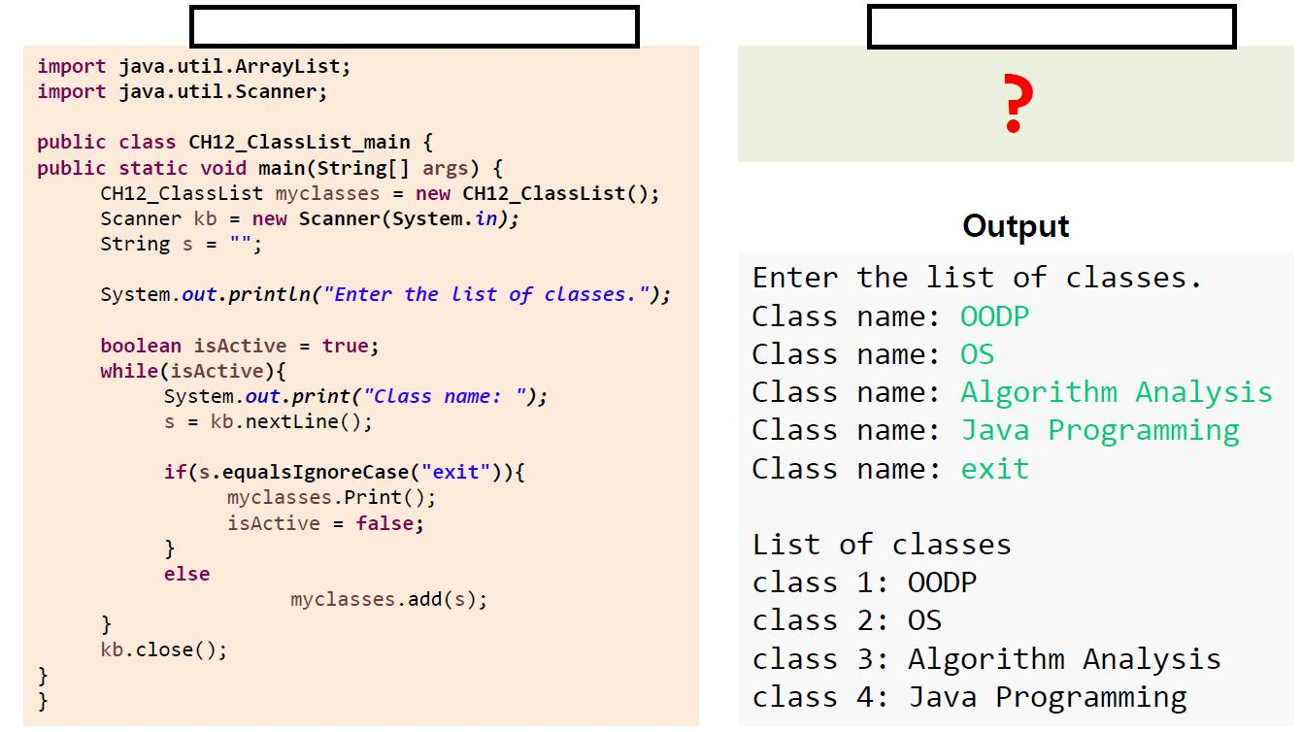
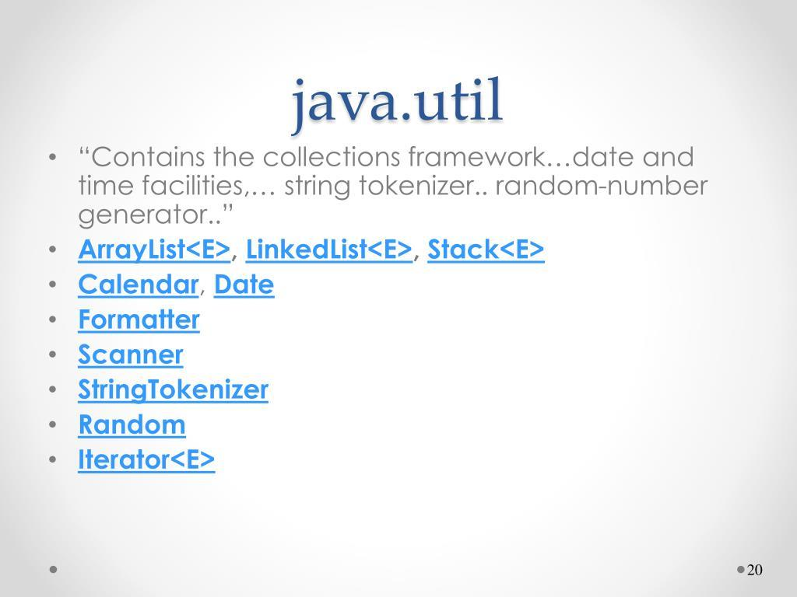
6

12.21 java.io Package
Definition
The java.io package provides classes and interfaces for input and output (I/O) operations.
It is commonly used for:
- Reading data
- Writing data
- Reading files
- Writing files
- Working with streams
I/O means:
Input / Output

12.22 Input and Output Concept
Java Program
│
┌─────────┴─────────┐
↓ ↓
INPUT OUTPUT
│ │
↓ ↓
Keyboard/File Screen/File
For example:
Keyboard → Java Program → Screen

12.23 Important java.io Classes
Class | Main Use
File | Represents file/directory information
FileReader | Reads character data from a file
FileWriter | Writes character data to a file
BufferedReader | Efficiently reads text
BufferedWriter | Efficiently writes text
PrintWriter | Convenient text output

12.24 File Class
The File class represents a file or directory pathname.
Example:
import java.io.File;

public class Main
{
public static void main(String[] args)
{
File file = new File("students.txt");

System.out.println(file.getName());
}
}
Output:
students.txt
The File class can also be used to obtain information about files.

12.25 FileWriter
FileWriter can be used to write character data to a file.
Example:
import java.io.FileWriter;
import java.io.IOException;

public class Main
{
public static void main(String[] args)
{
try
{
FileWriter fw = new FileWriter("students.txt");

fw.write("Rahul");
fw.close();

System.out.println("Data written successfully.");
}
catch (IOException e)
{
System.out.println("An error occurred.");
}
}
}
Output
Data written successfully.
A file named:
students.txt
can contain:
Rahul

12.26 FileReader
FileReader can be used to read character data from a file.
Example:
import java.io.FileReader;
import java.io.IOException;

public class Main
{
public static void main(String[] args)
{
try
{
FileReader fr = new FileReader("students.txt");

int ch;

while ((ch = fr.read()) != -1)
{
System.out.print((char) ch);
}

fr.close();
}
catch (IOException e)
{
System.out.println("Error reading file.");
}
}
}
If the file contains:
Rahul
the program displays:
Rahul

12.27 BufferedReader
BufferedReader provides efficient character-input reading.
Example:
import java.io.BufferedReader;
import java.io.FileReader;
import java.io.IOException;

public class Main
{
public static void main(String[] args)
{
try
{
BufferedReader br =
new BufferedReader(new FileReader("students.txt"));

String line = br.readLine();

System.out.println(line);

br.close();
}
catch (IOException e)
{
System.out.println("Error reading file.");
}
}
}

12.28 java.io Concept Diagram
java.io
│
┌──────────────┼───────────────┐
↓ ↓ ↓
File FileReader FileWriter
│ │ │
File details Read Write
│ │
↓ ↓
BufferedReader BufferedWriter
│ │
└───────┬───────┘
↓
Input / Output
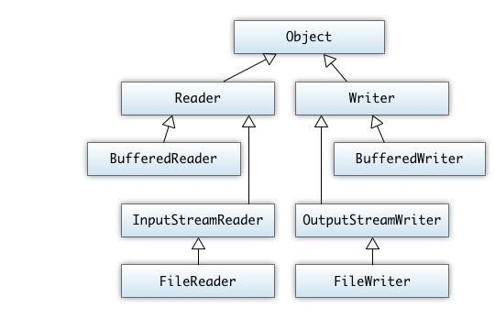
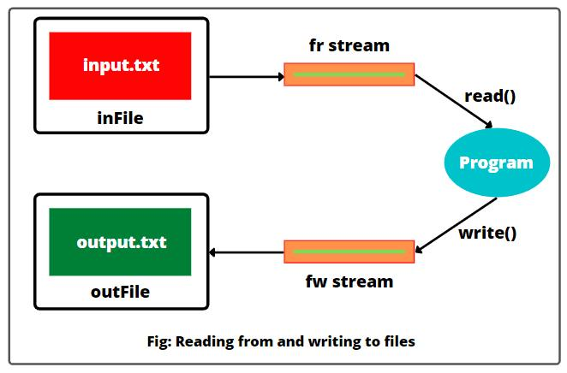
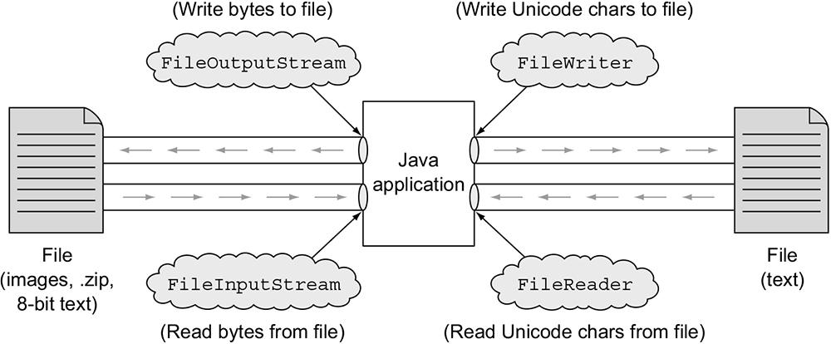
5

12.29 java.lang vs java.util vs java.io
Package | Main Purpose | Examples
java.lang | Basic/core Java functionality | String, Math, System, Integer
java.util | Utility classes and collections | Scanner, ArrayList, Random, Arrays
java.io | Input/output and file operations | File, FileReader, FileWriter, BufferedReader
Easy Way to Remember
java.lang → Language basics
java.util → Utilities
java.io → Input / Output

12.30 Import Statement
An import statement allows a Java program to use classes from another package without writing their complete package name every time.
Syntax
import package_name.ClassName;
Example
import java.util.Scanner;
Now we can write:
Scanner sc = new Scanner(System.in);
instead of:
java.util.Scanner sc =
new java.util.Scanner(System.in);

12.31 Importing Multiple Classes
We can import multiple classes individually:
import java.util.Scanner;
import java.util.ArrayList;
import java.util.Random;
Or use a wildcard:
import java.util.*;
This makes classes in java.util available by simple name.
Note: Importing a package does not recursively import its subpackages.

12.32 Packages and Classes – Diagram
Java API
│
┌────────────────┼────────────────┐
↓ ↓ ↓
java.lang java.util java.io
│ │ │
┌───┼───┐ ┌───┼────┐ ┌───┼────────┐
↓ ↓ ↓ ↓ ↓ ↓ ↓ ↓ ↓
String Math System Scanner ArrayList Random File Reader Writer

12.33 Example Using Multiple Libraries
The following program uses classes from different packages:
import java.util.Scanner;
import java.io.File;

public class Main
{
public static void main(String[] args)
{
Scanner sc = new Scanner(System.in);

System.out.print("Enter your name: ");
String name = sc.nextLine();

File file = new File("students.txt");

System.out.println("Name: " + name);
System.out.println("File: " + file.getName());
}
}
Here:
Class | Package
String | java.lang
System | java.lang
Scanner | java.util
File | java.io

12.34 Library Usage in NetBeans
In NetBeans, Java libraries can be used directly by importing the required classes.
Typical workflow:
Create Java Project
↓
Create Java Class
↓
Write import statement
↓
Create object / call static method
↓
Write program
↓
Run program
Example
import java.util.Scanner;
Then:
Scanner sc = new Scanner(System.in);
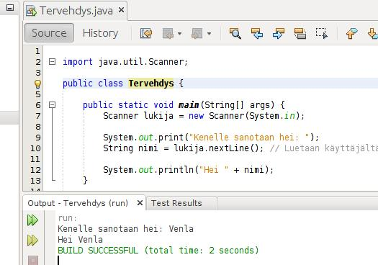
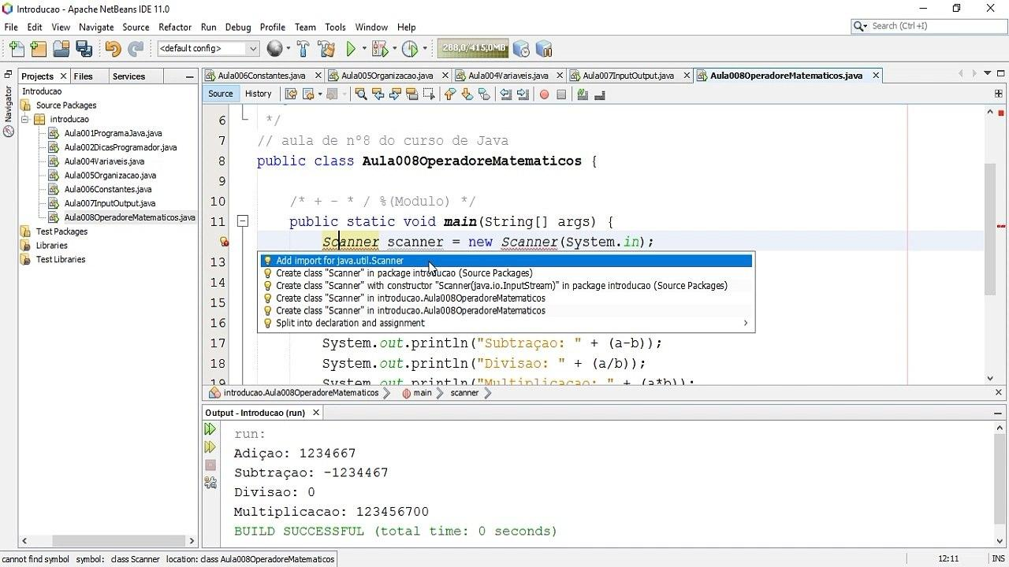
Screenshot note: The NetBeans interface can look different depending on the version and operating system.

12.35 Common Library Classes – Quick Reference
Package | Class | Use
java.lang | String | Text processing
java.lang | Math | Mathematical operations
java.lang | System | Standard input/output and system operations
java.lang | Integer | Operations involving int wrapper objects
java.util | Scanner | Keyboard/input reading
java.util | ArrayList | Resizable list
java.util | Random | Pseudo-random values
java.util | Arrays | Array utility methods
java.io | File | File/directory pathname information
java.io | FileReader | Reading character files
java.io | FileWriter | Writing character files
java.io | BufferedReader | Buffered text input

12.36 Important Difference: Library, Package and Class
Students often confuse these three terms.
Library
A collection of reusable programming functionality.
Package
A group/namespace containing related Java classes and interfaces.
Class
A blueprint containing fields, methods, constructors and other members.
Java Library / API
↓
Package
↓
Class
↓
Methods
Example
Java API
↓
java.util
↓
Scanner
↓
nextInt()
nextLine()
nextDouble()

12.37 Important Points to Remember
- Java libraries provide pre-written reusable functionality.
- Java's standard libraries are available through the Java API.
- A package groups related classes and interfaces.
- java.lang contains fundamental classes.
- java.lang is automatically available to Java programs.
- String, Math and System are important java.lang classes.
- java.util provides utility classes and collection-related functionality.
- Scanner belongs to java.util.
- ArrayList belongs to java.util.
- Random belongs to java.util.
- Arrays belongs to java.util.
- java.io provides input/output and file-related classes.
- FileReader reads character data from a file.
- FileWriter writes character data to a file.
- An import statement allows a class to be referred to by its simple name.
- Libraries improve code reuse, development speed, reliability and productivity.

12.38 Quick Revision Table
Package | Remember As | Important Examples
java.lang | Core Java language functionality | String, Math, System
java.util | Utilities and collections | Scanner, ArrayList, Random, Arrays
java.io | Input/Output | File, FileReader, FileWriter, BufferedReader
Memory Trick
LANG → Language basics
UTIL → Utilities
IO → Input/Output

12.39 Practice Questions
A. Very Short Answer
- What is a Java library?
- What is Java API?
- What is a package?
- Name three Java packages.
- Which package contains the Scanner class?
- Which package contains the Math class?
- Which package contains FileReader?
- Why is java.lang special?
- What is the purpose of an import statement?
- Name two classes from java.io.

B. Short Answer
- Define Java libraries and explain their benefits.
- Explain the difference between a library, package and class.
- Explain the java.lang package with examples.
- Explain the java.util package with examples.
- Explain the java.io package with examples.
- What is the purpose of the Scanner class?
- Explain the difference between FileReader and FileWriter.
- Why do we use the import statement?
- Explain ArrayList with a suitable example.
- Write a short note on the Java API.

C. Programming Questions
Q1. Scanner
Write a Java program using Scanner to accept a student's name and age and display them.
Q2. Math
Write a Java program to calculate the square root and power of two numbers using the Math class.
Q3. ArrayList
Write a Java program to create an ArrayList of five student names and display them.
Q4. FileWriter
Write a Java program using FileWriter to write student information into a text file.
Q5. FileReader
Write a Java program using FileReader to read and display the contents of a text file.
Q6. Multiple Libraries
Write a Java program that uses:
java.lang
java.util
java.io
and identify which class belongs to each package.

⭐ Final Concept Map
JAVA LIBRARIES
│
Java API
│
┌─────────────────────┼─────────────────────┐
│ │ │
↓ ↓ ↓
java.lang java.util java.io
│ │ │
↓ ↓ ↓
Core functionality Utilities Input/Output
│ │ │
┌────┼────┐ ┌─────┼─────┐ ┌─────┼──────┐
↓ ↓ ↓ ↓ ↓ ↓ ↓ ↓ ↓
String Math System Scanner ArrayList Random File Reader Writer
Exam-ready summary: Java libraries are collections of pre-written reusable classes and methods. The java.lang package provides core language functionality, java.util provides utility and collection classes, and java.io provides input/output and file-handling functionality. Libraries save development time, promote code reuse, and make Java programming easier and more efficient.
12.1 Data input(meaning, java.uitl.Scanner, java.io.BuffeReader, syntaxes, examples) Scanner vs BufferReader 12.2 Array Manipulation- java.utilArrays, Sorting Arrays. 12.3 Strings- charAt(), Concatenate- concat(), contains(), endsWith(), equals(), equalsIgnoreCase(), indexOf() (string, character), isEmpty(), legth(), replace(), toLowerCase(), toUpperCase(). (write definition, syntax, with proper example)
Unit 4: Java Programming with NetBeans
Content 12: Java Libraries — Data Input, Array Manipulation & Strings
Class 12 CBSE Information Technology (402)
This section covers 12.1 Data Input, 12.2 Array Manipulation, and 12.3 Strings with definitions, syntax, examples, outputs, comparison tables, and diagrams.

12.1 Data Input
12.1.1 Meaning of Data Input
Data input means taking information from the user while a Java program is running.
For example, if a program asks the user to enter their name, age, marks, or salary, the values entered by the user are called input data.
Java provides several classes for accepting input. Two commonly used classes are:
- Scanner — from java.util package
- BufferedReader — from java.io package
Data Input Flow
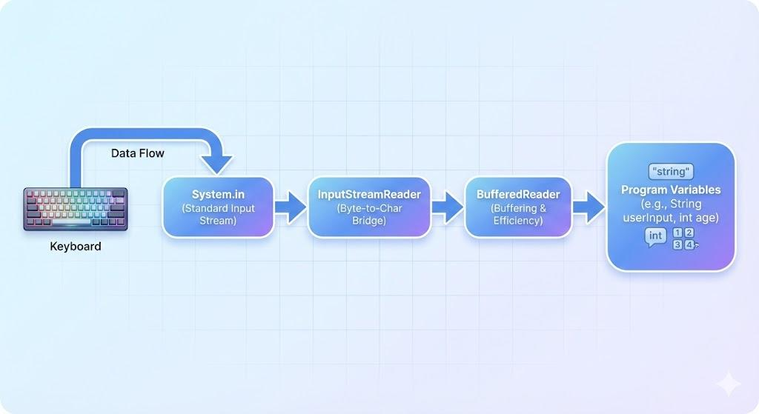
5
USER
│
│ enters data
▼
┌───────────────────┐
│ Input Method │
│ Scanner / │
│ BufferedReader │
└─────────┬─────────┘
│
▼
Java Program
│
▼
Processing
│
▼
Output

12.1.2 java.util.Scanner
Definition
Scanner is a predefined Java class used to read input from various sources, especially from the keyboard.
It belongs to the java.util package.
Import Statement
import java.util.Scanner;
Creating a Scanner Object
Scanner sc = new Scanner(System.in);
Here:
- Scanner → class name
- sc → object/reference variable
- System.in → standard input stream, normally the keyboard

Syntax
Scanner objectName = new Scanner(System.in);
For example:
Scanner sc = new Scanner(System.in);

Common Scanner Methods
Method | Used for
nextInt() | Reading an integer
nextFloat() | Reading a float
nextDouble() | Reading a double
nextLong() | Reading a long integer
next() | Reading one word
nextLine() | Reading a complete line
nextBoolean() | Reading true or false
nextShort() | Reading a short integer
nextByte() | Reading a byte

Example 1: Taking Integer Input
import java.util.Scanner;

public class InputDemo {
public static void main(String[] args) {

Scanner sc = new Scanner(System.in);

System.out.print("Enter your age: ");
int age = sc.nextInt();

System.out.println("Your age is: " + age);
}
}
Output
Enter your age: 17
Your age is: 17

Example 2: Taking String Input
import java.util.Scanner;

public class NameDemo {
public static void main(String[] args) {

Scanner sc = new Scanner(System.in);

System.out.print("Enter your name: ");
String name = sc.nextLine();

System.out.println("Hello " + name);
}
}
Output
Enter your name: Rahul
Hello Rahul

12.1.3 java.io.BufferedReader
Definition
BufferedReader is a Java class used to read text efficiently from an input stream.
It belongs to the java.io package.
Usually, BufferedReader is used with InputStreamReader to read keyboard input.
Required Import Statements
import java.io.BufferedReader;
import java.io.InputStreamReader;

Syntax
BufferedReader br =
new BufferedReader(new InputStreamReader(System.in));
Here:
- BufferedReader → class
- br → object/reference
- InputStreamReader → converts byte stream into character stream
- System.in → keyboard input

Important Method
readLine()
readLine() reads a complete line of text.
Syntax
String variable = br.readLine();
Since readLine() returns a String, numeric input needs conversion.
For example:
int age = Integer.parseInt(br.readLine());

Example: BufferedReader
import java.io.BufferedReader;
import java.io.InputStreamReader;
import java.io.IOException;

public class BufferedInputDemo {
public static void main(String[] args) throws IOException {

BufferedReader br =
new BufferedReader(new InputStreamReader(System.in));

System.out.print("Enter your name: ");
String name = br.readLine();

System.out.print("Enter your age: ");
int age = Integer.parseInt(br.readLine());

System.out.println("Name: " + name);
System.out.println("Age: " + age);
}
}
Output
Enter your name: Rahul
Enter your age: 17
Name: Rahul
Age: 17

Converting BufferedReader Input
Because readLine() returns a String, conversion methods are commonly used.
Required Data Type | Conversion
int | Integer.parseInt()
long | Long.parseLong()
float | Float.parseFloat()
double | Double.parseDouble()
short | Short.parseShort()
byte | Byte.parseByte()
boolean | Boolean.parseBoolean()
Example
int marks = Integer.parseInt(br.readLine());

double salary = Double.parseDouble(br.readLine());

float percentage = Float.parseFloat(br.readLine());

12.1.4 Scanner vs BufferedReader
Feature | Scanner | BufferedReader
Package | java.util | java.io
Main purpose | Easy user input | Efficient character input
Numeric input | Directly supported | Requires conversion
String input | next() / nextLine() | readLine()
Ease of use | Easier for beginners | Slightly more complex
Parsing | Built-in methods | Manual conversion usually required
Example | sc.nextInt() | Integer.parseInt(br.readLine())
Exception | Usually does not require checked exception for keyboard input | IOException may need handling
Speed | Generally slower | Generally faster for large text input
Best suited for | Beginner programs and simple input | Large text input / efficient reading
Simple Comparison
Scanner
│
├── Easy to use
├── nextInt()
├── nextDouble()
└── nextLine()

BufferedReader
│
├── Efficient text reading
├── readLine()
└── Numeric conversion required
Exam Point
Scanner is generally easier to use, while BufferedReader is generally preferred when efficient reading of large amounts of text is required.

12.2 Array Manipulation — java.util.Arrays
12.2.1 Meaning of Array Manipulation
Array manipulation means performing different operations on the elements of an array, such as:
- Sorting
- Searching
- Comparing
- Filling
- Copying
- Converting an array into a string
Java provides the Arrays class for performing many such operations.
The Arrays class belongs to:
java.util
Import
import java.util.Arrays;
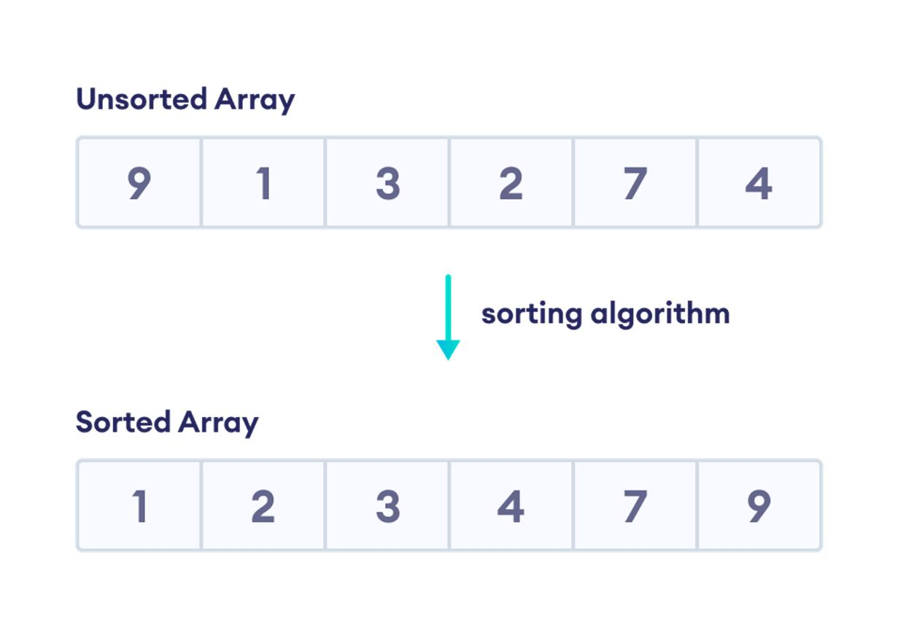
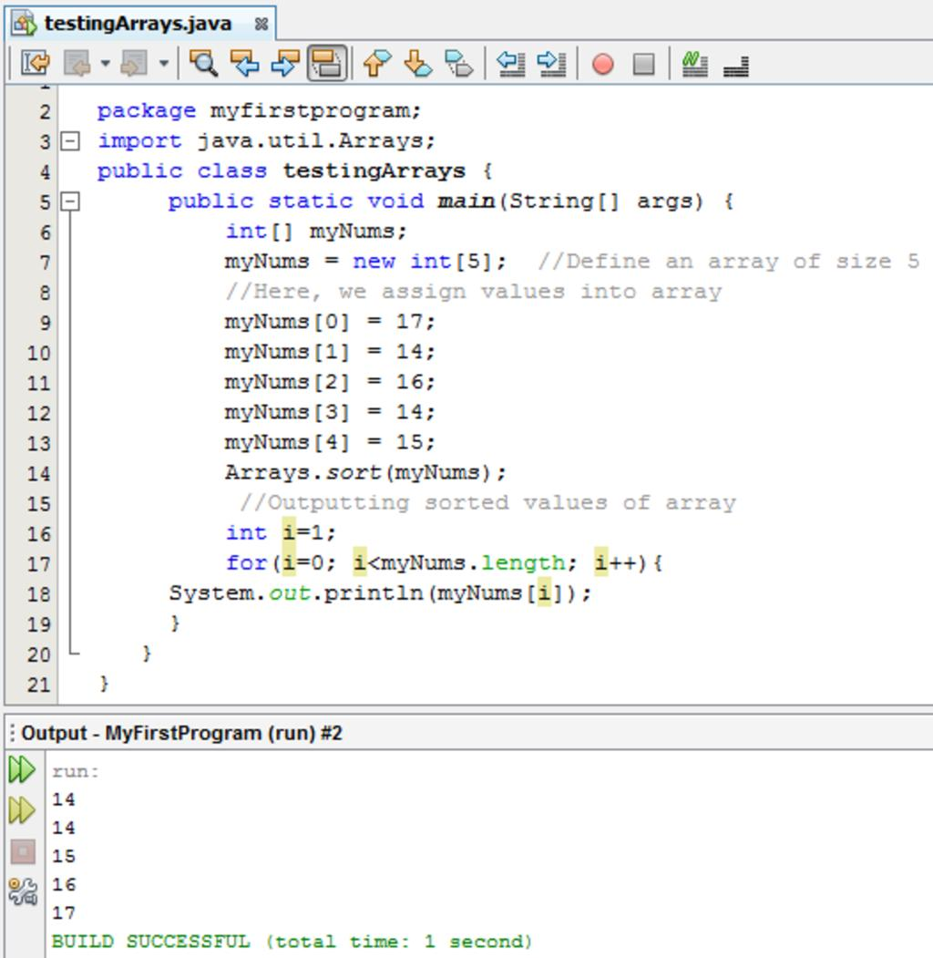
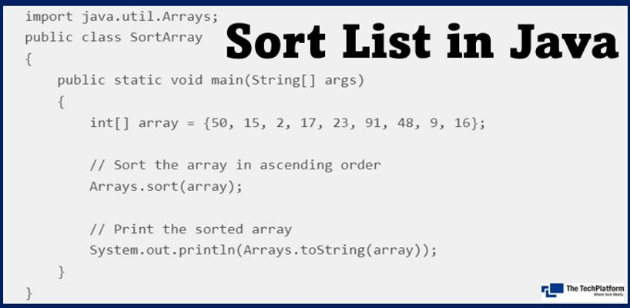

12.2.2 Arrays.sort()
Definition
Arrays.sort() is a method used to arrange the elements of an array in ascending order.
Syntax
Arrays.sort(arrayName);

Example
import java.util.Arrays;

public class ArraySortDemo {
public static void main(String[] args) {

int[] marks = {75, 42, 89, 56, 63};

System.out.println("Before sorting:");
System.out.println(Arrays.toString(marks));

Arrays.sort(marks);

System.out.println("After sorting:");
System.out.println(Arrays.toString(marks));
}
}
Output
Before sorting:
[75, 42, 89, 56, 63]

After sorting:
[42, 56, 63, 75, 89]

How Sorting Works Conceptually
Before Sorting

75 42 89 56 63
│ │ │ │ │
└────┴────┴────┴────┘
│
▼
Arrays.sort()
│
▼
42 56 63 75 89

After Sorting

12.2.3 Other Useful Arrays Methods
Method | Purpose | Example
Arrays.sort() | Sorts an array | Arrays.sort(a);
Arrays.toString() | Displays array contents | Arrays.toString(a)
Arrays.equals() | Compares two arrays | Arrays.equals(a,b)
Arrays.fill() | Fills array with a value | Arrays.fill(a, 0);
Arrays.copyOf() | Copies an array | Arrays.copyOf(a, 5)
Arrays.binarySearch() | Searches sorted array | Arrays.binarySearch(a, 50)

Example: Sorting a String Array
import java.util.Arrays;

public class StringSortDemo {
public static void main(String[] args) {

String[] names = {"Rahul", "Amit", "John", "David"};

Arrays.sort(names);

System.out.println(Arrays.toString(names));
}
}
Output
[Amit, David, John, Rahul]
Note: For String arrays, sorting is based on the natural ordering of strings.

12.3 Strings
12.3.1 Meaning of String
A String is a sequence of characters.
For example:
String name = "Rahul";
Here:
R a h u l
0 1 2 3 4
The position of the first character is 0. This is called zero-based indexing.
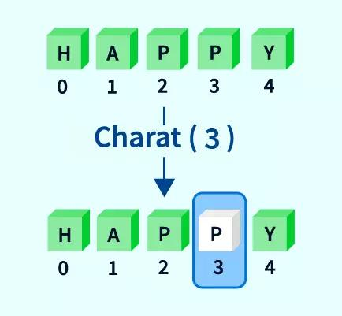
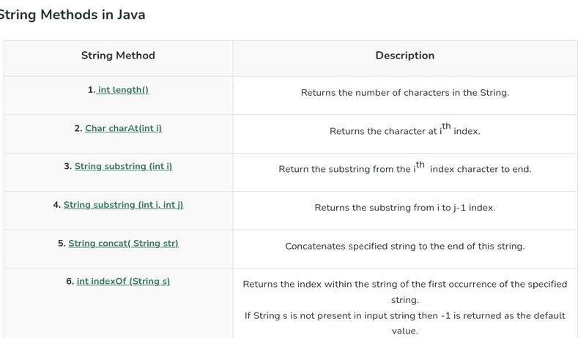
5

12.3.2 String Methods
Java provides many predefined methods for manipulating strings.
The following methods are important:
- charAt()
- concat()
- contains()
- endsWith()
- equals()
- equalsIgnoreCase()
- indexOf()
- isEmpty()
- length()
- replace()
- toLowerCase()
- toUpperCase()

1. charAt()
Definition
charAt() returns the character present at a specified index of a string.
Syntax
stringName.charAt(index);
Example
String name = "Rahul";

char ch = name.charAt(2);

System.out.println(ch);
Output
h
Because:
String: R a h u l
Index : 0 1 2 3 4
↑
'h'

2. concat()
Definition
concat() joins one string with another string.
Syntax
string1.concat(string2);
Example
String firstName = "Rahul";
String lastName = "Sharma";

String fullName = firstName.concat(" ").concat(lastName);

System.out.println(fullName);
Output
Rahul Sharma
Another Method
String concatenation can also be performed using +.
String fullName = firstName + " " + lastName;

3. contains()
Definition
contains() checks whether a specified sequence of characters exists inside a string.
It returns a boolean value:
- true → found
- false → not found
Syntax
stringName.contains("sequence");
Example
String message = "Welcome to Java";

System.out.println(message.contains("Java"));
System.out.println(message.contains("Python"));
Output
true
false

4. endsWith()
Definition
endsWith() checks whether a string ends with a specified suffix.
It returns true or false.
Syntax
stringName.endsWith("suffix");
Example
String fileName = "student.java";

System.out.println(fileName.endsWith(".java"));
System.out.println(fileName.endsWith(".txt"));
Output
true
false

5. equals()
Definition
equals() compares two strings based on their contents.
It returns:
- true → contents are exactly the same
- false → contents are different
Syntax
string1.equals(string2);
Example
String a = "Java";
String b = "Java";

System.out.println(a.equals(b));
Output
true
Important
equals() is case-sensitive.
String a = "Java";
String b = "java";

System.out.println(a.equals(b));
Output:
false

6. equalsIgnoreCase()
Definition
equalsIgnoreCase() compares two strings without considering differences in uppercase and lowercase letters.
Syntax
string1.equalsIgnoreCase(string2);
Example
String a = "Java";
String b = "java";

System.out.println(a.equalsIgnoreCase(b));
Output
true
Difference
equals()
↓
Case-sensitive

"Java" ≠ "java"

equalsIgnoreCase()
↓
Case-insensitive

"Java" = "java"

7. indexOf()
Definition
indexOf() returns the index of the first occurrence of a specified character or string.
If the character or string is not found, it returns:
-1

Syntax — Character
stringName.indexOf('character');
Example
String name = "Rahul";

System.out.println(name.indexOf('h'));
Output
2

Syntax — String
stringName.indexOf("string");
Example
String message = "Welcome to Java";

System.out.println(message.indexOf("Java"));
Output
12

Example: Character Not Found
String name = "Rahul";

System.out.println(name.indexOf('z'));
Output
-1

8. isEmpty()
Definition
isEmpty() checks whether a string contains zero characters.
It returns:
- true → string length is 0
- false → string contains one or more characters
Syntax
stringName.isEmpty();
Example
String name = "";

System.out.println(name.isEmpty());
Output
true
Another Example
String name = "Rahul";

System.out.println(name.isEmpty());
Output:
false
Note: A string containing spaces is not empty.
String name = " ";

System.out.println(name.isEmpty());
Output:
false

9. length()
Definition
length() returns the total number of characters in a string.
Syntax
stringName.length();
Example
String name = "Rahul";

System.out.println(name.length());
Output
5
Important
String indexing starts from 0, but length() counts the number of characters.
R a h u l
0 1 2 3 4

length = 5
Common mistake: For a String, use length() with parentheses.
For an array, use the length property without parentheses.
String name = "Rahul";
System.out.println(name.length());
int[] marks = {80, 90, 75};
System.out.println(marks.length);

10. replace()
Definition
replace() replaces occurrences of a specified character or sequence of characters with another character or sequence.
Syntax — Character
stringName.replace(oldChar, newChar);
Example
String word = "banana";

String result = word.replace('a', 'o');

System.out.println(result);
Output
bonono

Syntax — String Sequence
stringName.replace("old", "new");
Example
String message = "I like Java";

String result = message.replace("Java", "Python");

System.out.println(result);
Output
I like Python

11. toLowerCase()
Definition
toLowerCase() converts all letters in a string to lowercase.
Syntax
stringName.toLowerCase();
Example
String name = "WELCOME TO JAVA";

System.out.println(name.toLowerCase());
Output
welcome to java

12. toUpperCase()
Definition
toUpperCase() converts all letters in a string to uppercase.
Syntax
stringName.toUpperCase();
Example
String name = "welcome to java";

System.out.println(name.toUpperCase());
Output
WELCOME TO JAVA

12.3.3 Quick Reference — String Methods
Method | Definition | Return Type | Example
charAt() | Returns character at specified index | char | s.charAt(2)
concat() | Joins two strings | String | s.concat("Java")
contains() | Checks whether sequence exists | boolean | s.contains("Java")
endsWith() | Checks ending of string | boolean | s.endsWith(".txt")
equals() | Compares string contents | boolean | a.equals(b)
equalsIgnoreCase() | Compares ignoring case | boolean | a.equalsIgnoreCase(b)
indexOf() | Finds first occurrence | int | s.indexOf('a')
isEmpty() | Checks whether string has zero characters | boolean | s.isEmpty()
length() | Returns number of characters | int | s.length()
replace() | Replaces characters/sequence | String | s.replace("A","B")
toLowerCase() | Converts to lowercase | String | s.toLowerCase()
toUpperCase() | Converts to uppercase | String | s.toUpperCase()

12.3.4 Complete String Methods Example
The following program demonstrates several methods together:
public class StringMethodsDemo {
public static void main(String[] args) {

String text = "Welcome to Java";

System.out.println("Character: " + text.charAt(3));

System.out.println("Concatenate: "
+ text.concat(" Programming"));

System.out.println("Contains Java: "
+ text.contains("Java"));

System.out.println("Ends with Java: "
+ text.endsWith("Java"));

System.out.println("Equals: "
+ text.equals("Welcome to Java"));

System.out.println("Equals Ignore Case: "
+ text.equalsIgnoreCase("WELCOME TO JAVA"));

System.out.println("Index of Java: "
+ text.indexOf("Java"));

System.out.println("Is Empty: "
+ text.isEmpty());

System.out.println("Length: "
+ text.length());

System.out.println("Replace: "
+ text.replace("Java", "Python"));

System.out.println("Lowercase: "
+ text.toLowerCase());

System.out.println("Uppercase: "
+ text.toUpperCase());
}
}
Expected Output
Character: c
Concatenate: Welcome to Java Programming
Contains Java: true
Ends with Java: true
Equals: true
Equals Ignore Case: true
Index of Java: 12
Is Empty: false
Length: 15
Replace: Welcome to Python
Lowercase: welcome to java
Uppercase: WELCOME TO JAVA

⭐ Important Exam Points
- Scanner belongs to java.util.
- BufferedReader belongs to java.io.
- Scanner can directly read different data types using methods such as nextInt().
- BufferedReader.readLine() returns a String.
- Numeric data read using BufferedReader generally needs conversion such as Integer.parseInt().
- Arrays.sort() sorts array elements in ascending order.
- String indexing starts from 0.
- charAt() returns a character.
- indexOf() returns -1 when the specified character/string is not found.
- equals() is case-sensitive.
- equalsIgnoreCase() ignores uppercase/lowercase differences.
- isEmpty() checks whether the string has zero characters.
- length() returns the number of characters in a String.
- String.length() uses parentheses, while array.length does not.
- String methods generally return a new String rather than changing the original String because Java Strings are immutable.

Content 13: Database Connectivity
13. Database Connectivity
Database Connectivity means connecting a Java program to a database so that the program can store, retrieve, update and delete data.
Java uses JDBC (Java Database Connectivity) to communicate with databases such as MySQL.
Important correction: The supplied material says “ZDBC” in one place. The correct term is JDBC — Java Database Connectivity.
JDBC and MySQL
JDBC is a Java API that provides classes and interfaces for communicating with databases. MySQL Connector/J is the JDBC driver that allows Java applications to communicate with a MySQL server.
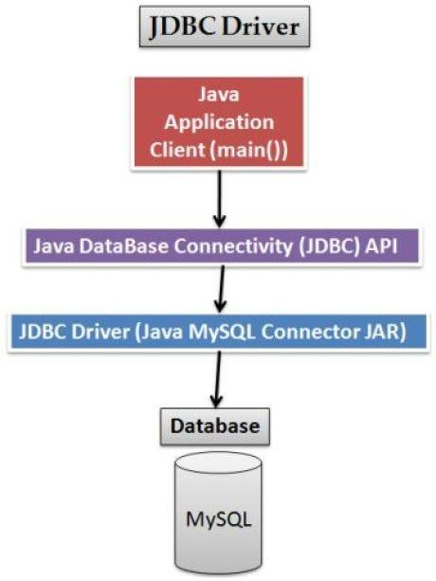
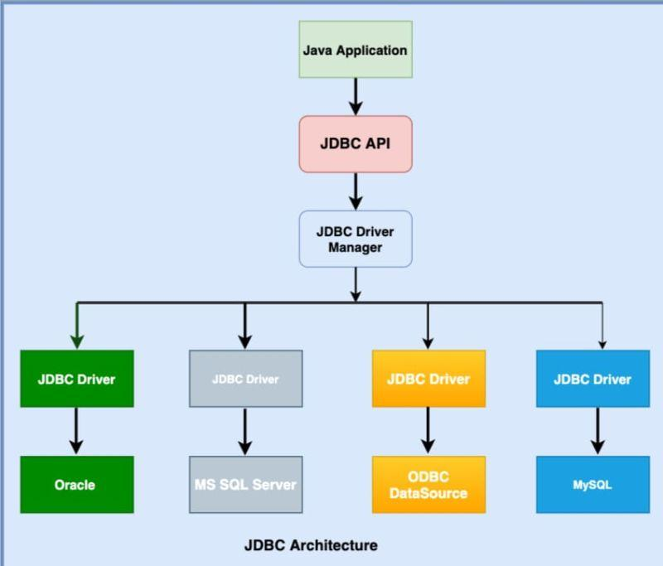
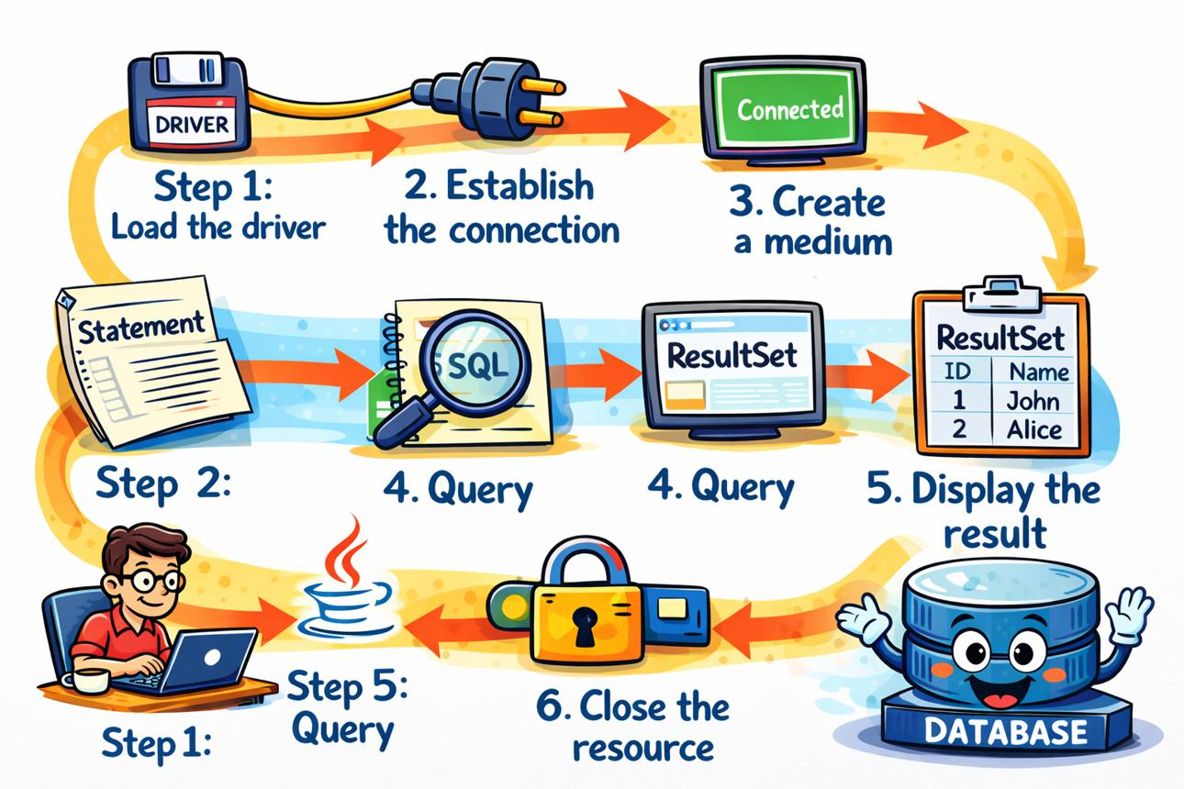
4
JDBC Connectivity Diagram
┌──────────────────────┐
│ Java Program │
│ (.java file) │
└──────────┬───────────┘
│
│ JDBC API
▼
┌──────────────────────┐
│ JDBC Driver │
│ MySQL Connector/J │
└──────────┬───────────┘
│
│ JDBC Protocol
▼
┌──────────────────────┐
│ MySQL Server │
│ Port: 3306 │
└──────────┬───────────┘
│
▼
┌──────────────────────┐
│ Database │
│ Tables & Records │
└──────────────────────┘
Main JDBC Components
Component | Purpose
JDBC API | Provides Java classes and interfaces for database programming
DriverManager | Manages JDBC drivers and helps establish connections
Connection | Represents a connection between Java and the database
Statement | Used to execute SQL statements
ResultSet | Stores the result returned by a SELECT query
SQLException | Handles database-related errors
MySQL Connector/J | JDBC driver used to communicate with MySQL

13.1 Setting Up MySQL Server in NetBeans
NetBeans provides a Services window through which a MySQL server can be registered and connected. The standard MySQL setup uses localhost and port 3306 by default.
Steps to Register MySQL Server
Step 1: Open NetBeans IDE.
Step 2: Open the Services tab.
Step 3: Expand Databases.
Step 4: Right-click Databases and select:
Register MySQL Server...
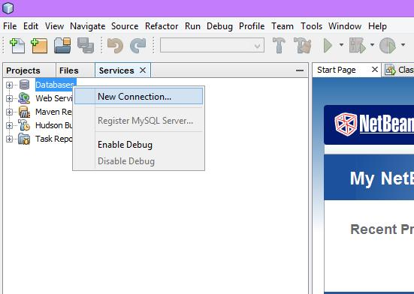
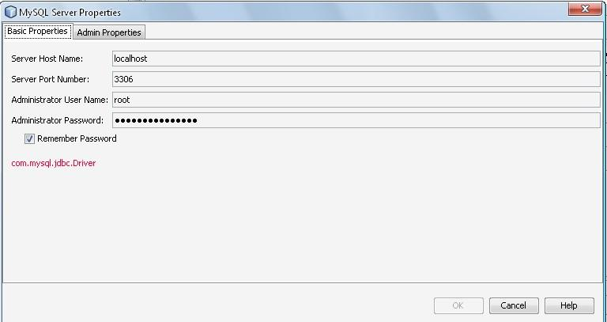
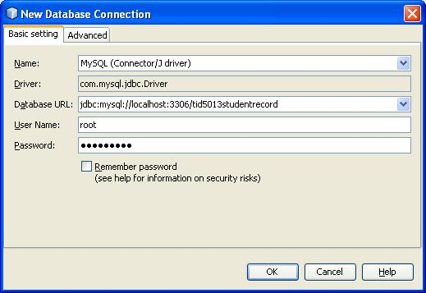
Step 5: The MySQL Server Properties window appears.
Enter the required details:
- Server Host Name: localhost
- Server Port: 3306
- Administrator User Name: usually root
- Password: password configured during MySQL installation
NetBeans documentation notes that localhost and 3306 are normally entered as the default host and port.
Step 6: Connect to the Server
After registration, a MySQL server node appears under Databases.
For example:
Services
└── Databases
└── MySQL Server 3306 [root]
If it shows:
MySQL Server 3306 [root] (disconnected)
right-click the MySQL Server node and select Connect.
When successfully connected, the server can be expanded to view available databases.

13.2 Installing MySQL Connector/J
What is MySQL Connector/J?
MySQL Connector/J is the official JDBC driver for MySQL. It acts as a bridge between a Java program and a MySQL database server.
Java Application
│
│ JDBC
▼
MySQL Connector/J
│
▼
MySQL Database
Downloading Connector/J
The official download page is:
MySQL Connector/J Download
The current MySQL documentation provides Connector/J as a platform-independent ZIP/TAR archive and also supports installation through Maven.
Steps
- Open the official MySQL Connector/J download page.
- Download the appropriate Connector/J package.
- Extract the downloaded ZIP file.
- Locate the .jar file, for example:
mysql-connector-j-<version>.jar
Note: Do not write a fixed version such as mysql-connector-j-8.2.0.jar in permanent notes. Connector/J versions change over time. Use the version downloaded from the official MySQL website.

13.3 Adding MySQL Connector/J to a Java Project
After downloading Connector/J, the JAR file must be available to the Java project.
Steps in NetBeans
Step 1: Open the Projects tab.
Step 2: Right-click your Java project.
Step 3: Select Properties.
Step 4: Select Libraries.
Step 5: Click + / Add JAR/Folder.
Step 6: Browse to the location of:
mysql-connector-j-<version>.jar
Step 7: Select the JAR file and click Open.
Step 8: Click OK.
The MySQL Connector/J library will now appear under the project's libraries.
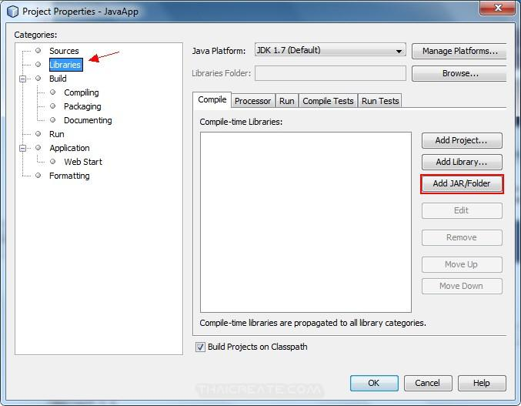
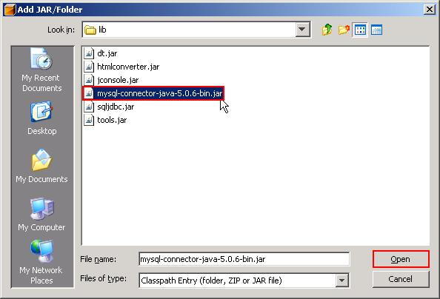
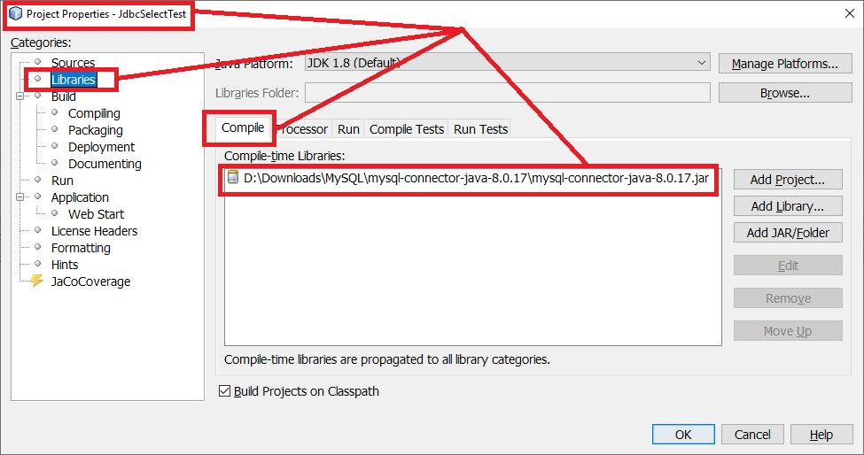
5
Important Note
The supplied material asks students to add Connector/J to the system CLASSPATH. For a NetBeans project, it is generally sufficient to add the Connector/J JAR to the project's Libraries/Class Path. MySQL documentation explains that a Connector/J JAR must be available on the Java classpath; NetBeans handles this when the JAR is added to the project.

13.4 How NetBeans Connects Java with MySQL
The basic process is:
Java Program
│
▼
Import java.sql.*
│
▼
Load/Use JDBC Driver
│
▼
Create Connection
│
▼
Create Statement
│
▼
Execute SQL Query
│
▼
ResultSet
│
▼
Process Records
│
▼
Close Resources
Basic Steps
- Import classes from java.sql package.
- Create a connection with the MySQL database.
- Handle database exceptions using try-catch.
- Create a Statement object.
- Execute the SQL query.
- Receive the result in a ResultSet.
- Process records using while and next().
- Close the connection and other resources.

13.5 Importing JDBC Classes
The java.sql package contains the important JDBC classes and interfaces.
Syntax
import java.sql.*;
This allows the program to use classes/interfaces such as:
Connection
DriverManager
Statement
ResultSet
SQLException

13.6 Establishing a Connection
The DriverManager class is used to establish a connection with a database.
General Syntax
Connection con = DriverManager.getConnection(
"jdbc:mysql://localhost:3306/database_name",
"username",
"password"
);
For example:
Connection con = DriverManager.getConnection(
"jdbc:mysql://localhost:3306/studentdb",
"root",
"password"
);
Here:
Part | Meaning
jdbc:mysql | Specifies JDBC communication with MySQL
localhost | MySQL server running on the same computer
3306 | Default MySQL port
studentdb | Name of the database
root | MySQL username
password | MySQL password
The general MySQL JDBC URL uses the jdbc:mysql: protocol followed by the host and database name.

13.7 Creating a Statement Object
A Statement object is used to send SQL commands to the database.
Syntax
Statement stmt = con.createStatement();
Here:
- con is the Connection object.
- stmt is the Statement object.

13.8 Executing a SQL Query
For a SELECT query, use the executeQuery() method.
Syntax
ResultSet rs = stmt.executeQuery("SELECT * FROM student");
The executeQuery() method returns a ResultSet containing the records returned by the query.

13.9 ResultSet
A ResultSet is an object that represents the data returned by a SQL SELECT query.
For example, suppose the database contains:
Roll_No | Name | Marks
101 | Rahul | 85
102 | Priya | 91
103 | Amit | 78
The query:
SELECT * FROM student;
returns these records in a ResultSet.
Processing ResultSet
The next() method moves the cursor to the next row.
while (rs.next()) {
System.out.println(rs.getInt("Roll_No"));
System.out.println(rs.getString("Name"));
System.out.println(rs.getInt("Marks"));
}
ResultSet Cursor Diagram
ResultSet

Cursor
↓
┌─────────┬──────────┬───────┐
│ Roll_No │ Name │ Marks │
├─────────┼──────────┼───────┤
│ 101 │ Rahul │ 85 │ ← Row 1
├─────────┼──────────┼───────┤
│ 102 │ Priya │ 91 │ ← Row 2
├─────────┼──────────┼───────┤
│ 103 │ Amit │ 78 │ ← Row 3
└─────────┴──────────┴───────┘
↓
rs.next()
↓
Next Row
The while(rs.next()) loop continues until there are no more rows.

13.10 Complete Java Program: Connect Java with MySQL
Example
Suppose:
- Database name = studentdb
- Table name = student
- Username = root
- Password = root123
import java.sql.*;

public class MySQLConnection {

public static void main(String[] args) {

try {
// Establish connection
Connection con = DriverManager.getConnection(
"jdbc:mysql://localhost:3306/studentdb",
"root",
"root123"
);

System.out.println("Database connected successfully.");

// Create Statement
Statement stmt = con.createStatement();

// Execute SQL query
ResultSet rs = stmt.executeQuery(
"SELECT * FROM student"
);

// Display records
while (rs.next()) {
System.out.println(
rs.getInt("Roll_No") + " " +
rs.getString("Name") + " " +
rs.getInt("Marks")
);
}

// Close connection
con.close();

} catch (SQLException e) {
System.out.println("Database Error: " + e.getMessage());
}
}
}
Expected Output
Database connected successfully.

101 Rahul 85
102 Priya 91
103 Amit 78

13.11 Understanding the Complete Program
1. Import JDBC package
import java.sql.*;
Provides the required JDBC classes and interfaces.
2. Use try block
try {
Database operations can generate exceptions, so they are placed inside a try block.
3. Establish connection
Connection con = DriverManager.getConnection(
"jdbc:mysql://localhost:3306/studentdb",
"root",
"root123"
);
Connects the Java program to the studentdb database.
4. Create Statement
Statement stmt = con.createStatement();
Creates a Statement object for executing SQL commands.
5. Execute query
ResultSet rs = stmt.executeQuery(
"SELECT * FROM student"
);
Executes the SQL SELECT command and stores the returned records in rs.
6. Read records
while (rs.next()) {
Moves through the records one row at a time.
7. Retrieve values
rs.getInt("Roll_No");
rs.getString("Name");
rs.getInt("Marks");
These methods retrieve values from the current row.
8. Close connection
con.close();
Closes the connection after database operations are completed.

13.12 Important JDBC Methods
Method | Purpose
DriverManager.getConnection() | Establishes database connection
createStatement() | Creates a Statement object
executeQuery() | Executes a SELECT query
executeUpdate() | Executes INSERT, UPDATE, DELETE, etc.
rs.next() | Moves ResultSet cursor to the next row
rs.getInt() | Retrieves an integer value
rs.getString() | Retrieves a string value
close() | Closes a database resource

13.13 executeQuery() vs executeUpdate()
executeQuery()
Used mainly for retrieving data using SELECT.
ResultSet rs = stmt.executeQuery(
"SELECT * FROM student"
);
It returns a ResultSet.
executeUpdate()
Used for operations such as:
INSERT
UPDATE
DELETE
Example:
int n = stmt.executeUpdate(
"UPDATE student SET Marks = 90 WHERE Roll_No = 101"
);
It returns the number of rows affected.
Comparison
executeQuery() | executeUpdate()
Mainly used with SELECT | Used with INSERT, UPDATE, DELETE
Returns ResultSet | Returns number of affected rows
Used to retrieve data | Used to modify data

13.14 Exception Handling in Database Connectivity
Database operations may produce errors such as:
- Incorrect username/password
- Database does not exist
- MySQL server is not running
- Wrong port number
- Incorrect SQL query
- JDBC driver is missing
- Incorrect table or column name
Therefore, database code should handle SQLException.
Syntax
try {
// Database code
}
catch (SQLException e) {
System.out.println(e.getMessage());
}

13.15 Complete Database Connectivity Flow
┌────────────────────────────┐
│ Start Java Program │
└─────────────┬──────────────┘
↓
┌────────────────────────────┐
│ Import java.sql.* │
└─────────────┬──────────────┘
↓
┌────────────────────────────┐
│ MySQL Connector/J available │
└─────────────┬──────────────┘
↓
┌────────────────────────────┐
│ DriverManager │
│ getConnection() │
└─────────────┬──────────────┘
↓
┌──────────────┐
│ Connection? │
└──────┬───────┘
Yes ↓
┌────────────────────────────┐
│ createStatement() │
└─────────────┬──────────────┘
↓
┌────────────────────────────┐
│ Execute SQL Query │
└─────────────┬──────────────┘
↓
┌──────────────┐
│ ResultSet │
└──────┬───────┘
↓
┌────────────────────────────┐
│ while(rs.next()) │
│ Process each record │
└─────────────┬──────────────┘
↓
┌────────────────────────────┐
│ Close Connection │
└─────────────┬──────────────┘
↓
END

13.16 Important Points to Remember
- JDBC stands for Java Database Connectivity.
- MySQL Connector/J is the JDBC driver for MySQL.
- JDBC allows Java applications to communicate with databases.
- java.sql.* contains important JDBC classes and interfaces.
- DriverManager is used to obtain a database connection.
- Connection represents the connection between Java and the database.
- Statement is used to execute SQL statements.
- executeQuery() is generally used for SELECT statements.
- executeUpdate() is generally used for INSERT, UPDATE and DELETE.
- ResultSet stores the result of a SELECT query.
- rs.next() moves the cursor to the next record.
- MySQL commonly uses port 3306.
- The JDBC URL for MySQL begins with jdbc:mysql:.
- Database-related errors are handled using SQLException.
- The database connection should be closed after use.
⚠️ Corrections to the original material
Original material | Correct form
ZDBC Connector | JDBC / MySQL Connector/J
Fixed mysql-connector-j-8.2.0 | Use the appropriate/current Connector/J version
Must always modify system CLASSPATH | In NetBeans, add the Connector/J JAR to the project Libraries/Class Path
MySQLadmin / MySQL command paths | These are version/installation-specific and are not required for the basic Java-to-MySQL JDBC program
Click on Service tab to Project tab | Use the Services tab for database/server management and Projects tab for project libraries
while which can a wild look | while(rs.next()) loop to iterate through ResultSet rows
The current MySQL documentation identifies Connector/J as the official MySQL JDBC driver and documents both its installation and JDBC URL format.
🖼️ Suggested screenshots to place in the printed notes
- NetBeans → Services → Databases → Register MySQL Server
- MySQL Server Properties window
- Connected MySQL Server in Services
- Project → Properties → Libraries → Add JAR/Folder
- MySQL Connector/J .jar file
- NetBeans project showing Connector/J under Libraries
- Java JDBC program in NetBeans
- MySQL database/table containing student records
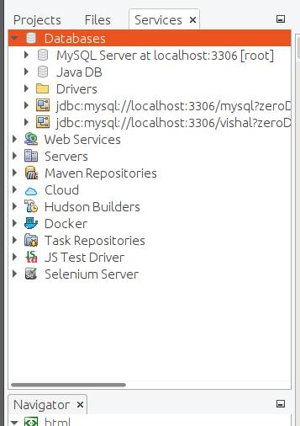
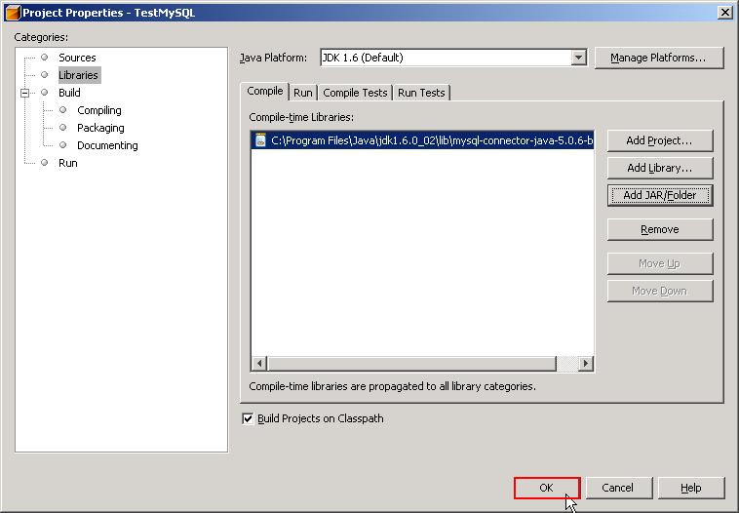
6
Official references for teacher preparation: MySQL Connector/J Documentation · Apache NetBeans — Connecting to MySQL Database

CONTENT 14: ASSERTIONS
14.1 What is an Assertion?
An assertion is a statement used to test whether a particular condition is true during program execution.
Assertions are mainly used for debugging and testing a Java program. If the condition given in an assertion is false, Java throws an AssertionError.
Syntax
assert booleanExpression;
Here:
- assert is a Java keyword.
- booleanExpression must produce either true or false.
- If the expression is true, execution continues normally.
- If the expression is false, an AssertionError is generated.
Example
int age = 20;

assert age >= 18;

System.out.println("Eligible");
Since age >= 18 is true, the program continues.
Example of a Failed Assertion
int age = 15;

assert age >= 18;

System.out.println("Eligible");
Here, age >= 18 is false, so an AssertionError occurs when assertions are enabled.

14.2 Assertion with a Message
Java also allows a message to be specified with an assertion.
Syntax
assert booleanExpression : message;
Example
int marks = 35;

assert marks >= 40 : "Marks are less than 40";

System.out.println("Pass");
If the assertion fails, the specified message can help identify the problem.
Assertion Flow Diagram
┌───────────────────┐
│ Evaluate condition│
└─────────┬─────────┘
↓
┌──────────────┐
│ Is it TRUE? │
└──────┬───────┘
Yes │ No
│
┌────────────┘ └──────────────┐
↓ ↓
┌──────────────────┐ ┌─────────────────┐
│ Continue program │ │ AssertionError │
└──────────────────┘ └─────────────────┘

14.3 Enabling Assertions
Assertions are disabled by default when a Java program runs normally.
To enable assertions from the command line, use:
java -ea ClassName
or:
java -enableassertions ClassName
For example:
java -ea TestAssertion
Important Point
Assertions are primarily intended for debugging and development, not for validating normal user input.
For example, this is not a good use of assertions:
assert age >= 18;
to enforce an age restriction on data entered by a user, because assertions may be disabled.

14.4 Example Program
public class TestAssertion {

public static void main(String[] args) {

int marks = 75;

assert marks >= 0 && marks <= 100 :
"Invalid marks";

System.out.println("Marks = " + marks);
}
}
Output
Marks = 75
If an invalid value is used
int marks = 150;
With assertions enabled, the assertion fails.

14.5 Advantages of Assertions
- Help detect programming errors.
- Useful during debugging.
- Make assumptions in a program explicit.
- Help identify unexpected program states.
- Can make testing easier.
Key Points
Assertion = A condition that the programmer expects to be true.
assert condition;

CONTENT 15: THREAD
15.1 What is a Thread?
A thread is a lightweight unit of execution within a program.
A Java program can have multiple threads running concurrently. This allows different tasks to be performed seemingly at the same time.
For example, a music application may:
- play music,
- download data,
- respond to user actions,
using different threads.
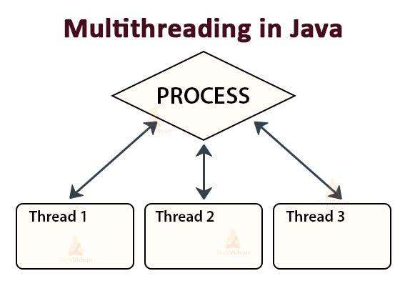
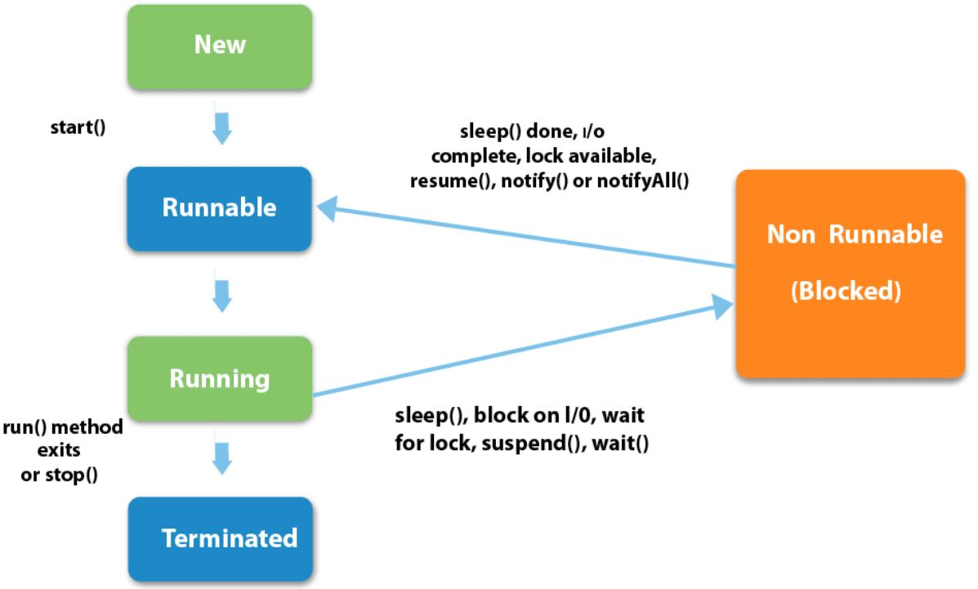
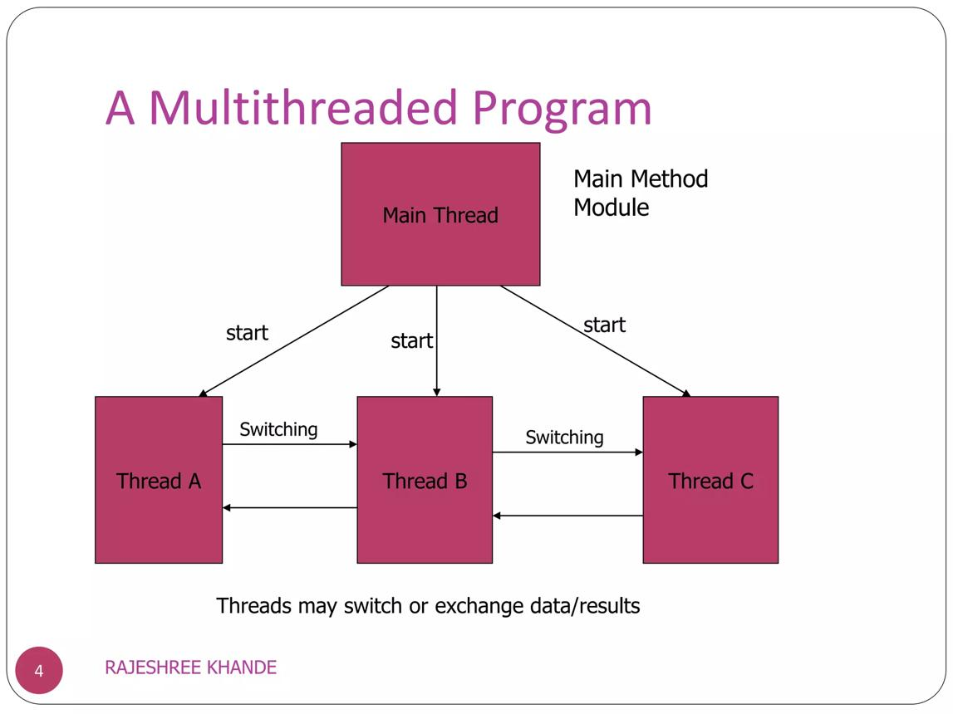
5

15.2 Process vs Thread
A process is a running program, whereas a thread is a smaller unit of execution within a process.
JAVA APPLICATION
│
┌───────────┼───────────┐
↓ ↓ ↓
Thread 1 Thread 2 Thread 3
│ │ │
Task A Task B Task C
Example
Suppose a web browser is running.
Browser Process
│
├── Thread 1 → Display webpage
├── Thread 2 → Download file
└── Thread 3 → Play audio

15.3 What is Multithreading?
Multithreading is the execution of multiple threads within a program.
It allows a program to perform multiple tasks concurrently.
Example
PROGRAM
│
┌─────────┼─────────┐
↓ ↓ ↓
Thread 1 Thread 2 Thread 3
Printing Reading Saving
Benefits of Multithreading
- Better utilization of CPU resources.
- Allows multiple tasks to execute concurrently.
- Can improve application responsiveness.
- Useful for games, servers, animations and GUI applications.
- Allows background tasks to run while the main program continues.

15.4 Thread Life Cycle
A thread can pass through different states during its lifetime.
A simplified lifecycle is:
┌─────────────┐
│ NEW │
└──────┬──────┘
│ start()
↓
┌─────────────┐
│ RUNNABLE │
└──────┬──────┘
│
↓
┌─────────────┐
│ RUNNING │
└──────┬──────┘
│
┌───────┼────────┐
↓ ↓ ↓
Waiting Blocked Sleep
│ │ │
└───────┴────────┘
│
↓
┌─────────────┐
│ TERMINATED │
└─────────────┘
Important Thread States
State | Meaning
NEW | Thread has been created but has not started
RUNNABLE | Thread is ready to run or running under the scheduler
BLOCKED | Thread is waiting to acquire a monitor lock
WAITING | Thread is waiting indefinitely for another thread
TIMED_WAITING | Thread is waiting for a specified period
TERMINATED | Thread has completed execution

15.5 Creating a Thread in Java
There are two common approaches for creating a thread:
Method 1
Extending the Thread class
Method 2
Implementing the Runnable interface

CONTENT 15.1: EXTENDING THE THREAD CLASS
15.1.1 Creating a Thread by Extending Thread
A class can be created by extending the built-in Java Thread class.
Syntax
class MyThread extends Thread {

public void run() {
// statements
}
}
The run() method contains the code that the thread executes.
Starting the Thread
MyThread t = new MyThread();
t.start();
The start() method starts a new thread and causes its run() method to execute.
Important: Normally, do not call run() directly when you want to start a new thread. Use start().

15.1.2 Example: Extending Thread Class
class MyThread extends Thread {

public void run() {

for (int i = 1; i <= 5; i++) {
System.out.println("Child Thread: " + i);
}
}
}

public class ThreadExample {

public static void main(String[] args) {

MyThread t = new MyThread();

t.start();

System.out.println("Main Thread");
}
}
Working
main()
│
├── creates MyThread object
│
├── t.start()
│ │
│ ↓
│ run() executes
│
└── main thread continues
Because the main thread and the newly started thread execute concurrently, the exact order of their output may vary.

15.1.3 start() vs run()
start() | run()
Starts a new thread | Executes like an ordinary method call if called directly
JVM schedules the new thread | Does not itself create a new thread
Calls run() as part of starting the thread | Contains the thread's task
Correct
t.start();
Not equivalent to starting a thread
t.run();

CONTENT 16: IMPLEMENTING THE Runnable INTERFACE
Another way to create a thread is by implementing the Runnable interface.
The Runnable interface contains the run() method.
Basic Syntax
class MyTask implements Runnable {

public void run() {
// statements
}
}
Then create a Thread object:
MyTask task = new MyTask();

Thread t = new Thread(task);

t.start();

16.1 Example Program
class MyTask implements Runnable {

public void run() {

for (int i = 1; i <= 5; i++) {
System.out.println("Runnable Thread: " + i);
}
}
}

public class RunnableExample {

public static void main(String[] args) {

MyTask task = new MyTask();

Thread t = new Thread(task);

t.start();

System.out.println("Main Thread");
}
}
Working Diagram
┌──────────────────────┐
│ MyTask │
│ implements Runnable │
└──────────┬───────────┘
│
│ object
↓
┌──────────────────────┐
│ Thread object │
│ new Thread(task) │
└──────────┬───────────┘
│
│ start()
↓
┌──────────────────────┐
│ run() method │
│ executes │
└──────────────────────┘

16.2 Extending Thread vs Implementing Runnable
Extending Thread | Implementing Runnable
Class extends Thread | Class implements Runnable
Thread behavior is placed in run() | Task is placed in run()
Create object of subclass | Create Runnable object and pass it to Thread
Cannot extend another class because Java supports single class inheritance | Class can extend another class while implementing Runnable
Simple for basic examples | Provides better separation between task and thread
Example
Extending Thread:
class A extends Thread {
public void run() {
System.out.println("Running");
}
}
Implementing Runnable:
class A implements Runnable {
public void run() {
System.out.println("Running");
}
}

CONTENT 17: WRAPPER CLASSES
Correction: The supplied word “Rapper classes” is a spelling error. The correct term is Wrapper Classes.
17.1 What are Wrapper Classes?
Java provides wrapper classes to represent primitive data types as objects.
Java has eight primitive data types:
byte
short
int
long
float
double
char
boolean
Each has a corresponding wrapper class.
Primitive → Wrapper
Primitive Data Type | Wrapper Class
byte | Byte
short | Short
int | Integer
long | Long
float | Float
double | Double
char | Character
boolean | Boolean
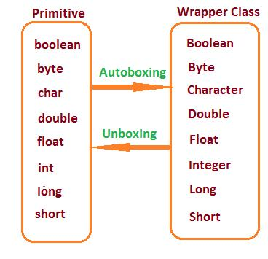
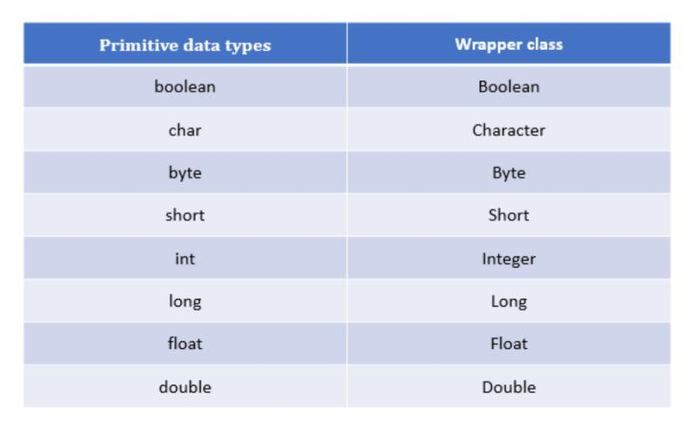
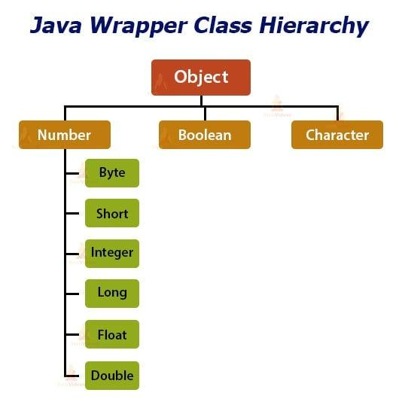
5

17.2 Why are Wrapper Classes Needed?
Primitive data types are not objects.
However, many Java APIs and collection classes work with objects.
For example, an ArrayList stores objects rather than primitive int values directly:
ArrayList<Integer> numbers;
Here, Integer is the wrapper class for int.

17.3 Autoboxing
Autoboxing is the automatic conversion of a primitive value into its corresponding wrapper object.
Example
int n = 10;

Integer obj = n;
Java automatically converts:
int → Integer
This is called autoboxing.
Diagram
Primitive Wrapper Object

int Integer
│ ▲
│ Autoboxing │
└─────────────────────────────┘
10

17.4 Unboxing
Unboxing is the automatic conversion of a wrapper object into its corresponding primitive value.
Example
Integer obj = 20;

int n = obj;
Java automatically converts:
Integer → int
This is called unboxing.
Diagram
Wrapper Object Primitive

Integer int
│ ▲
│ Unboxing │
└──────────────────────────┘
20

17.5 Autoboxing and Unboxing Example
public class WrapperExample {

public static void main(String[] args) {

int a = 10;

// Autoboxing
Integer obj = a;

// Unboxing
int b = obj;

System.out.println("Primitive value: " + a);
System.out.println("Wrapper object: " + obj);
System.out.println("Unboxed value: " + b);
}
}
Output
Primitive value: 10
Wrapper object: 10
Unboxed value: 10

17.6 Useful Methods of Wrapper Classes
Wrapper classes provide useful methods for converting and processing values.
Integer.parseInt()
Converts a String into an int.
Syntax
Integer.parseInt(String);
Example
String s = "100";

int n = Integer.parseInt(s);

System.out.println(n + 20);
Output
120

Double.parseDouble()
Converts a String into a double.
String s = "25.50";

double d = Double.parseDouble(s);

System.out.println(d);
Output
25.5

String.valueOf()
The String.valueOf() method can convert a value into its string representation.
int n = 100;

String s = String.valueOf(n);

System.out.println(s);

17.7 Wrapper Classes Summary
WRAPPER CLASSES
│
┌───────────┴───────────┐
│ │
Primitive → Object Object → Primitive
│ │
Autoboxing Unboxing
│ │
int Integer
double Double
char Character
boolean Boolean

QUICK REVISION – CONTENT 14 TO 17
Content | Topic | Main Concept
14 | Assertions | assert booleanExpression;
15 | Thread | Unit of execution
15.1 | Extending Thread | class A extends Thread
16 | Implementing Interface | class A implements Runnable
17 | Wrapper Classes | Primitive values represented as objects
Important Syntax
Assertion
assert condition;
Assertion with Message
assert condition : "message";
Thread Class
class MyThread extends Thread {
public void run() {
// task
}
}
MyThread t = new MyThread();
t.start();
Runnable Interface
class MyTask implements Runnable {
public void run() {
// task
}
}
Thread t = new Thread(new MyTask());
t.start();
Autoboxing
int x = 10;
Integer y = x;
Unboxing
Integer x = 10;
int y = x;
⭐ Remember
Assertion checks a programmer's assumption.
Thread represents an independent path of execution.
Thread class and Runnable interface are common ways to create threads.
Wrapper classes represent primitive data types as objects.
Autoboxing: primitive → wrapper object.
Unboxing: wrapper object → primitive.

